College Panhellenic Association || San Diego State University
Delegate Meeting Minutes || 10/9/23 || 3pm || Pierce Greek Life Center

See “HIGHLIGHTS” section below for important information for chapters to bring back to their chapters!

ΑΧΩ, ΑΓΔ, ΑΦ,ΔΓ, ΓΦΒ, ΚAΘ, ΚΔ, ΠΒΦ

ROLL CALL:
Present: ΑΓΔ
ΚΔ, ΚAΘ, ΑΧΩ, ΑΦ, ΠΒΦ, ΔΓ

Absent: ΓΦΒ

GUESTS:
- SISSTER/FratMANers
  - Asked cpa if they would be willing to make a $500 donation to help run the events
  - They do not charge for any events that they put on

APPROVAL OF MINUTES::
Motion: ΑΓΔ | Seconded: ΠΒΦ

FINANCIAL UPDATE: The Treasurer reported as follows as of:

Beginning balance: $190,607.87

Revenue | --
Expenses | $2,321.70

Ending Balance: $188,286.17

GREEK COMMUNITY RELATIONS REPORTS:
NPHC Representative: President - Regena Gomes - (president.nphc@gmail.com) reported:
- NPHC bingo card fundraiser on instagram (sdsu.nphc)!!! Donate $4-5 to me (reg.enaa) and I’ll make a ASL tiktok to a sound of your choice
- 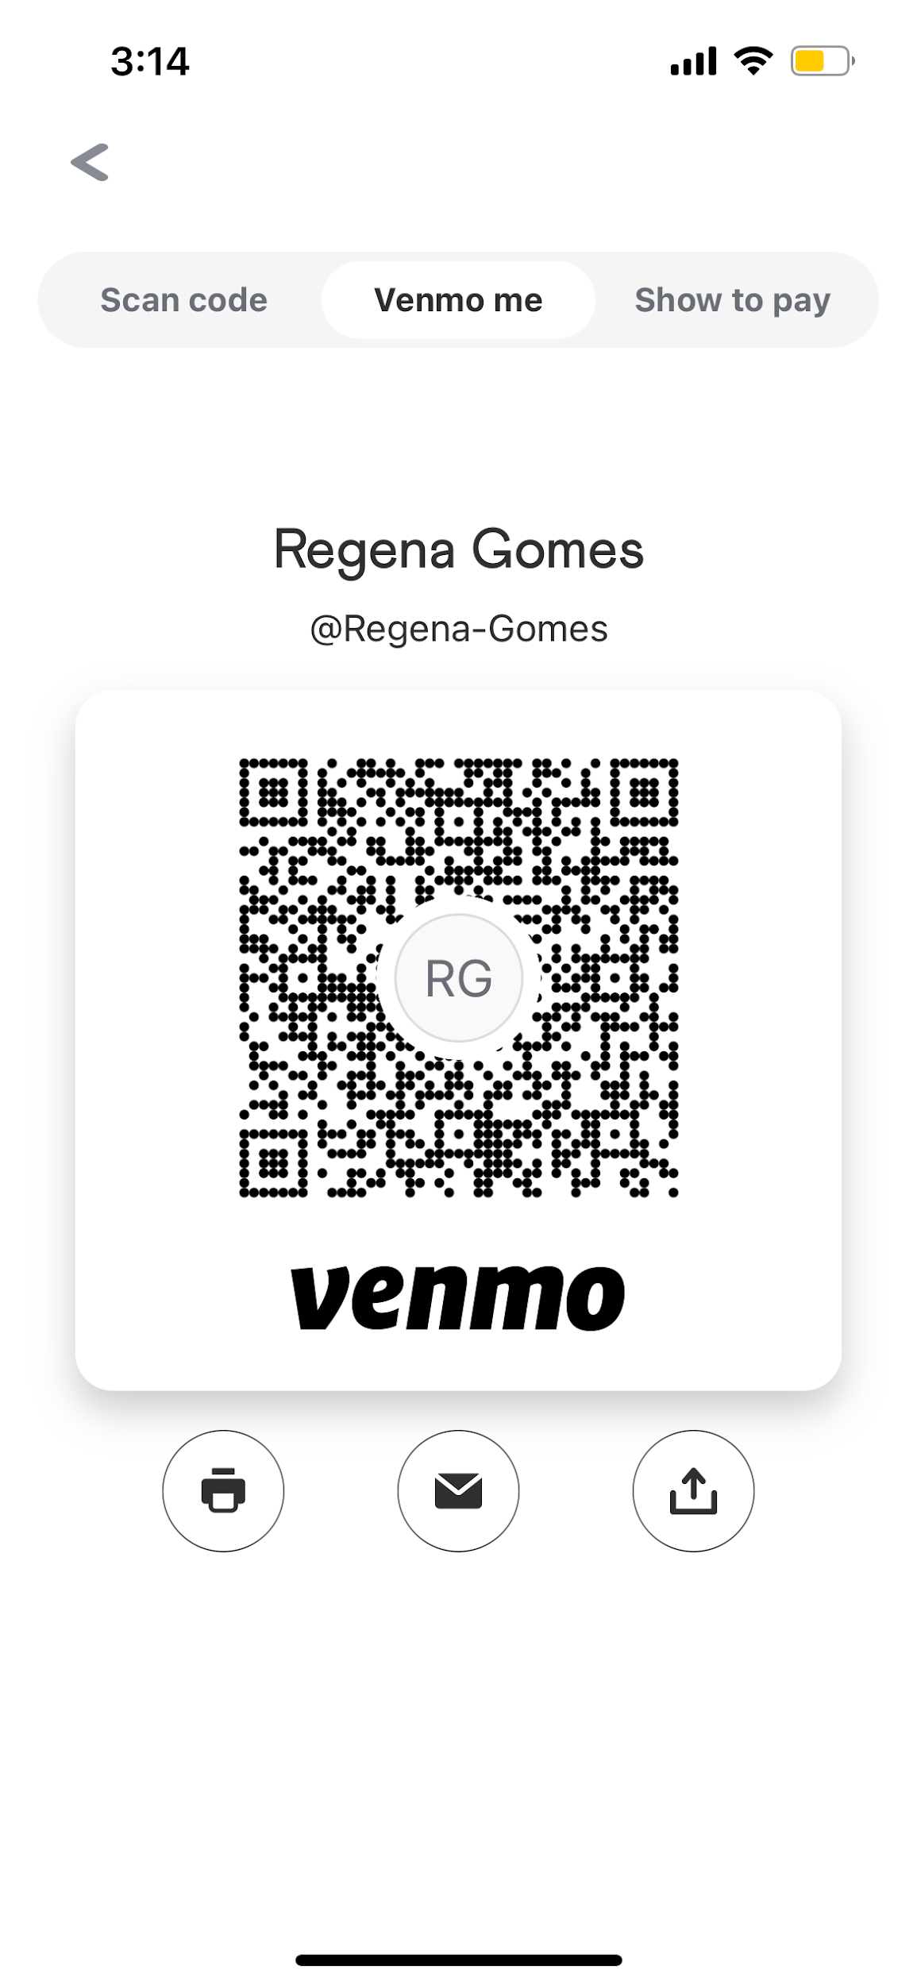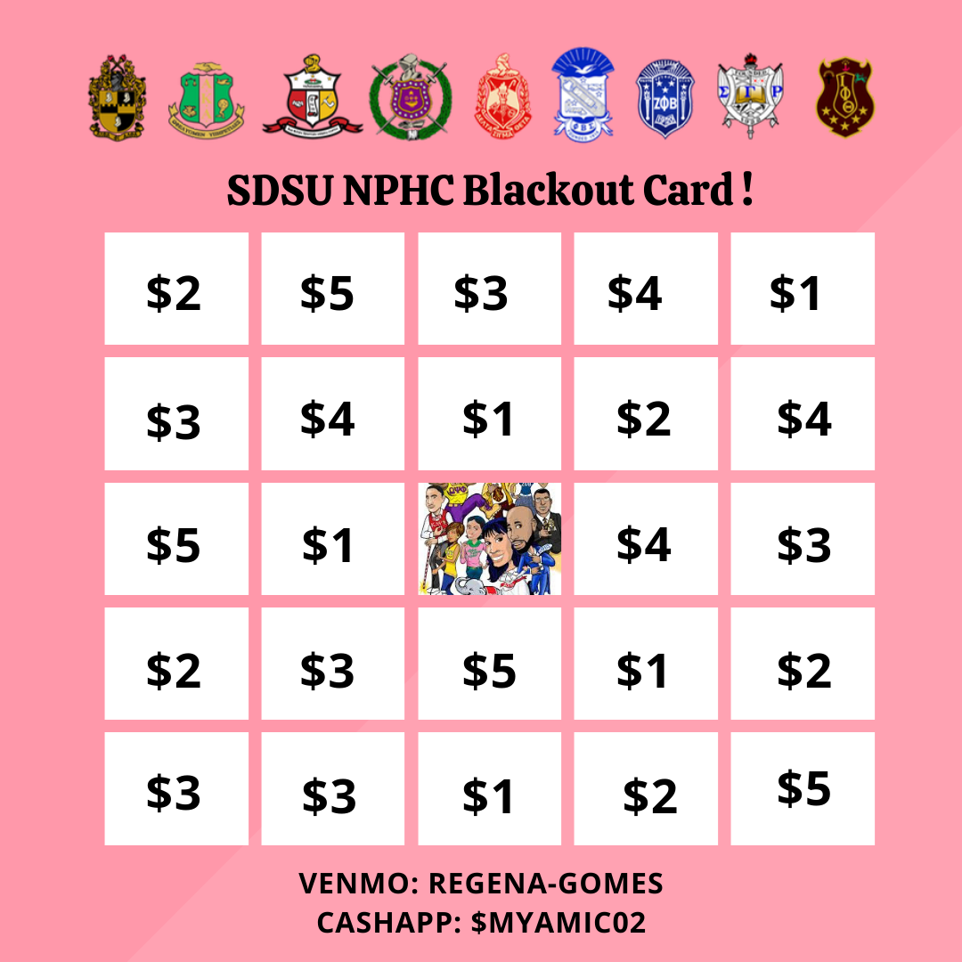
- Kappa Alpha Psi- Kappa Homekoming on Nov 2
- Delta Sigma Theta- Hip-ocracy 10/10 at UCSD BRC starting at 8:13pm
- Phi Beta Sigma- Sigma Halloween 10/21 at 9pm
- Zeta Phi Beta- Ta Ta Trivia in BRC at 6:30pm on 10/11 in collab with Sigma Gamma Rho

USFC Representative: Scholarship Director - Jalen Arbis - (scholarshipdirector.usfc@gmail.com) reported:
- Alpha Psi Rho: Icebox Fundraiser
  - Tuesday - all day
  - Mention APsiRho when ordering
- Delta Sigma Psi: Chipotle Fundraiser
  - Today 5-9pm at Chipotle in the Union
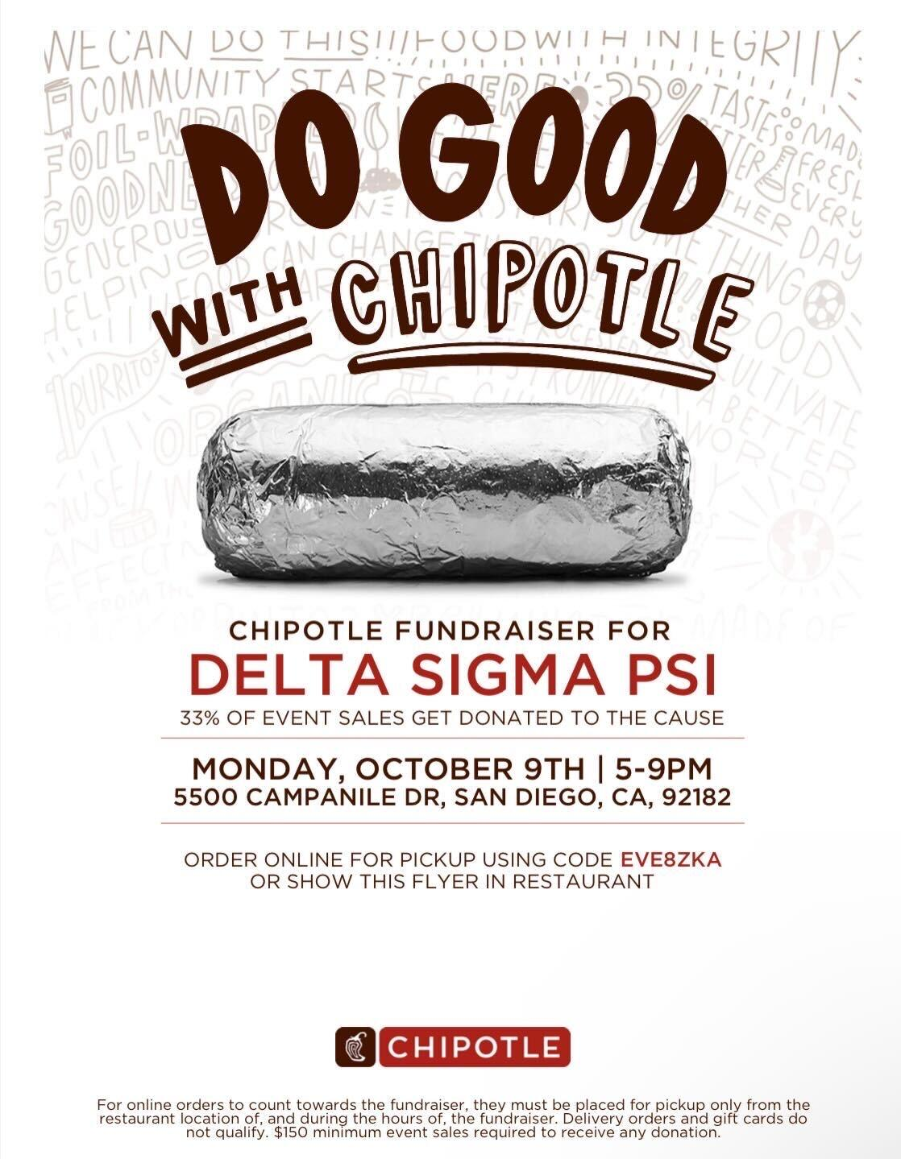
- Sigma Alpha Zeta: “Donut Let Love Hurt” Fundraiser
  - Oct 23rd-26th at Centennial walkway (10am-2pm)
  - $2/donut
- Upsilon Kappa Delta: Annual Philanthropy event
  - Friday Oct. 13th at Templo Mayor (starts 5pm)
  - RSVP Link: https://docs.google.com/forms/d/e/1FAIpQLSeQ_SI6ptYfDbArIwWGB4GZDhH_EFOK3qU0McTO2gd0Bq5jiw/viewform
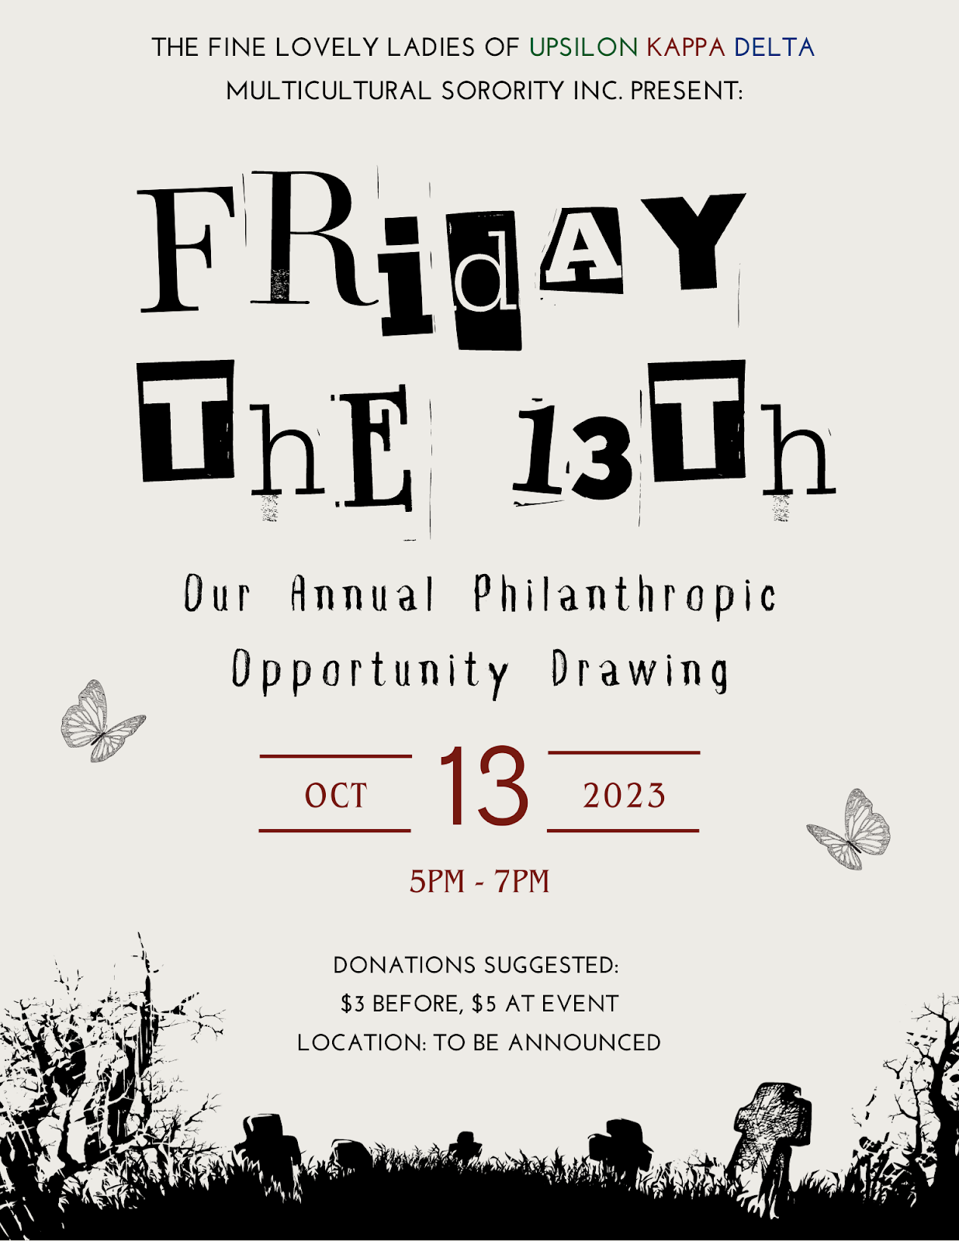

IFC Representative: - Joey Salvail - (jsalvail3784@sdsu.edu) reported:
- IFC is putting in new risk measurements
GLAB Representative: TBA (cpa.sdsuglab@gmail.com) reported:
- N/A

Rho Lambda Representative: TBA reported:
- N/A

OFFICER REPORTS
The President, Sophie Rokaw, (president.cpa.sdsu@gmail.com) reported:
- Hi all! Hope you all had a safe & fun weekend!
- Keep promoting the Girls Supporting Girls Shirts! LINK!! We will hit the minimum, so let members know they won’t need to worry about that!
- If anyone was interested in shadowing me, please let me know!
- We will be using our safety budget for Halloween Weekend, if there are any specifics things your chapters would like to be seen implemented let me know.

The Executive Vice President, Lex Sabbatino, (executivevp.cpa.sdsu@gmail.com) reported:
- CPA applications will be coming out next Monday, October 16th at 4pm! Please advertise this to your members.
- Some of exec will be coming by your chapter meetings to discuss applications as well.

The Vice President of Programming, Macy Kobzeff, (programming.cpa.sdsu@gmail.com) reported:
- Speaker coming soon (hopefully Nov 1st) <3
- Have a good week

The Vice President of Community Wellness, Elizabeth Gill, (communitywellness.cpa.sdsu@gmail.com) reported
- Happy Monday!
- No report
The Vice President of Finance, Marissa Temple, (finance.cpa.sdsu@gmail.com) reported:
- Happy Monday
- Working on scholarship checks, will hopefully have in the next couple of weeks

The Vice President of Membership, Alexa Trcka, (membership.cpa.sdsu@gmail.com) reported:
- No report<3

The Vice President of New Members, Roxanne Elisha, (newmembers.cpa.sdsu@gmail.com) reported:
- Nothing from me! Hope midterms went well!

The Vice President of Communications, Riley Bellomo, (communications.cpa.sdsu@gmail.com) reported:
- Hi everyone!
- Composites are on the way yay!
- Continue to promote the panhellenic tshirts :) Here’s a personalized graphic for each chapter!!
The Vice President of Judicial Affairs, Adriana Juricic, (judicial.cpa.sdsu@gmail.com) reported:
- No report from me besides new business

The Vice President of Campus Relations, Maisie Vargas, (campusrelations.cpa.sdsu@gmail.com) reported:
- If ur having any philos or other events open to people aside from your chapter and you’re not mentioning them in your minutes let me know & send me a flyer so I can report to other councils :) (if they’re in your minutes I got ‘em)
- At 4PM Hillel is having a peaceful walk in support of Israel if anyone wants to join me & go
- Have a good weeeeeekkkk

The Vice President of Philanthropy, Taylor Cloutier, (philanthropy.cpa.sdsu@gmail.com) reported:
- Hey happy monday!
- Congrats to AGD on your philanthropy event!! <33
- Make sure to buy the Girls Supporting Girls shirt!!! Link is in Sophie’s report!!
  - On that note, Circle of Sisterhood Tabling event will be October 25th now! I will give more information next week about how this will run but get hyped!
  - We will be doing walk arounds at your meetings to briefly educate about circle of sisterhood…I will reach out to your chapters individually about scheduling this!
- 2023 Volunteer Opportunities
- Remember if you want to shadow me and learn about all things cpa philanthropy related let me know!! 7607038735

The Vice President of Scholarship, Noemi Portillo, (scholarship.cpa.sdsu@gmail.com) reported:
- Happy week 8!
- Please remind the scholarship recipients to send me their photos if they haven’t already!
- New member scholarship recipients:
  - Alpha Chi Omega: Marwa Moustakib, Sadie Stephens
  - Alpha Gamma Delta: see me after please !
  - Alpha Phi: Kanyada Doughty, Isabella Ortega
  - Delta Gamma: Saralyn Martin, Zoe Merola
  - Gamma Phi Beta: Ashlyn Morris, Kayla Anvaripour
  - Kappa Alpha Theta: Saga Oneill, Meran Neese
  - Kappa Delta: Bobbi Kelly, Lesli Licea
  - Pi Beta Phi: Melina Christodoulides, Ella Irving
- Reach out to me if you are having difficulty finding accred opportunities! I am here to support you all but please reach out so I can help!
- Here is the Fall 2023 Accred Packet – please reference this first!

The Vice President of Diversity, Equity, and Inclusion, Kenna Mo, (dei.cpa.sdsu@gmail.com) reported
- 10 Year Pride Center Survey: https://tinyurl.com/10yrpridecenter - In preparation for the 10 year anniversary of The Pride Center, we are compiling a history of The Pride Center and 2SLGBTQIA+, queer, and trans organizations at San Diego State University including the narratives and experiences of the many individuals who have been a part of and impacted by the space. From participating in a Pride Parade, being part of the Pride ERG, performing in a Drag Show, to forming the Queer Student Union, and every other aspect of our history; to the extent you are comfortable, tell us your stories, memories, and experiences at SDSU in relation to The Pride Center. DEADLINE TO SUBMIT RESPONSES: November 1, 2023 at 11:59pm
- The Brave Project - The Brave Project is a certification program that provides education to the SDSU community on sexual assault prevention, resources, and support through a holistic social, feminist, and trauma-informed lens. Session 2: October 17 - November 7. Register for Session 2 at bit.ly/bravefall23-2
- Please remind your members to be respectful when at accreditation events. You are a representation of our community. These events are held in cultural safe spaces.
  - CREDIT WILL NOT BE GIVEN IF WE RECEIVE REPORTS.

Panhellenic Advisory Team
Kayla Snow (ksnow@sdsu.edu)
Jason Fitzer (jfitzer@sdsu.edu)
Kristen Lemaster (klemaster@sdsu.edu)
- FSL Chapter Coach reminder - you can always reach out if you need support!
- EAS Event Planning reminder - late requests will not be approved
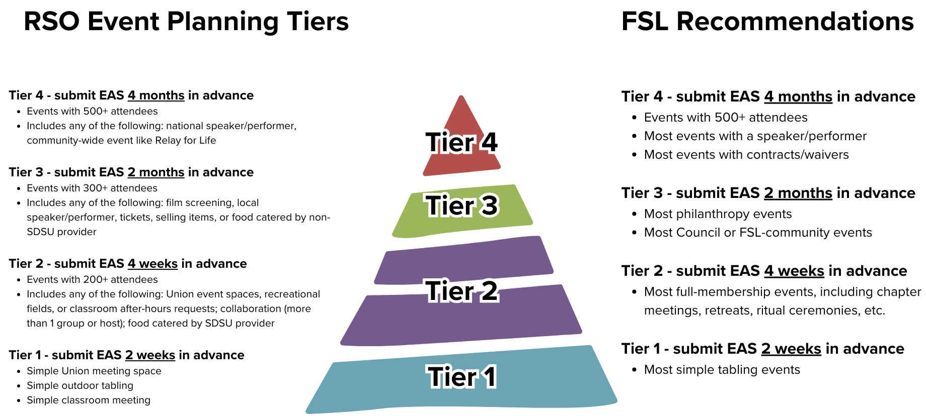
- Incomplete COB processes:
  - Alpha Gamma Delta
  - Alpha Phi
  - Gamma Phi Beta
  - Kappa Alpha Theta
- Missing NME plans:
  - Alpha Gamma Delta
- Pending e-bids:
  - All chapters have pending e-bids. FSL staff can decline a bid for someone if you let us know, but we cannot accept bids on anyone’s behalf. We’ll start declining anyone who you haven’t already contacted us about.
- Submit your updated chapter roster to FSL as soon as all bids have been answered
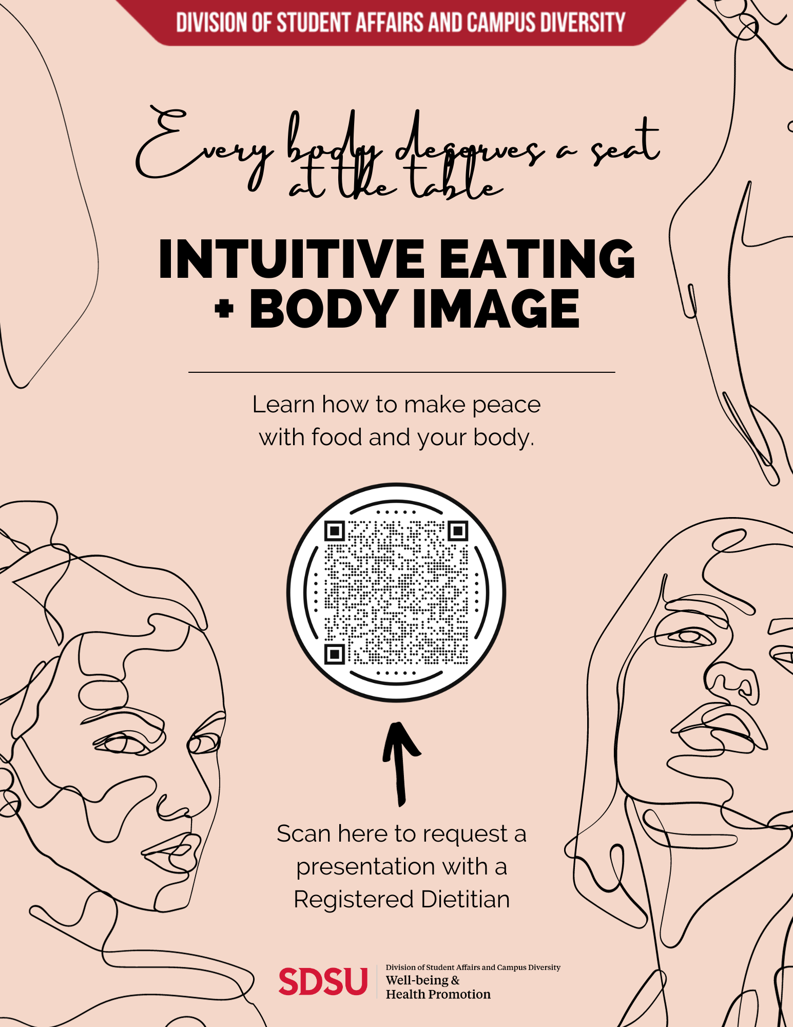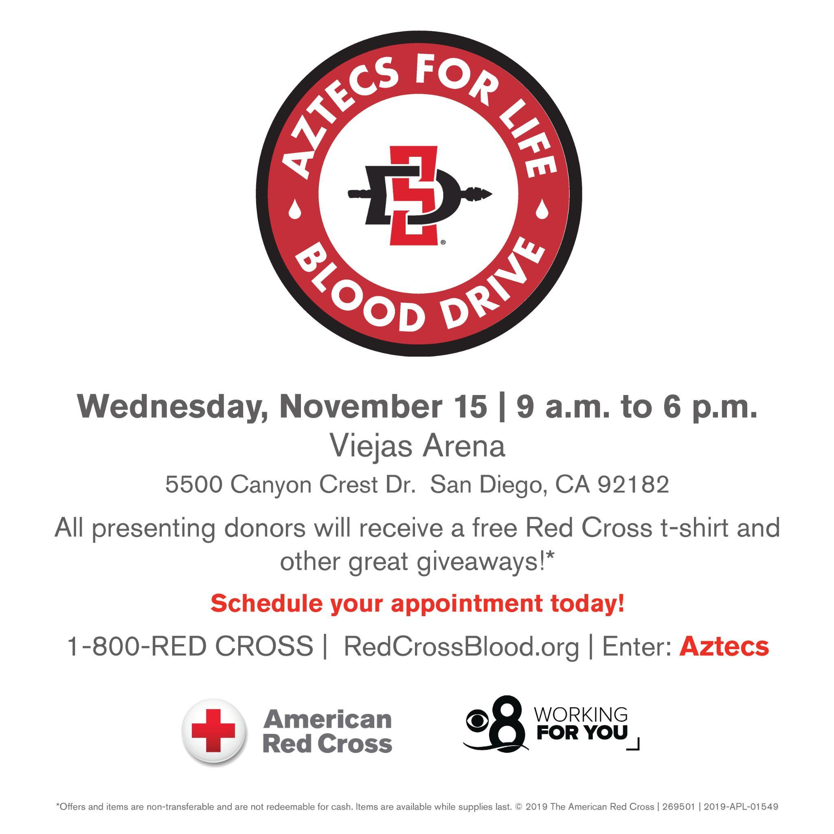

New Business

CPA Position Bylaw Changes
Sophie: I would like to entertain a motion to revise the CPA position bylaws. This revision would include dividing Vice President of Membership into two positions, Vice President of Recruitment Internal and Vice President of Recruitment External. This would also include renaming Vice President of New Members to Vice President of Recruitment Counselors. The position bylaws would be shortened as they are in total forty-two pages right now. Detailed position descriptions will be in a separate document. All position specifics as well as all revisions will be shown in this bylaws. Here is the full position descriptions if you are interested officer descriptions.

Alondra Orozco, Kappa Delta delegate moves to approve the motion. Seconded by Lucia Bronzo-Munich, Alpha Phi delegate. The vote will take place on Monday, October 16th.

Increasing Financial Scholarship Budget
Sophie: I would like to entertain a motion to increase the budget for the financial need scholarship. This is the rolling scholarship that Vice President of Finance, Marissa, oversees. Last year, we had around 30 applicants and this year we have 80 This would increase the budget from $7,000 to $9,000 a semester ($14,000 to $18,000)allowing for more members to be provided assistance.

Avery LeBlanc, Alpha Gamma Delta delegate moves to approve the motion. Seconded by Alondra Orozco, Kappa Delta delegate. The vote will take place on Monday, October 16th.

SISSTER Donation
Sophie: I would like to entertain a motion to donate $500 to SISSTER and FRAT manners in order to help them put on the events they put on for our community for free.

Alondra Orozco, Kappa Delta chapter delegate moves to approve the motion. Seconded by Morgan Anapolsky, chapter delegate for Alpha Chi Omega. The vote will take place on Monday, October 16th.

Old/Unfinished Business
n/a

CHAPTER NEWS:
Alpha Chi Omega- Morgan Anapolsky (alphachiomegapanhellenic@gmail.com)
- Chapter news: We are planning a fun beach sisterhood this Friday
- Highlights: We’re getting super excited for our date dash
- Lowlights: None
- Questions:

Alpha Gamma Delta- Avery LeBlanc (agd.campusrelations.sdsu@gmail.com)
- Chapter news: We have our Space Gam Date Dash this friday and we cannot wait!
- Highlights: Last week we had our painting over or insecurities sisterhood event which was a great way to bond with our sisters
- Lowlights:
- Questions: IDK if i missed it but how will we receive our Panhellenic shirts??
  - I will bring them to the chapter houses! -Sophie
Alpha Phi- Lucia Bronzo-Munich (alphaphipanhellenicsdsu@gmail.com):
- Chapter news: Our red dress gala philanthropy is coming up oct 20th
- Highlights: We had an amazing time at our Bikers and Babes themed date dash this week!
- Lowlights: n/a
- Questions: Can we see the list of girls who haven’t accepted e-bids again?
  - Come see me after meeting! - kayla

Delta Gamma- Kenna McCabe (sdsudgpanhellenic@gmail.com):
- Chapter news: It’s our big little week and we are so excited to welcome new members into the families!
- Highlights: Yesterday we held a backpack charm making sisterhood at the house which was so much fun!
- Lowlights: N/A
- Questions: N/A

Gamma Phi Beta- Kayla Mendoza (sdsugammaphibetapavp@gmail.com):
- Chapter news: We had a great time at date dash this Friday!
- Highlights: Looking forward to holding our annual philanthropy event Pancake this Friday from 9pm-1am:)
- Lowlights: n/a
- Questions: n/a

Kappa Alpha Theta- Taryn Greenlee (vpp.theta.sdsu@gmail.com)
- Chapter news: We had a great time at Sister Dash on Friday
- Highlights: We’re excited for our Big Little reveal this Friday
- Lowlights: N/A
- Questions: N/A

Kappa Delta- Alondra Orozco ( panheldelbetarho@gmail.com )
- Chapter news: Our new mems will be initiated on Wednesday!
- Highlights: We have a build a bear workshop sisterhood event on Wednesday :)
- Lowlights: None
- Questions: None

Pi Beta Phi- Annie Deal (caepsilonpd@gmail.com)
- Chapter news: pie a pi phi this wed at hepner 10-2!
- Highlights: we are pumped for our parents weekend planning
- Lowlights: n/a
- Questions: n/a

ANNOUNCEMENTS

ADJOURNMENT:
Motion:
Time: 3:32PM

