College Panhellenic Association || San Diego State University
Delegate Meeting Minutes || 9/25/23 || 3pm || Pierce Greek Life Center

See “HIGHLIGHTS” section below for important information for chapters to bring back to their chapters!

ΑΧΩ, ΑΓΔ, ΑΦ,ΔΓ, ΓΦΒ, ΚAΘ, ΚΔ, ΠΒΦ

ROLL CALL:
Present: ΚΔ, ΚAΘ, ΑΓΔ, ΔΓ, ΑΧΩ, ΑΦ, ΠΒΦ, ΓΦΒ
Absent:

GUESTS:
- Aztecs Rock Hunger
  - Annual university-wide campaign led by Associated Students with the goal of raising as much money as possible for SDSUs Economic Crisis Response Team, the AS Food Bank, and the Jacobs and Cushman San Diego Food Bank.
  - Goal this year is to raise $100,000
  - From October 13th - November 5th
  - Competition between CPA chapters

APPROVAL OF MINUTES::
Motion: ΑΓΔ | Seconded: ΓΦΒ

FINANCIAL UPDATE: The Treasurer reported as follows as of:

Beginning balance: $191,516.45

Revenue | --
Expenses | $468.58

Ending Balance: $191,047.87

GREEK COMMUNITY RELATIONS REPORTS:
NPHC Representative: President - Regena Gomes - (president.nphc@gmail.com) reported:
- These Hands Don’t Haze on Sept 28 at 7pm in the BRC
- Be Owt Thursday on Oct 5, 11am at Campanile Walkway
- Breast Cancer Walk Oct 15 with the American Cancer Society

- AKAs- Elementary school drive
  - https://www.amazon.com/registries/gl/guest-view/XOIK5H03HA3L
- Kappas- Study session with CIR young men of color, Sept 27 at 3pm
  - Informational for those interested in Kappa Sept 27 at 8:11pm in Scripps Cottage
  - Kappa Homekoming- annual homecoming party Nov 2
- Sigmas- Camp Blu and White, HIIT workout Sept 26 at 2pm in the BRC backyard
  - Sigma halloween, Oct 21 9pm at the Encore Event Center
- Zetas- Collab workout event with the Sigmas
  - Zeta Block community clean up, Sept 30 at Lincoln High School at 9am

USFC Representative: Scholarship Director - Jalen Arbis - (scholarshipdirector.usfc@gmail.com) reported:
- Many of our orgs had successful fundraisers this past week
- We have finalized a date for our biannual Scholastithon (Nov. 27th)
  - Provide a study space for people before finals
- Upsilon Kappa Delta - Icebox fundraiser Sept. 28 (11am-8pm)

IFC Representative: - Jayce Hafdal- (jsalvail3784@sdsu.edu) reported:
- we have anti-hazing symposium this week
- we are very excited for dry period to end!
GLAB Representative: TBA (cpa.sdsuglab@gmail.com) reported:

Rho Lambda Representative: TBA reported:

OFFICER REPORTS
The President, Sophie Rokaw, (president.cpa.sdsu@gmail.com) reported:
- Hope everyone is doing well <3
- Stoles have been ordered! No more changes can be made!
- Hard launching the Girls Supporting Girls shirts for this term! The design has been finished, currently working on getting the order link, and details in line, but this is the design! Get your chapters excited! <3
  - 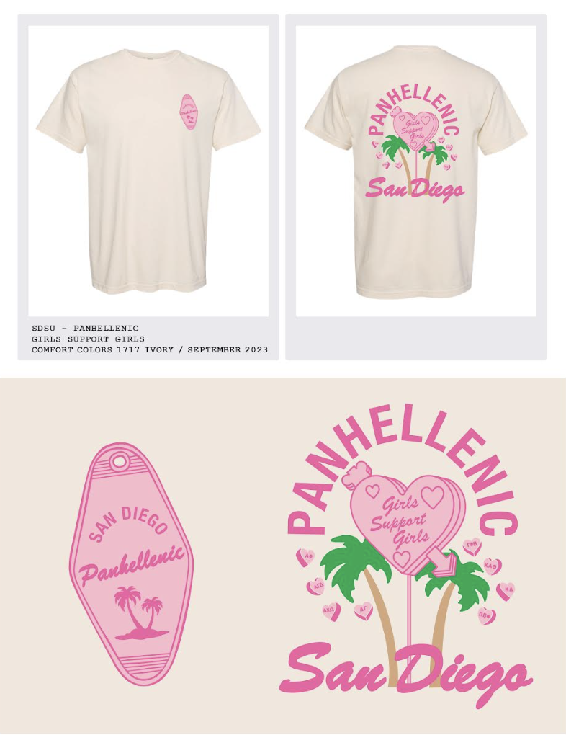
- Extension is going great! I wanted to quickly touch upon the confidentiality agreement the committee signed!
  - Confidentiality Agreement
- As a board we have been discussing increasing the scholarship budget to accommodate for increasing chapter sizes and give back more to you all. We discussed this previously in our delegate groupchat/president meetings, but to give you all a specific number we would increase from 5000$ to 8200$. This wouldn’t increase panhellenic dues, we simply have the budget and want to help you, help operate with your large chapter sizes. If this is something everyone would be interested in we could have a motion proposed during New Business.

The Executive Vice President, Lex Sabbatino, (executivevp.cpa.sdsu@gmail.com) reported:
- Please keep pushing shadowing to your members, it’s no commitment and can just be a quick meeting! Any member can text me at (571) 465-0334 for questions about the application process, and positions, or if they need to be connected with the right CPA member whose position they’re interested in so feel free to send that info in your chats!
- Tell your presidents to check for upcoming emails and respond regarding interviews and walk arounds:)
- Basic overview of eligibility for CPA:
- One has a minimum 2.7 cumulative GPA
- One has completed OR will complete AT LEAST 1 semester as an Active Member by the conclusion of the Fall 2023 Semester
- One must have completed OR will complete 60 units by the conclusion of the Fall 2023 Semester
- One is currently in Good Standing with the University (academic and judicial)
- One is currently in good standing with their Chapter (judicial, academic, financial)
- One will be a full-time student at SDSU during the term
- One will be available during formal recruitment

The Vice President of Programming, Macy Kobzeff, (programming.cpa.sdsu@gmail.com) reported:
- Programming event soon I promise
- Only one person has reached out to shadow! Let’s get coffee or go on a hot girl walk
→ feel free to use my phone number 714-475-4888

The Vice President of Community Wellness, Elizabeth Gill, (communitywellness.cpa.sdsu@gmail.com) reported
- Happy Monday!
- Reminder
  - Sister sororities
    - Alpha Chi Omega + Kappa Alpha Theta
    - Alpha Phi + Gamma Phi Beta
    - Pi Beta Phi + Alpha Gamma Delta
    - Kappa Delta + Delta Gamma
- Suggestions: intramural sport team, picnic, movie night, study night, tiktoks, etc.
- Good samaritan/amnesty policy
The Vice President of Finance, Marissa Temple, (finance.cpa.sdsu@gmail.com) reported:
- Happy Monday :)
- Financial Hardship Assistance Application: https://forms.gle/xABGyrAbVWSzh7ek9
  - Completely confidential, need based opportunity for any members experiencing financial hardship
  - Will be open the rest of the semester so please send this out and also put it somewhere members can access it at any time
  - Will be contacting the first round of recipients in the next few weeks (most likely the second week of October at the earliest) but since this is a rolling application there is no hard deadline

The Vice President of Membership, Alexa Trcka, (membership.cpa.sdsu@gmail.com) reported:
- Happy monday! Tell your girlies to shadow me<3
- https://docs.google.com/forms/d/e/1FAIpQLSfnUhVK8eZDG0SR3z2vKkKrI1-C9xrjhTwKXonzgyjxCG077g/viewform?usp=sf_link
- Please send this post-recruitment feedback survey out to your members, it MUST be filled out by every single member who was a recruiter this year…. NO ONE IN PC 23!!!
- Form is due by next Monday at 11:59PM and will I will be distributing it to VPMs as well, XOXO <3

- There is a Hazing Prevention workshop on Wednesday at 7:00pm in Storm Hall West 12 and it is open to all members of CPA and IFC if any of your members are interested
- 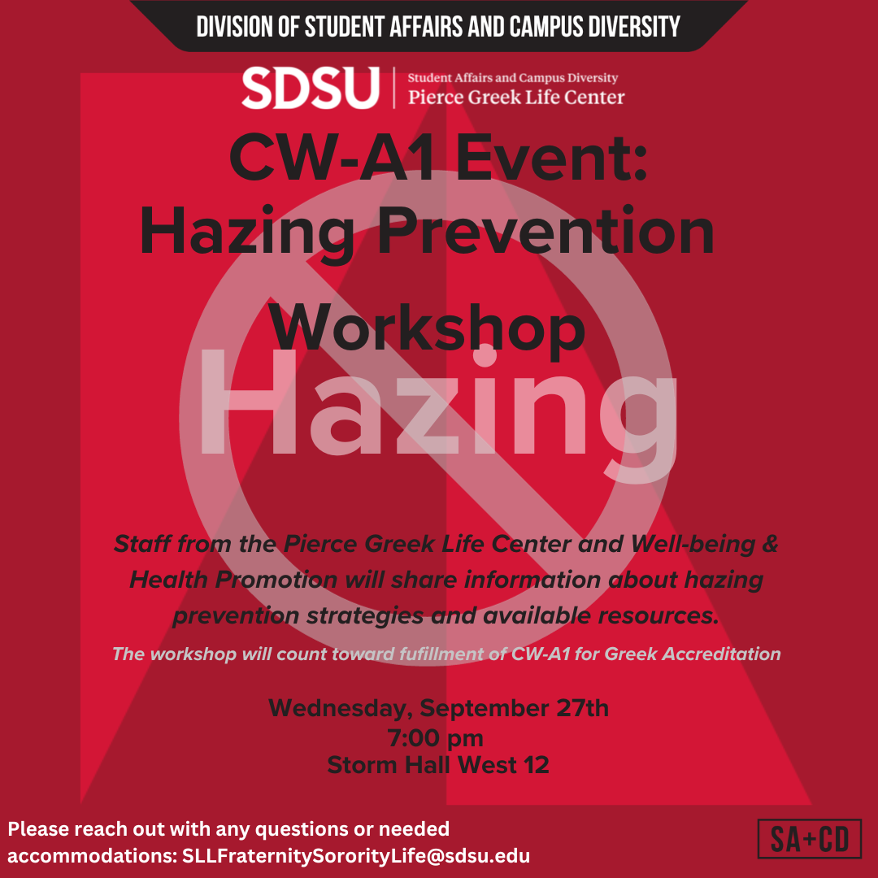

The Vice President of New Members, Roxanne Elisha, (newmembers.cpa.sdsu@gmail.com) reported:
- Hi everyone! Nothing from me :)
- Have a fantastic week, hit my line if you want to shadow me

The Vice President of Communications, Riley Bellomo, (communications.cpa.sdsu@gmail.com) reported:
- Hi!!
- New panhellenic instagram photo circle!!! Here’s a QR code, and the link:https://join.photocircleapp.com/5XNFNWKG97
- Will start doing shadowing soon! But text me if anyone is interested :) 6508501215

The Vice President of Judicial Affairs, Adriana Juricic, (judicial.cpa.sdsu@gmail.com) reported:
- Kappa Delta, Gamma Phi Beta, Kappa Alpha Theta please tell your Presidents to look in their email for an email from me from last week and respond ASAP
- If anyone wants to shadow me email me!

The Vice President of Campus Relations, Maisie Vargas, (campusrelations.cpa.sdsu@gmail.com) reported:
- No reporrtttt
- Hope u are all taking care of yourselves while classes are getting busier!!

The Vice President of Philanthropy, Taylor Cloutier, (philanthropy.cpa.sdsu@gmail.com) reported:
- Happy monday!
- Get excited…circle of sisterhood philanthropy tabling event october 11th! We will also be doing walkarounds/announcements that monday (october 9th) at your chapter meetings! I will be in contact with you individually about this soon!
- 2023 Volunteer Opportunities
  - JDRF One Walk November 11th/12th

The Vice President of Scholarship, Noemi Portillo, (scholarship.cpa.sdsu@gmail.com) reported:
- Happy week 6! Sorry I can’t be there, hope y’all have a great week!
- Encourage your members to apply for the scholarships! They all close on September 29th at 11:59pm and no late submissions will be accepted.
  - Freshmen new mems are able to apply! They just need to put their high school GPA and indicate it’s from high school (ex: 4.00 (high school))
  - Here are the links for each chapter if anyone needs them:
    - Alpha Chi Omega
    - Alpha Gamma Delta
    - Alpha Phi
    - Delta Gamma
    - Gamma Phi Beta
    - Kappa Alpha Theta
    - Kappa Delta
    - Pi Beta Phi
- SDSU Career Services Resumania
  - Location: SDSU Career Services, Student Services East 1200
  - Event Date: Thursday, October 12, 2023
  - Event Time: 11:00 am - 3:00 pm
  - Details: Drop-in to Career Service anytime between 11:00 am - 3:00 pm for a 15-minute resume review. All majors are welcome. REGISTER here. Registration is not required.
- Women in STEM annual lecture with Nalini Nadkarni
  - Lecture and Reception | October 23, 2023 | RSVP HERE
  - 5:30pm - 7:30pm @ SDSU’s Parma Payne Goodall Alumni Center
  - Open to SDSU students, faculty, staff, community members and guests Reception will include light hors d'oeuvres and refreshments. Free entry! Please RSVP by Friday, October 6th
- Here is the Fall 2023 Accred Packet – please reference this first!

The Vice President of Diversity, Equity, and Inclusion, Kenna Mo, (dei.cpa.sdsu@gmail.com) reported
- No Report!
- Be safe this weekend (:
- Shadowing - 425-686-0824

Panhellenic Advisory Team
Kayla Snow (ksnow@sdsu.edu)
- Has been out of office sick but will be back this week! Thanks for sending love.
Jason Fitzer (jfitzer@sdsu.edu)
Kristen Lemaster (klemaster@sdsu.edu)
- Chapter Coaches will begin reaching out soon!
  - Each chapter is assigned a member of the FSL staff to be your direct point of contact.
  - They’ll start by meeting with chapter presidents but are a resource to any & all!
- Greek Accreditation Feedback opportunity: Monday, September 25th from 4:00-4:30pm.
  - Intentionally scheduled right after CPA delegates - stay behind if you are able
    - Thank you to those who stayed and gave feedback!! Feel free to review here
  - Can also submit the survey: http://bit.ly/23fslaccred by September 29th
  - If you don’t give feedback, nothing can change!
- New Member Education Plans (template here if you need it)
  - Chapters should submit to sllfraternitysororitylife@sdsu.edu if they haven’t already.
  - Will continue to share NMES updates as we have them.
- E-bids
  - Most were sent out last week (9/19)! Continue encouraging them to accept or decline by TOMORROW (September 26th).
  - If having issues signing in, make sure they are using their email address (@sdsu.edu).
  - Chapter officers can check e-bid statuses by logging into the RSO system (https://stuapp.sdsu.edu/RSO/3/Login/Officer ) and reviewing the chapter membership roster (under "Membership" -> "Edit Membership List" -> at the bottom).
  - If missing an e-bid, make sure they checked their spam/trash/filtered inboxes. As a last resort, email Kristen at klemaster@sdsu.edu.
  - COB e-bids cannot be extended until their eligibility is confirmed AND we have their signed MRABA. Continue checking your COB spreadsheet for updates.
- Rosters
  - After all your chapter’s e-bids have been declined/accepted, please send your updated chapter membership roster to sllfraternitysororitylife@sdsu.edu.

New Business
Sophie: I would like to entertain a motion to approve increasing the scholarship budget from $5000 to $8200 to give $205 scholarships to 5 members of each chapter; 2 new members, 3 actives.
Avery LeBlanc, Alpha Gamma Delta delegate moves to approve the motion. Seconded by Alondra Orozco, Kappa Delta delegate. The vote will take place on Monday, October 2nd.

Old/Unfinished Business
N/A

CHAPTER NEWS:
Alpha Chi Omega- Morgan Anapolsky (alphachiomegapanhellenic@gmail.com)
- Chapter news: We are planning our Date Dash and are so excited!
- Highlights: Our new members loved spending time together at the Padres sisterhood last week.
- Lowlights: None
- Questions: None

Alpha Gamma Delta- Avery LeBlanc (agd.campusrelations.sdsu@gmail.com)
- Chapter news: We are finalizing all our plans for Date Dash in a couple weeks !
- Highlights: We had a blast at our brunch event this sunday !
- Lowlights:
- Questions:

Alpha Phi- Emma Davis (alphaphipanhellenicsdsu@gmail.com):
- Chapter news: Our chapter just announced our Disneyland sisterhood on Nov. 2nd😄
- Highlights: New member letter painting sisterhood this week
- Lowlights: n/a
- Questions: When will we hear about when our chapter is able to go to New Member Symposium?

Delta Gamma- Kenna McCabe (sdsudgpanhellenic@gmail.com):
- Chapter news: We are excited to have a Hang Loose Hut sisterhood pop up this week!
- Highlights: We had so much fun with our sisters at the Padres Game sisterhood!
- Lowlights: N/A
- Questions:
  - Can the link for the CPA calendar be reshared?

Gamma Phi Beta- Bella and Kayla (sdsugammaphibetapavp@gmail.com):
- Chapter news: We welcomed new fall cobs to our PC 23 and are so excited they are home.
- Highlights: We had a great wellness week full of charcuterie board making, candle painting and journaling together.
- Lowlights: n/a
- Questions: n/a

Kappa Alpha Theta- Taryn Greenlee (vpp.theta.sdsu@gmail.com)
- Chapter news: We were glad to have our first in person chapter together yesterday
- Highlights: We had a fun sisterhood event on Saturday hiking in La Jolla
- Lowlights: n/a
- Questions: n/a

Kappa Delta- Alondra Orozco ( panheldelbetarho@gmail.com )
- Chapter news: Our new members will be meeting their academic big today!
- Highlights: We had a Bob Ross sisterhood event on Sunday.
- Lowlights: n/a
- Questions:
  - How many community wellness events do we have to attend this semester? The accred packet says 2 but the CW tracker says 3
    - The packet and tracker both have 4 events listed. Some of the dates are still TBD, but there is one for Sept. Oct., Nov., and December - JRF
  - Is there a way to check if we hit the 90% for NMES
    - Once we can review who attend, we’ll make the info available
      - The chapter has not hit the 90% yet - JRF
  - Will there be a makeup NMES? If so, is there a date and time?
    - Yes, future dates still need to be scheduled - JRF

Pi Beta Phi- Annie Deal (caepsilonpd@gmail.com)
- Chapter news: self-care sisterhood last night
- Highlights: We have date dash coming up!
- Lowlights: n/a
- Questions: n/a

ANNOUNCEMENTS

Hi everyone! Tonight’s Dress is an app that my friends and I created in order to promote a more sustainable way to shop for formal dresses! Everyone in your chapter I’m sure has a few dresses in their closets they wore one time for a fall or spring formal and they have no plans to wear them again. Instead of buying a dress for one-time use and having it collect dust, I would love to introduce student-to-student dress rentals! The app has picked up speed on the east coast starting at Villanova University Panhellenic, and I am hoping SDSU can be the next school to promote sustainable fashion within sororities! You post a picture of a dress you own, choose how much to rent it for, and even add cleaning instructions, so your dress comes back to you just the way it was before. You communicate with other students through the app, can filter by size and color, and payment goes through Venmo! It is an amazing way to make back some money from an old dress, and it’s also great to rent a one-time-use dress instead of paying one or two hundred dollars on a new one. It would be amazing for the Panhellenic delegates to promote this app to their chapter during meetings or send this message into their group chats because I think each chapter would really benefit from it! If you have any questions at all please text me! My name is Avery Versaw, I’m the VP Inclusion for Kappa Delta, and my phone number is 7037440097

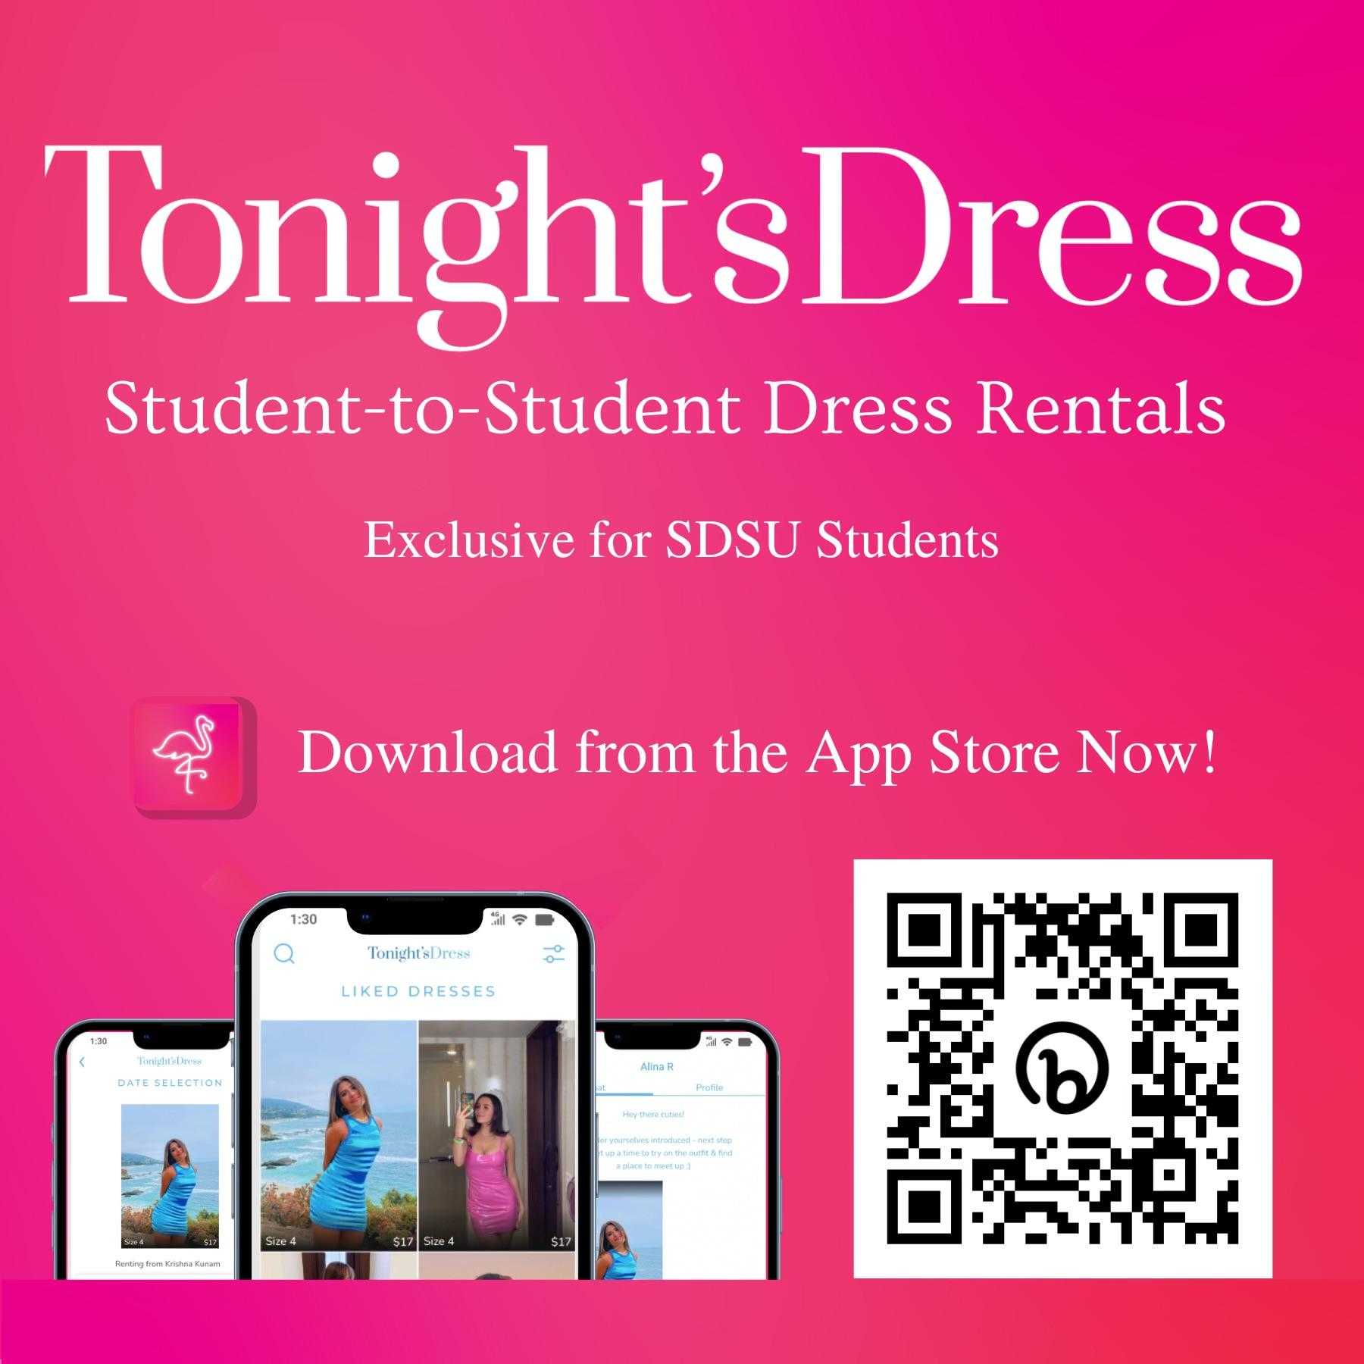

ADJOURNMENT:
Motion: ΑΓΔ Second: ΚΔ
Time: 3:35pm

