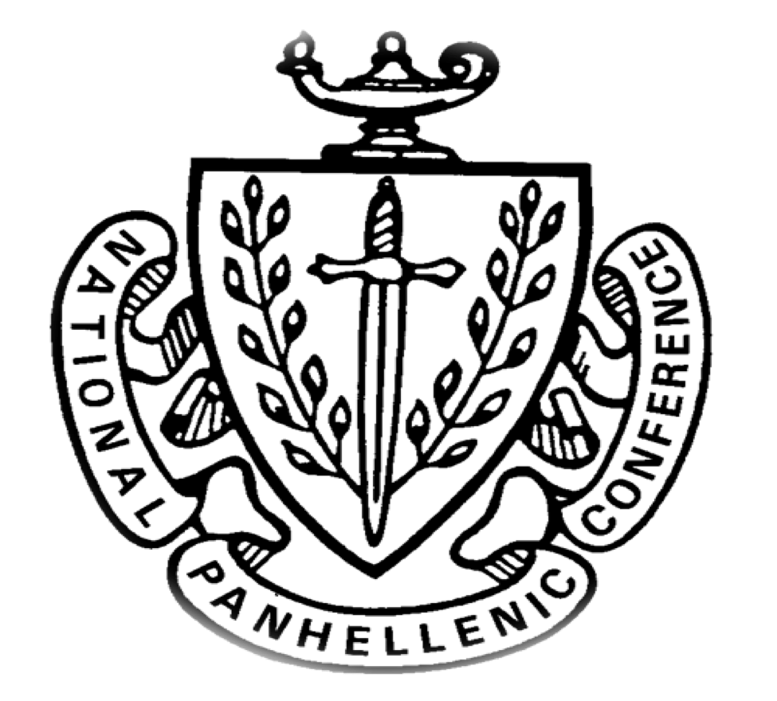
College Panhellenic Association || San Diego State University
Delegate Meeting Minutes || 9/11/2023 || 3pm || Pierce Greek Life Center

See “HIGHLIGHTS” section below for important information for chapters to bring back to their chapters!

ΑΧΩ, ΑΓΔ, ΑΦ,ΔΓ, ΓΦΒ, ΚAΘ, ΚΔ, ΠΒΦ

ROLL CALL:
Present: ΑΓΔ, ΑΧΩ, ΔΓ, ΚΔ, ΚAΘ, ΠΚA, ΓΦΒ, ΑΦ

Absent: ΠΒΦ

GUESTS:
- Phi Kappa Tau
  - @sdsuphitau
  - Looking for member referrals, looking to donate $1 per member referral
  - Have chapter presidents/delegates contact them to come to chapter meetings!

APPROVAL OF MINUTES::
Motion: ΑΓΔ | Seconded: ΚΔ

FINANCIAL UPDATE: The Treasurer reported as follows as of:

Beginning balance: $204,202.72

Revenue | --
Expenses | $10,936.27

Ending Balance: $193,266.45

GREEK COMMUNITY RELATIONS REPORTS:
NPHC Representative: President - Regena Gomes - (president.nphc@gmail.com) reported:

- Meet the Greek- Sept 19 @ Student union theater
- These Hands Don't Haze- Sept 28 @ BRC

USFC Representative: - TBA - (email) reported:

IFC Representative: - Joey Salvail - (jsalvail3784@sdsu.edu) reported:
- IFC recruitment starts today and ends 9/22
- Congrats to everyone on recruitment!
GLAB Representative: TBA (cpa.sdsuglab@gmail.com) reported:

Rho Lambda Representative: TBA (email) reported:
- Rho Lambda applications open today, open until end of September!
  - https://docs.google.com/forms/d/e/1FAIpQLSdYeeXg-ovR5sCQ3eeQnNJwtFSPjbmBHCy_2G2RUwk20UDcGg/viewform?fbclid=PAAaYeQoAvHUOAJz07be4xonH0dYKD74OkUSUdcmrbbLrd6_f8AIl9ES-QfR4_aem_ASYMC_3HhWoNbbekHxubgNMAga3uekMua594hJrgYUrmDYY4hMGt6xj3dyPSyRicc2c

OFFICER REPORTS
The President, Sophie Rokaw, (president.cpa.sdsu@gmail.com) reported:
- Shadowing! If interested in shadowing me! Text me 213-514-2372
- Delegates! Please confirm the spelling of your names by this Wednesday! STOLES
- Extension Committee Selections
  - London Hultgren
  - Adriana Juricic
  - Anna Gunning
  - Cassidy Marshman
  - Hannah Morris
  - Georgia Stitt
  - Megan Pearce
  - Mallory Gannon
- Gone Bananas Interest Form for an Event! On September 22nd!

The Executive Vice President, Lex Sabbatino, (executivevp.cpa.sdsu@gmail.com) reported:
- Please tell you chapter presidents to check their email!

The Vice President of Programming, Macy Kobzeff, (programming.cpa.sdsu@gmail.com) reported:
- Kendra Scott pop up on the 21st/28th!
→ location and flyer will be at the next meeting :)

The Vice President of Community Wellness, Elizabeth Gill, (communitywellness.cpa.sdsu@gmail.com) reported
- Happy Monday!
- Reminder
  - Sister sororities
    - Alpha Chi Omega + Kappa Alpha Theta
    - Alpha Phi + Gamma Phi Beta
    - Pi Beta Phi + Alpha Gamma Delta
    - Kappa Delta + Delta Gamma
  - Suggestions: intramural sport team, picnic, movie night, study night, tiktoks, etc.
The Vice President of Finance, Marissa Temple, (finance.cpa.sdsu@gmail.com) reported:
- Happy Monday!
- Please let your VPFs know I just added them all to the 2023 Financial Transparency drive so if they need that info they should have access to it now
  - Have them text me if they didn’t get it!
- If you know anyone interested in shadowing me lmk! My number is 707-780-7533

The Vice President of Membership, Alexa Trcka, (membership.cpa.sdsu@gmail.com) reported:
- Happy Monday!!!1
- Hope you all had the best in-person recruitment weekend and had so much fun at bid day!!!
- So exciting seeing the biggest new member classes ever run home<3333

The Vice President of New Members, Roxanne Elisha, (newmembers.cpa.sdsu@gmail.com) reported:
- Hi everyone! Nothing from me!
- If anyone wants to shadow, hit my line
- Have an amazing week!!

The Vice President of Communications, Riley Bellomo, (communications.cpa.sdsu@gmail.com) reported:
- Hi! Nothing from me this week!
  - If anyone is interested in shadowing me let me know :) 6508501215

The Vice President of Judicial Affairs, Adriana Juricic, (judicial.cpa.sdsu@gmail.com) reported:
- congrats on finishing recruitment and welcome to everyone’s new member classes!
- infraction reports are being written up and I am in contact with your presidents so they will know if your chapter receives one
- Please pass along this info to your president and VPM “As infraction reports have been reported, they are currently being written up as violation reports. From then, I will send the president an email asking for a time to meet for an informal meeting. This meeting is not a mediation nor is it written up as an infraction report but it is just a time for us to talk about the reports I received and how we can better our chapters for next year.”
- I’ll be opening for shadowing in like 2 weeks if anyone is interested please email me

The Vice President of Campus Relations, Maisie Vargas, (campusrelations.cpa.sdsu@gmail.com) reported:
- No report have a good week!

The Vice President of Philanthropy, Taylor Cloutier, (philanthropy.cpa.sdsu@gmail.com) reported:
- Hey everyone happy happy Monday! Hope everyone had a great end to recruitment!
- If you want to shadow me or know anyone interested let me know! 7607038735
- 2023 Volunteer Opportunities
  - Conversations with International Students September 19th
  - PB Half Marathon October 5th, 6th, 7th
  - Susan G. Komen More than Pink walk November 5th

The Vice President of Scholarship, Noemi Portillo, (scholarship.cpa.sdsu@gmail.com) reported:
- Happy week 4!!
- I’m planning a panhellenic scholarship dinner!
  - It is tentatively planned for November 16 from 6-8 PM
  - More information coming soon!
- Here is the Fall 2023 Accred Packet – please reference this first!

The Vice President of Diversity, Equity, and Inclusion, Kenna Mo, (dei.cpa.sdsu@gmail.com) reported
- I am taking shadows
  - If anyone in your chapter wants to shadow me for DEI please text me (425) 686-0824
  - Maddy Nance (AXO)
- Improving Chapter Relations
  - Please utilize sister sororities
  - Interacting with each other to minimize talking negatively about chapters
    - Be leaders and do not egg on hateful, untrue comments about other chapters. It does affect their mental health.
    - Ask your chapters if they would be willing to push members to go to Panhellenic (fun) community-wide events and any ideas they would enjoy going to, to bond our chapters.

Panhellenic Advisory Team
Kayla Snow (ksnow@sdsu.edu)
Kristen Lemaster (klemaster@sdsu.edu)
Jason Fitzer (jfitzer@sdsu.edu)

- PNM/NM Updates
  - Great work on COB! 20+ additional new members so far & going strong.
  - Conducting final judicial eligibility checks
  - E-bids will be extended this week
- EAS & Space Requests
  - We are working with campus partners to identify spaces given larger chapter sizes, but it takes time! No updates for tonight but will follow up as soon as we have more info.
  - Reminder about EAS event submission timelines: timeline is extended for larger scale events, philanthropy events/fundraisers

Risk Management Attestation
All chapters were sent a Risk Management Attestation for electronic signature through Adobe Sign. The Chapter President, Alumni Advisor, and Faculty/Staff advisor must all complete the document. The following chapters have completed their attestation:

CPA | Alpha Chi Omega
 | Alpha Gamma Delta
 | Alpha Phi | 9/1/23
 | Delta Gamma | 8/31/23
 | Gamma Phi Beta
 | Kappa Alpha Theta | 9/4/23
 | Kappa Delta | 9/1/23
 | Pi Beta Phi

Donuts with the Deans
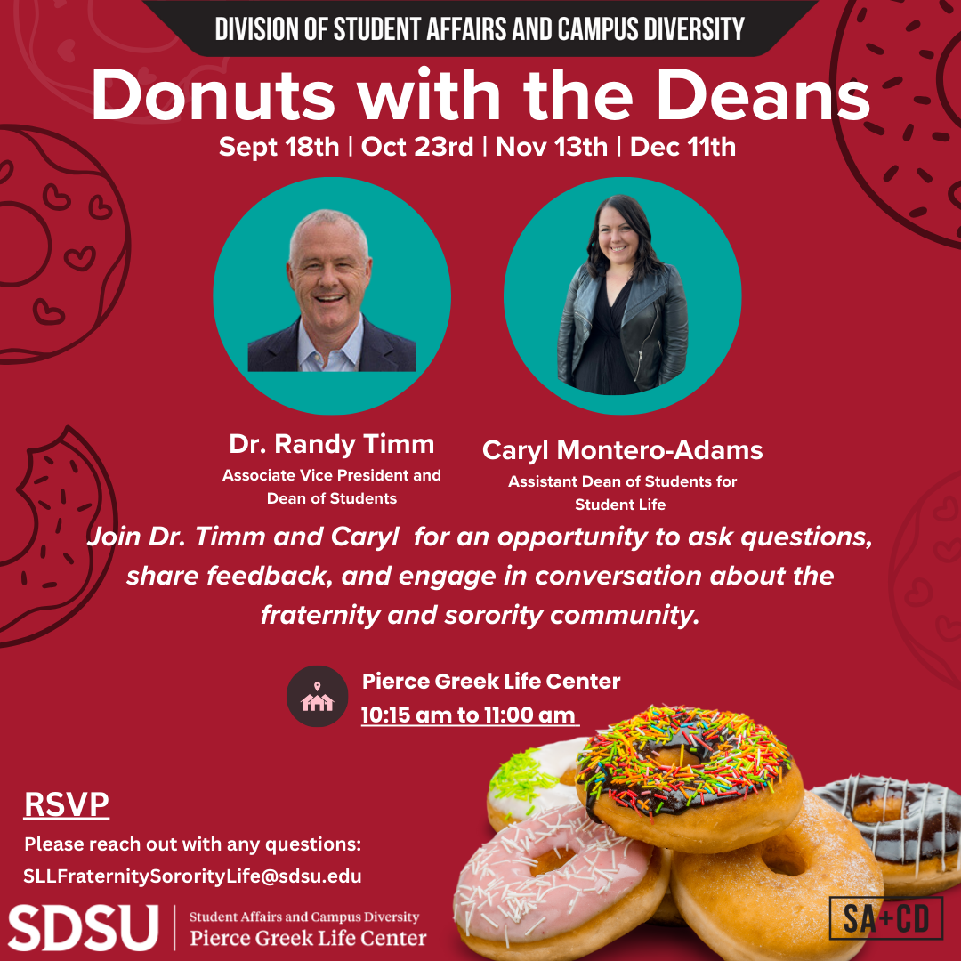
Each month, Dr. Randy Timm, Associate Vice President and Dean of Students and Caryl Montero-Adams will host time for members of the fraternity and sorority community. The time will provide an opportunity to ask questions, share feedback, and engage in conversation about the fraternity and sorority community.

Donuts with the Deans will occur from 10:15 am to 11:00 am in the Pierce Greek Life Center on:
- September 18th
- October 23rd
- November 13th
- December 11th
Please RSVP to attend.

New Business
- Discussion about having CPA pay for Greek Week shirts or changing how that process went
- Based on new member size
- There should be a vote and discussion

Old/Unfinished Business

CHAPTER NEWS:
Alpha Chi Omega- Morgan Anapolsky (alphachiomegapanhellenic@gmail.com)
- Chapter news: We are looking forward to our first chapter meeting with our new members tonight.
- Highlights: We had such a fun bid day with our new members last week!
- Lowlights: None
- Questions: Is there any way you could resend the accred packet? Our president has not received it yet. Thank you!
  - Accred Packet

Alpha Gamma Delta- Avery LeBlanc (agd.campusrelations.sdsu@gmail.com)
- Chapter news: We have a new member study night for all our cutie new memes :)
- Highlights: We had SO much fun at bid day!
- Lowlights:
- Questions:
  - When are panhellenic dues due?
    - Not until later in the semester - I will make sure to give at least 2 or 3 weeks notice for these! It will likely be end of October to early November - Marissa
Alpha Phi- Lucia Bronzo-Munich (alphaphipanhellenicsdsu@gmail.com):
- Chapter news: We were thrilled to welcome our largest group of new members to the chapter this monday
- Highlights: We had our first sisterhood event this friday which was a sunset yoga class!
- Lowlights:
- Questions: Accred packet says that New Member symposium starts 14th and 15th do we have locations and times for that? Or more info?

Delta Gamma- Kenna McCabe (sdsudgpanhellenic@gmail.com):
- Chapter news: We are so excited to be in person for our meeting tonight to welcome our new members!
- Highlights: We had a very successful and fun Bid Day!
- Lowlights: N/A
- Questions:
  - How will new members be included for this semester's accreditation?
    - Specific info on new mems are on pages 3 and 4 of the accred packet! - noemi
  - Is there a date set for the meeting about accreditation for next semester, and if so when will it be?
    - In friday’s email
    - Feedback survey
    - Open forum dates
  - Is there a link to sign up for Rho Lambda?
    - https://docs.google.com/forms/d/e/1FAIpQLSdYeeXg-ovR5sCQ3eeQnNJwtFSPjbmBHCy_2G2RUwk20UDcGg/viewform?fbclid=PAAaYeQoAvHUOAJz07be4xonH0dYKD74OkUSUdcmrbbLrd6_f8AIl9ES-QfR4_aem_ASYMC_3HhWoNbbekHxubgNMAga3uekMua594hJrgYUrmDYY4hMGt6xj3dyPSyRicc2c
  - Can the accred packet be resent? We have not yet received it.
    - Accred Packet

Gamma Phi Beta- Kayla Mendoza (sdsugammaphibetapavp@gmail.com):
- Chapter news: Super happy all our new mems are home!
- Highlights: Bid day was a blast.
- Lowlights: N/a
- Questions: N/a

Kappa Alpha Theta- Taryn Greenlee (vpp.theta.sdsu@gmail.com)
- Chapter news: We have a Sunset Swim sisterhood event this Thursday!
- Highlights: We had a fun and successful bid day last week
- Lowlights: N/A
- Questions: N/A

Kappa Delta- Alondra Orozco ( panheldelbetarho@gmail.com )
- Chapter news: Our activists were very excited to welcome our new mems this past week:)
- Highlights: We have a trucker hat sisterhood event this week
- Lowlights: None
- Questions:
  - When is community wellness this semester? They are reflected differently on the accred packet and the community wellness attendance tracker.
    - Apologies, the tracking sheet is now updated - JRF
  - Are the times finalized for the new member symposiums?
  - Will we have a classroom for tonight’s chapter meeting?

Pi Beta Phi- Annie Deal (caepsilonpd@gmail.com)
- Chapter news:
- Highlights:
- Lowlights:
- Questions:

ANNOUNCEMENTS

ADJOURNMENT:
Motion:
Time:

