College Panhellenic Association || San Diego State University
Delegate Meeting Minutes || 10/23/23 || 3pm || Pierce Greek Life Center

See “HIGHLIGHTS” section below for important information for chapters to bring back to their chapters!

ΑΧΩ, ΑΓΔ, ΑΦ,ΔΓ, ΓΦΒ, ΚAΘ, ΚΔ, ΠΒΦ

ROLL CALL:
Present: ΚΔ, ΑΓΔ, ΚAΘ, ΠΒΦ, ΑΧΩ, ΔΓ, ΑΦ, ΓΦΒ

Absent:

GUESTS:
- Trenton Lane - Interfraternity Council President
  - Spending $1400 on security this week for Halloween, is asking CPA to give $200 to purchase chips and waters.

APPROVAL OF MINUTES::
Motion:ΚΔ | Seconded: ΑΓΔ

FINANCIAL UPDATE: The Treasurer reported as follows as of:

Beginning balance: $180,086.17

Revenue | —
Expenses | $1,638.40

Ending Balance: $178,447.77

GREEK COMMUNITY RELATIONS REPORTS:
NPHC Representative: President - Regena Gomes - (president.nphc@gmail.com) reported:
- NPHC Yard Show on Nov 3 at Montezuma Hall
- Kappa Homekoming Nov 2

USFC Representative: Scholarship Director - Jalen Arbis - (scholarshipdirector.usfc@gmail.com) reported:
- Alpha Psi Rho: Academic Excellence Presentation today
  - 6:30-7pm @ Metzli Room 230A in the Union

IFC Representative: - Joey Salvail </3 - (jsalvail3784@sdsu.edu) reported:
- Working on a new risk management plan.
- Meeting with NIC this week.

GLAB Representative: TBA (cpa.sdsuglab@gmail.com) reported:
- No report.

Rho Lambda Representative: TBA reported:
- All new members have been notified & we look forward to welcoming all 30 new members to our chapter meeting on Sunday!

OFFICER REPORTS
The President, Sophie Rokaw, (president.cpa.sdsu@gmail.com) reported:
- Hi all! Hope you all had a safe, and fun weekend!
- Girls supporting Girls shirt closes tonight! Please push them at your chapter meeting one last time! We only have around 70 purchased, when in reality our community has over 1000 women! So please please push these if your meetings/groupchats tonight. I have been hearing they havent been advertised at all in some chapters! ( I know it says 140, but that is from Panhellenic buying a ton to donate!)

The Executive Vice President, Lex Sabbatino, (executivevp.cpa.sdsu@gmail.com) reported:
- Hi! Please keep promoting CPA applications, they close next Monday! Taylor and I will see GPhi and Pi Phi tonight! I am going to be sending out texts to presidents that have no applications
- @Kenna can I chat with you after meeting:)

The Vice President of Programming, Macy Kobzeff, (programming.cpa.sdsu@gmail.com) reported:
- We’re going to dinner with IFC this week (trent will be shunned because he got rid of joey)
- Bonny Shade is coming to the SDSU panhellenic community to speak on November 1st from 6-8 in ENS 280! Graphic otw for your chapters
→ passionate about sexual violence prevention and building healthy relationships

The Vice President of Community Wellness, Elizabeth Gill, (communitywellness.cpa.sdsu@gmail.com) reported
- Happy Monday! Hope y’all have a great week
The Vice President of Finance, Marissa Temple, (finance.cpa.sdsu@gmail.com) reported:
- Hi everyone!
- AS banking has had staff out of office last week and this week, so they can’t process any checks until next Monday. Because of this, I won’t have scholarship checks available until the first week of November. So sorry for the delay

The Vice President of Membership, Alexa Trcka, (membership.cpa.sdsu@gmail.com) reported:
- Hi! No report from me, message me if you are interested in one/both of my Recruitment positions!
- Have a safe halloweekend<3

The Vice President of New Members, Roxanne Elisha, (newmembers.cpa.sdsu@gmail.com) reported:
- Nothing from me pookies

The Vice President of Communications, Riley Bellomo, (communications.cpa.sdsu@gmail.com) reported:
- Happy founders day to Kappa Delta!!!
- Nothing from me:) (so sorry the minutes were late) Have a great week!!!

The Vice President of Judicial Affairs, Adriana Juricic, (judicial.cpa.sdsu@gmail.com) reported:
- Heyo nothing from me, I am just working on bylaw things for the rest of semester so be prepared for new business motions

The Vice President of Campus Relations, Maisie Vargas, (campusrelations.cpa.sdsu@gmail.com) reported:
- No report!! Have a good week
- Sending love and support to joey in this hard time

The Vice President of Philanthropy, Taylor Cloutier, (philanthropy.cpa.sdsu@gmail.com) reported:
- Hi everyone!!! A lot from me this week!
- First congrats to Alpha Phi on your philanthropy event this past weekend!
- Happy cpa philo week!!
  - Make sure to buy the Girls Supporting Girls shirt by TONIGHT since a portion of the proceeds will go towards Circle of Sisterhood: https://link-itsgoldbaby.myshopify.com/products/sdsu-panhellenic-girls-support-girls-tees
  - Thank you to axo, theta, and dg for letting me come speak at your meetings yesterday, everyone else we are looking forward to seeing you tonight at your meetings!
  - 10/25 Circle of Sisterhood Philanthropy Tabling Sign Up
    - I still have a few more spots for tabling on Wednesday! Share with members, this is easy community service hours that they can earn
  - Opportunity drawing information:
    - Venmo @sdsupanhellenic
    - $3 for one entry and $5 for two entries
    - 2 Prize packages: (1) Sol De Janeiro travel beauty set, an SDSU pennant flag, and a mini JBL speaker. (2) $15 Chipotle gift card, a Stanley cup, and wallet case from the SDSU bookstore.
    - Winners will be announced Friday on the panhellenic instagram! I will also reach out to winners as well
- That’s all from me please text me with any questions you have 7607038735…let's raise a lot of money for Circle of Sisterhood!

The Vice President of Scholarship, Noemi Portillo, (scholarship.cpa.sdsu@gmail.com) reported:
- Happy week 9! I’m so sad I can’t be at meeting today, I’m sick :( so please use this as a reminder to make sure y’all are taking care of yourselves!
- Please reach out to me if you need any help finding opportunities for accred, that’s what I’m here for!
- As usual, here is the Fall 2023 Accred Packet – please reference this before texting me!
- If you or something in your chapter wants to shadow me, feel free to text me (714)833-4896. I’m always happy to chat about my position!

The Vice President of Diversity, Equity, and Inclusion, Kenna Mo, (dei.cpa.sdsu@gmail.com) reported
- No report.

Panhellenic Advisory Team
Kayla Snow (ksnow@sdsu.edu)
Jason Fitzer (jfitzer@sdsu.edu)
- Fentanyl Awareness Forum
  - A forum to foster awareness about fentanyl will take place on Tuesday, October 24th in Peterson Gym 153, at 6:00 pm.
  - The forum will also feature Summer Stephan, San Diego County District Attorney.
  - In addition to providing relevant and important information about fentanyl, the event meets accreditation standards. Chapters with members in attendance at the event can submit the event as part of Greek Accreditation (CW-C).
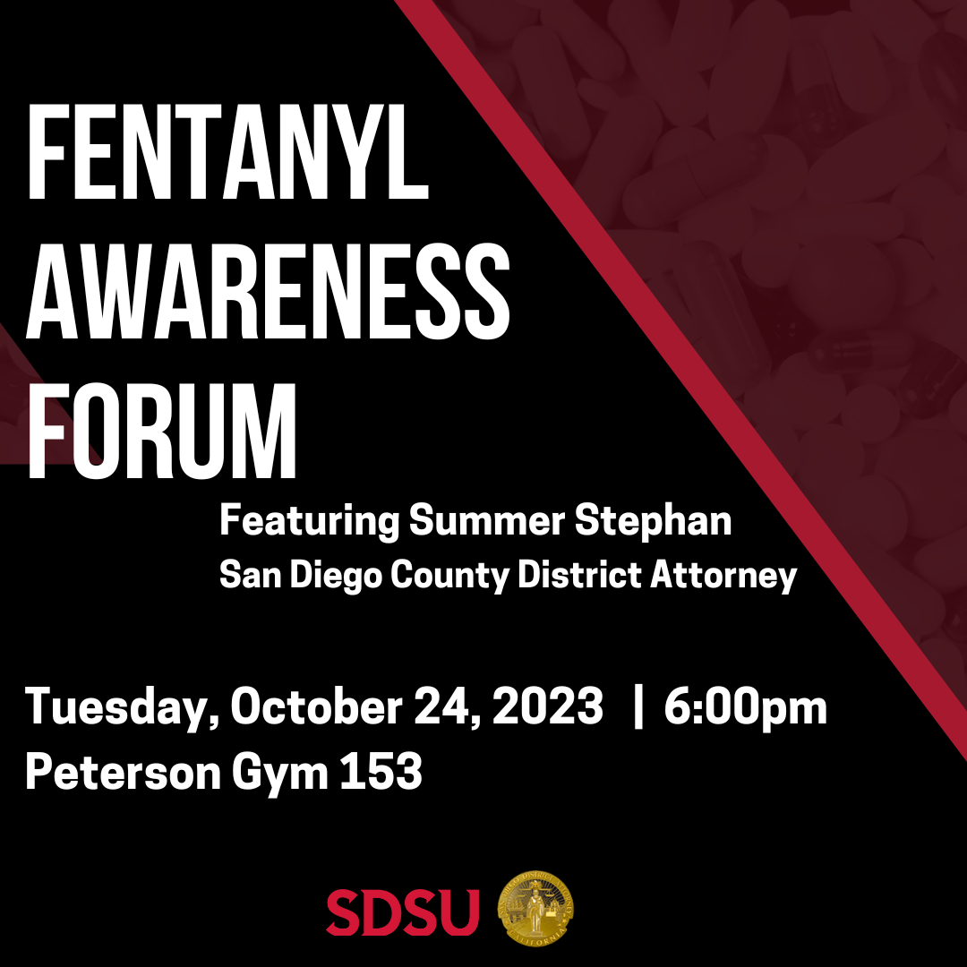

Kristen Lemaster (klemaster@sdsu.edu)
- 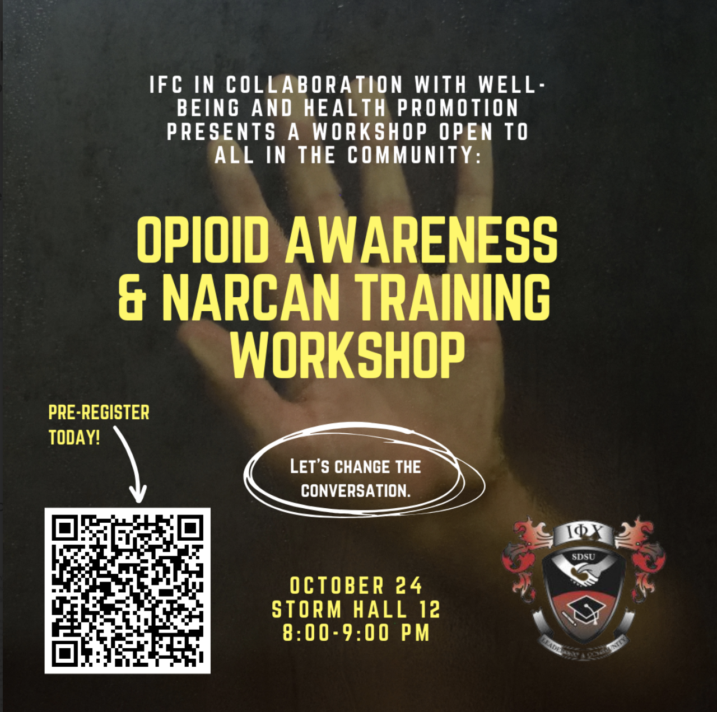
- Accredited event (CW-C) open to the community. Will be eligible to receive narcan and testing strips after attending! This is different from the fentanyl symposium being put on by SD county the same day/location/right before this one fyi

New Business
Sophie: I motioned to give $200 to help IFC purchase chips and waters to give out to people this weekend.
Alondra Orozco, Kappa Delta delegate moves to approve the motion. Seconded by Avery LeBlanc, Alpha Gamma Delta delegate. The vote will take place on Monday, October 30th.

Sophie: I move to amend the CPA Bylaws, Article IX. Finances to read as follows:

Section 1. Fiscal Year
The fiscal year of the CPA shall be from [July, 31] to [June, 30] inclusive.

Section 2. Contracts
Signatures of the President, Executive Vice President, or Vice President of Finance shall be required to bind the San Diego State University Panhellenic Association on any contract.

Section 3. Checks
All checks issued on behalf of the CPA shall bear dual signatures. The following shall be authorized to be one of the two required signatures: President, Vice President of Finance, CPA Advisor.

Section 4. Payments
All payments due to the CPA shall be received by the Vice President of Finance who shall record them. Checks for payments shall be made payable to the CPA.

Section 5. Dues
- NPC dues shall be paid yearly as invoiced by the NPC office.

- CPA membership dues shall be an assessment per member and new member.
  - The amount of such dues for the next academic year shall be determined by the CPA Vice President of Finance and President and voted on by the CPA Delegates.
  - The dues of each CPA member fraternity and sorority shall be payable semesterly.
  - Dues will be invoiced per total amount of active and new members registered on the CPA chapter roster. If not paid by due date, a $10 late fee per day.
  - Spring dues will be invoiced the 1st week of March, and will be paid, in full, two weeks following the invoice date.
  - Fall dues will be invoiced on the 1st week of November, and will be paid, in full, two weeks following the invoice date.
C. FINANCIAL DELINQUENCY: If a chapter fails to complete council dues payment within allotted time frame, the chapter will be placed on Financial Delinquency status.
  - A late fee will be enacted after a 30 day grace period. Any days that school is not in sessions shall not count towards the 30 days
    - A 10% penalty may be levied on any unpaid amount after the 30 days.

Section 6. Fees and Assessments
The CPA Delegates shall have the authority to determine fees and assessments as may be considered necessary.

Section 7. CPA Financial Sponsorships:
A. Proposal Submission
- All organizations or entities seeking a financial sponsorship from the College Panhellenic Association (CPA) must submit either a written proposal to the CPA President and CPA Vice President of Finance with why they are requesting a financial sponsorship from the council. The details shall include, but are not limited to, the event date(s), event time(s), purpose of funds, and what the funds will be used for. The requesting organization can either present in-person to the CPA Executive Board and the CPA Chapter Delegates at a CPA delegate meeting or have the CPA President and/or CPA Vice President of Finance read and insert the entity’s written request proposal in the CPA Delegate Meeting Minutes under the “New Business” section.
B. Voting Process
- After the proposal(s) has been presented to CPA Chapter Delegates via “New Business”, the proposal shall be placed under “Old Business” of the CPA Delegate Meeting Minutes at the following CPA Delegate Meeting. In this instance, the CPA Chapter Delegates may motion to entertain a discussion and/or conduct a vote on whether to fulfill the requested amount from the entity. If a CPA Delegate Meeting is not being held, an electronic vote may be conducted by the CPA President with all CPA Chapter Delegates.
C. Granting Financial Sponsorship
- If the vote is passed, the CPA President shall email the requesting entity within 24 hours of the vote being conducted that a sponsorship is being granted on behalf of CPA. The CPA President shall also inform the requesting entity of the expectations aligned below.
- The CPA President shall collaborate with the CPA Vice President of Finance to submit a completed check request with a corresponding memo to Associated Students.
D. Expectations of Entities/Organizations Granted a Financial Sponsorship
- Entities granted a financial sponsorship from CPA shall adhere to the following expectations to ensure CPA is recognized and/or representation at the event which must include at least one (1) of the following components:
I. Verbal recognition of College Panhellenic Association at the event
II. Listing “Sponsored by College Panhellenic Association (and/or NPC Crest)” on the event flier

Section 8. Presidential Stipend:
1. The CPA President shall receive a stipend of one thousand dollars ($1,000.00) out of the College Panhellenic Association’s General Budget that amounts to five hundred dollars ($500) each semester.
2. The CPA President will be responsible for fulfilling her duties. If at any time the council determines that the CPA President isn’t fulfilling her duties, the council may, through two-thirds (2/3) vote, terminate the stipend, on a prorated basis. If such action is to be considered by the Council, the CPA Executive Vice President will preside over the meeting during the discussion and vote on the matter.
Alondra Orozco, Kappa Delta delegate moves to approve the motion. Seconded by Avery LeBlanc, Alpha Gamma Delta delegate. The vote will take place on Monday, October 30th.

Old/Unfinished Business

CPA Slating Bylaw
Sophie: I move to amend the CPA Bylaws, Article IV. Section 4 Officer-Holding Limitations and Section 5 Slating Procedure to read as follows:

Section 4. Officer Eligibility

- No more than 4 members from the same CPA regular members association shall hold office during the same term.
- CPA Delegates may not concurrently hold an office in the CPA.
- All candidates slated must have completed at least one semester as an active member in a CPA Chapter, have a cumulative 2.7 overall GPA, and have completed or be in the semester that they are completing 60 academic units to qualify for the position. All candidates slated for an office holding a Vice President title are recommended but not limited to having held a leadership position in a CPA Chapter or other Student Organization.
- The candidates slated to the positions of CPA President or CPA Executive Vice President are recommended but not limited to having held an office on the CPA Executive Board or on their own Chapter's Executive Board, The officer slated to the position of CPA Vice President of Membership must have participated in Fall Primary Recruitment as an active chapter member on a Chapter’s Recruitment Team and/or CPA officer and/or recruitment guide (Rho Gamma) to qualify for the position.
- The Officer slated to the position of CPA Vice President of New Members is recommended but not limited to having participated in Primary Recruitment as a CPA Officer and/or recruitment guide (Rho Gamma).
- CPA Executive Board officers are ineligible to serve as recruitment counselors (Rho Gammas) in the same period as they are serving your term unless extra Recruitment Guides are needed during Primary Recruitment due to the amount of women registered for the recruitment process. Additionally, appointed Rho Gammas and elected CPA officers cannot serve on the recruitment team for their respective chapters.

Section 5. Election Process
- Applications will be made available during the fall semester.
- Once the application deadline closes, the CPA Executive Board will review the applications and determine which candidates will move on to the interview phase.
- Members of the CPA Executive Board, one member of Sigma Chi Alpha and a SLL staff member will serve as the interview panel. Each applicant will be interviewed individually.
  - Sigma Chi Alpha is the coalition of Chapter Presidents.
- Once interviews have concluded, the CPA Executive Board will come together to produce the slate with one applicant per office. Each candidate slated and unslated for office will be contacted. All results will be kept confidential until the slate is presented at the Panhellenic Council meeting.
  - The CPA President serves as chair for the election process.
  - If the CPA President is rerunning for the next board, the Executive Vice President shall serve as chair for the election process.
- Challenges to the slate
  - Within 72 hours, un-slated candidates must determine if a challenge will be made to the selection slate.
  - Only candidates that applied and were interviewed are eligible to challenge the slate.
  - The CPA Executive Board will notify the current slated candidate that they will be challenged.
  - If a slated candidate chooses to challenge another position, the slated candidate relinquishes their slated position.
  - The selected slate will be presented at the next Panhellenic Council meeting.
- Voting procedure on challenges to the slate:
  - The slating meeting will be held the week following the presentation of the slate to the CPA Delegates.
  - Sigma Chi Alpha are invited to the meeting.
  - The CPA President will ask whether or not there are any challenges to the slate.
If there is a challenge(s), proceed with the following steps.
- The challenges will go in order of the officers stated in Article IV Officers and Duties Section 1 Officers, starting with President.
- Each candidate challenging the slated office shall give a speech of no more than 3 minutes.
  - Following the challenging speech(es), the member slated for the office that is challenged will give a speech of no more than 3 minutes.
  - Following the speeches, the challenging candidate(s) and slated candidate will leave the room.
  - The Panhellenic Council shall have the opportunity to discuss the qualifications of the candidates. Once discussion has concluded, the CPA President shall call for a vote on the candidates for the office being discussed.
  - The chapter delegates shall participate in an eyes open vote on whether to keep the slated individual or replace with a member who challenged the slate. The individual with the majority votes will be placed on the slate.
  - In the case there are more than 1 challenger and one candidate does not receive a majority vote, the top two candidates with the highest vote will be placed in a runoff.
- Voting on the selection slate shall proceed as follows:
  - The CPA President will present the slate.
  - Each chapter regardless of the number of representatives present will only have one vote.
  - The slate will be voted on as a whole by eyes open vote and will pass with majority vote of the chapter delegates.
  - If the slate does not pass by majority vote, each office is voted upon individually.
  - The offices will be voted on individually in order of the officers stated in Article IV Officers and Duties Section 1 Officers, starting with President.
  - A majority vote is needed to affirm the slated candidate.
  - If a slated officer does not receive a majority vote, then the CPA Executive Board will reconvene. The CPA Executive Board will identify a new candidate and present to the Panhellenic Council for approval
Avery LeBlanc, Alpha Gamma Delta delegate moves to approve the motion. Seconded by Morgan Anapolsky, Alpha Chi Omega delegate. The vote will take place on Monday, October 23rd.
- VOTE: PASSED
- IN FAVOR: ΑΧΩ, ΑΓΔ, ΑΦ,ΔΓ, ΓΦΒ, ΚAΘ, ΚΔ, ΠΒΦ
- AGAINST: n/a

NPHC Donation
Sophie: I would like to entertain a motion to donate $1500 to NPHC to help fund their NPHC Thanksgiving. Alondra Orozco, Kappa Delta delegate moves to approve the motion. Seconded by Taryn Greenlee, Kappa Alpha Theta delegate. The vote will take place on Monday, October 23rd.
- VOTE: PASSED
- IN FAVOR: ΑΧΩ, ΑΓΔ, ΑΦ,ΔΓ, ΓΦΒ, ΚAΘ, ΚΔ, ΠΒΦ
- AGAINST: n/a

Dance Marathon Donation
Sophie: I would like to entertain a motion to donate $1500 to Dance Marathon. Annie Deal, Pi Beta Phi delegate moves to approve the motion. Seconded by Kenna McCabe, Delta Gamma delegate. The vote will take place on Monday, October 23rd.
- VOTE: PASSED
- IN FAVOR: ΑΧΩ, ΑΓΔ, ΑΦ,ΔΓ, ΓΦΒ, ΚAΘ, ΚΔ, ΠΒΦ
- AGAINST: n/a

CHAPTER NEWS:
Alpha Chi Omega- Morgan Anapolsky (Brittyn my amazing shadow) (alphachiomegapanhellenic@gmail.com)
- Chapter news: We are so excited for our date dash this Thursday!
- Highlights: We had the best time with our families this weekend!
- Lowlights: None
- Questions: None

Alpha Gamma Delta- Avery LeBlanc (agd.campusrelations.sdsu@gmail.com)
- Chapter news: We are prepping for Big/Little week next week :)
- Highlights: We had so much fun at all of our family weekend events this past weekend !
- Lowlights:
- Questions:
Alpha Phi- Lucia Bronzo-Munich (alphaphipanhellenicsdsu@gmail.com):
- Chapter news: We raised $38,000 at our annual Red Dress Gala this weekend
- Highlights: We all had a blast spending time with our fams and showing them Alpha Phi
- Lowlights:n/a
- Questions:
  - Does participating in Aztecs Rock Hunger push day count for PS-E
    - Noemi Portillo
  - Is the CW-A-1 tracking sheet updated? My chapter went to the hazing prevention thing but isn't noted
    - jfitzer@sdsu.eduNoemi Portillo

Delta Gamma- Kenna McCabe (sdsudgpanhellenic@gmail.com):
- Chapter news: We have three sisterhood events this week, one being with KD for a movie night, a pumpkin patch trip, and pumpkin carving/painting!
- Highlights: Our Anchor Gala, HLH, and Kendra Scott pop up all went well and we were all happy to see our families!
- Lowlights: N/A
- Questions:
  - Who can my VP Member Education contact about NMES?
    - sllfraternitysororitylife@sdsu.edu email directly
  - Do we have an updated version for the accreditation packet for what will/won’t be counted for?
    - This is will be updated through the score card. Which would be released at the end of the semester
    - jfitzer@sdsu.eduKsnow@sdsu.eduklemaster@sdsu.edu
  - Answered: For the events being held tomorrow, what areas of accreditation do they fulfill? CW-A-1? More?
    - CW-A1
    - Noemi Portillo
  - Are two or three CW-A-1 events required for this semester? The packet says ⅔ but the form says ⅗ but doesn't include all the event dates.
    - It is likely because the number of CW-A1 events has changed. We apologize for the confusion and will determine how many total options there will be. It should remain 2 of 3
    - jfitzer@sdsu.eduKsnow@sdsu.eduklemaster@sdsu.edu
  - Last week’s minutes included an updated CW-A-1 form tracker but aren’t filled out. When will these be updated?
    - We will look at this during our team meeting on thursday
    - jfitzer@sdsu.eduklemaster@sdsu.eduKsnow@sdsu.edu

Gamma Phi Beta- Kayla Mendoza (sdsugammaphibetapavp@gmail.com):
- Chapter news: Big little is this Friday everyone is so excited.
- Highlights: Spending time with everyone at our parents weekend tailgate.
- Lowlights: N/a
- Questions: I keep getting asked when we will be getting the checks for the scholarship girls, will it be next week?
  - I should have them November 6 - Marissa

Kappa Alpha Theta- Taryn Greenlee (vpp.theta.sdsu@gmail.com)
- Chapter news: Our Parents Weekend Event and fundraiser went really well
- Highlights: We’re looking forward to our retreat at Belmont in a few weeks
- Lowlights: N/A
- Questions: N/A

Kappa Delta- Alondra Orozco ( panheldelbetarho@gmail.com )
- Chapter news: We have a joint sisterhood movie night event with DG on Friday :)
- Highlights: It’s our big/little week!
- Lowlights: none
- Questions: none

Pi Beta Phi- Annie Deal (caepsilonpd@gmail.com)
- Chapter news: so sorry I can’t be here today! our parents weekend was amazing!
- Highlights: we are thrilled for big little coming up!
- Lowlights: n/a
- Questions: n/a

ANNOUNCEMENTS

ADJOURNMENT:
Motion: First: ΚΔ Seconded: ΑΦ
Time: 3:21pm

