College Panhellenic Association || San Diego State University
Delegate Meeting Minutes || 10/2/23 || 3pm || Pierce Greek Life Center

See “HIGHLIGHTS” section below for important information for chapters to bring back to their chapters!

ΑΧΩ, ΑΓΔ, ΑΦ, ΔΓ, ΓΦΒ, ΚAΘ, ΚΔ, ΠΒΦ

ROLL CALL:
Present: ΑΓΔ, ΚΔ, , ΠΒΦ, ΓΦΒ, ΚAΘ, ΑΧΩ, ΔΓ, ΑΦ,

Absent:

GUESTS:
- Women in Stem
  - 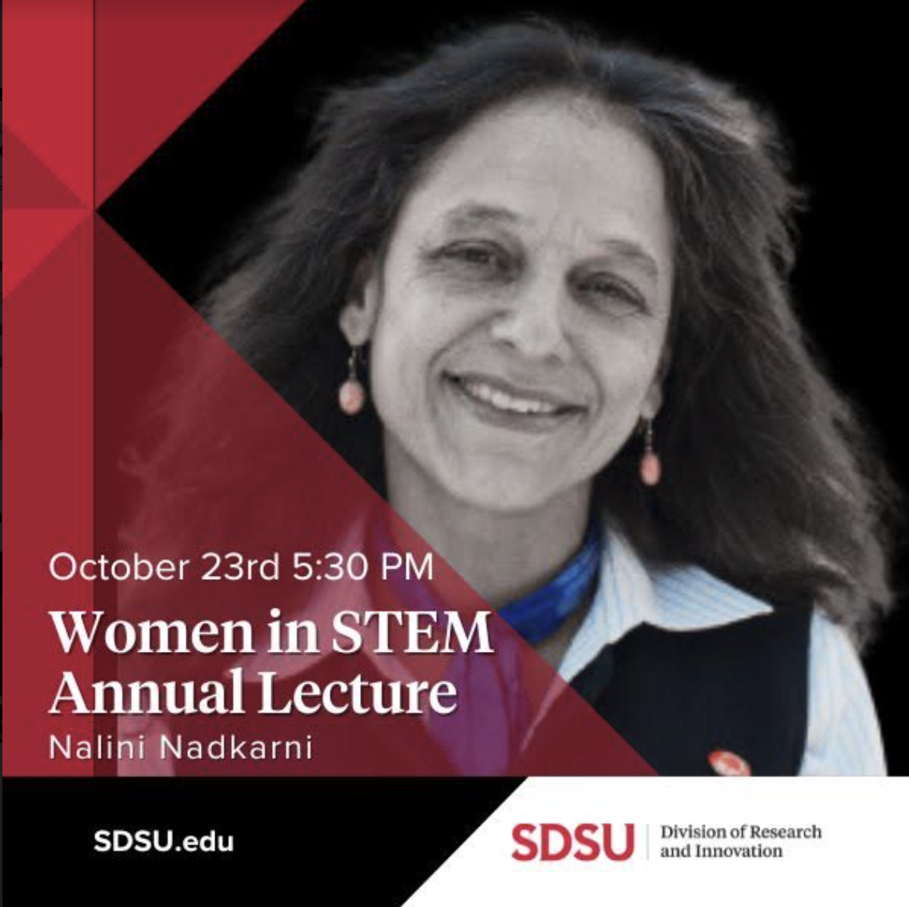
  - Invitation Link: https://docs.google.com/forms/d/e/1FAIpQLScYB7sMkV3iDLIEUOuiSOamAyNYqb_2HyBxF-2vxFJeFwV8VQ/viewform

- Susan Hykten
  - Noah Hytken Memorial Fund
  - Starr Healing

APPROVAL OF MINUTES::
Motion: ΑΓΔ | Seconded: ΚΔ,

FINANCIAL UPDATE: The Treasurer reported as follows as of:

Beginning balance: $191,047.87

Revenue | --
Expenses | $440.00

Ending Balance: $190,607.87

GREEK COMMUNITY RELATIONS REPORTS:
NPHC Representative: President - Regena Gomes - (president.nphc@gmail.com) reported:
- Be Owt Thursday 10/5 at 11am on Campanile Walkway
- Sigma halloween 10/21 9pm

USFC Representative: Scholarship Director - Jalen Arbis - (scholarshipdirector.usfc@gmail.com) reported:
- Hey y’all sorry I wasn't able to make it today, I had lab. However here are some updates:
  - Sigma Lambda Beta is hosting a study night Oct 10th at 6pm in the library (LA 2228B).
    - 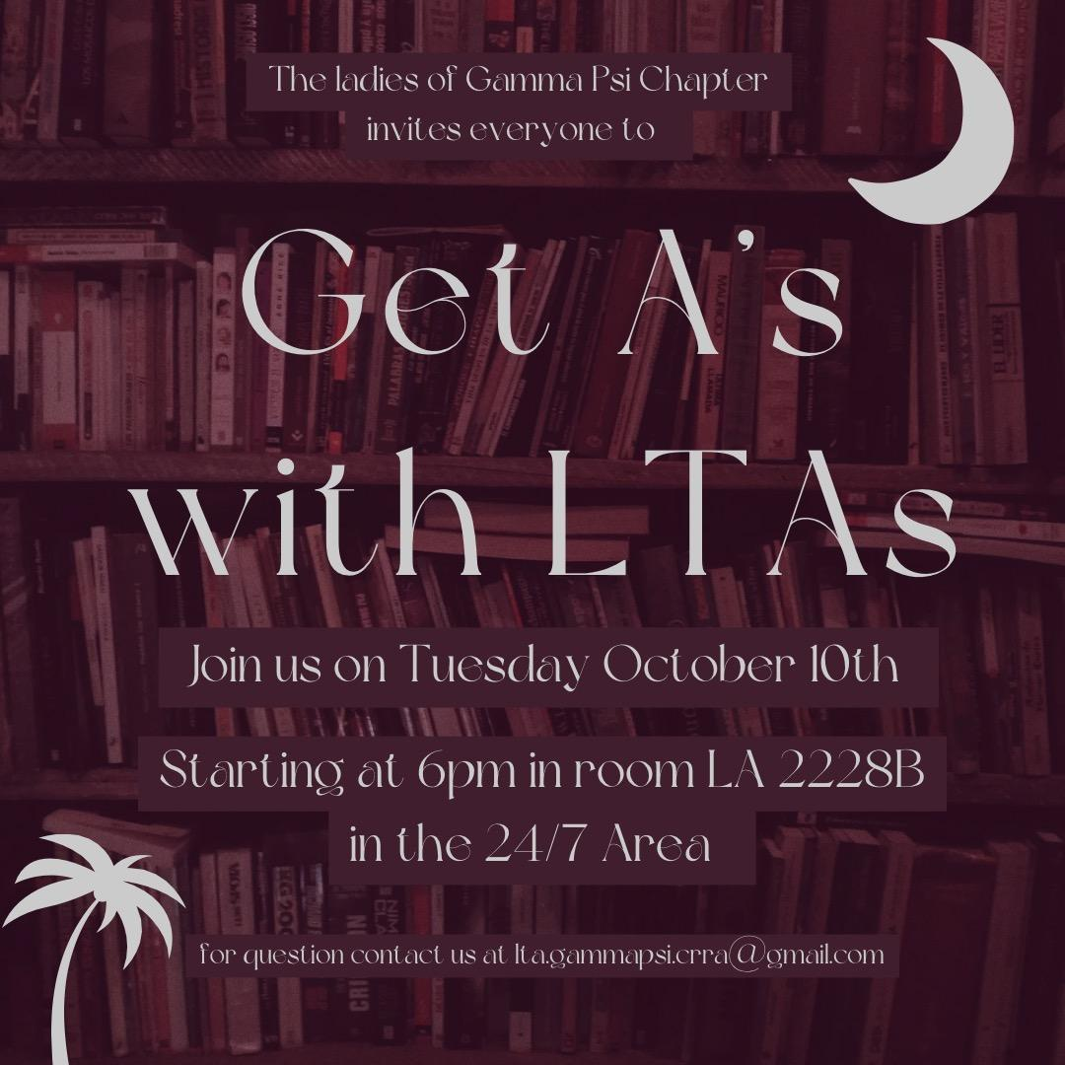
  - Sigma Phi Omega is having a Croc charm fundraiser
    - Order form: https://docs.google.com/forms/d/e/1FAIpQLSeneILedsmNDh8CAZUhRvRXzyd9r_qtaM1TpbS4kCKR_wYP9g/viewform

IFC Representative: - Joey Salvail - (jsalvail3784@sdsu.edu) reported:
- Ian Henderson told me he can not wait for the IFC/CPA Dinner
- Happy Monday it is finally October, I expect some cool sisterhood events
GLAB Representative: TBA (cpa.sdsuglab@gmail.com) reported:

Rho Lambda Reported:
- New members will be notified by the end of this week and we look forward to welcoming them to their first meeting on Sunday evening

OFFICER REPORTS
The President, Sophie Rokaw, (president.cpa.sdsu@gmail.com) reported:
- Hi everyone! Hope you all had a safe and fun weekend <3
- SHIRTS ARE LIVE!!!!!!!!! PANHEL SHIRTS! BUY!
- For those of you who have chapter meeting on Sunday, we want to ensure that the information we present at meeting is getting properly spread to your chapters! If anyone needs support in ensuring this, please let me know!
- If anyone needs me text me!

The Executive Vice President, Lex Sabbatino, (executivevp.cpa.sdsu@gmail.com) reported:
- This is my weekly reminder to promote shadowing CPA exec! Text me with questions, 571-465-0334.
- I won’t be here next week but there will be more information on applications then!
- Presidents will need to look out for an email from me regarding interviews.

The Vice President of Programming, Macy Kobzeff, (programming.cpa.sdsu@gmail.com) reported:
- Me and Elizabeth are getting a speaker in early November so look out for that!
- Have a good week and hmu to shadow :) 714-475-4888

The Vice President of Community Wellness, Elizabeth Gill, (communitywellness.cpa.sdsu@gmail.com) reported
- No Report
- Have a great week!
The Vice President of Finance, Marissa Temple, (finance.cpa.sdsu@gmail.com) reported:
- Happy Monday :)
- Keep reminding your members about the financial hardship assistance application if they need it https://forms.gle/KCdsWmJRgPez8jgL9
  - Also since this will be open the rest of the semester I would really appreciate if you could put it wherever you put the recurring links/forms/thingys for your chapter, thank you!

The Vice President of Membership, Alexa Trcka, (membership.cpa.sdsu@gmail.com) reported:
- Happy monday
- https://docs.google.com/forms/d/e/1FAIpQLSfnUhVK8eZDG0SR3z2vKkKrI1-C9xrjhTwKXonzgyjxCG077g/viewform?usp=sf_link
- Please send this post-recruitment feedback survey out to your members, it MUST be filled out by every single member who was a recruiter this year…. NO ONE IN PC 23!!!
- This is due by 11:59PM tonight!!!
  - Alpha Gamma Delta: 23 responses
  - Gamma Phi Beta: 31
  - Kappa Alpha Theta: 37
  - Alpha Chi Omega: 44
  - Alpha Phi: 54
  - Delta Gamma: 69
  - Pi Beta Phi: 75
  - Kappa Delta: 80

The Vice President of New Members, Roxanne Elisha, (newmembers.cpa.sdsu@gmail.com) reported:
- Happy Monday!!
- Please remind rho gammas to fill out the form that I sent to them or else…

The Vice President of Communications, Riley Bellomo, (communications.cpa.sdsu@gmail.com) reported:
- Happy October!! Have a great week:)
- Please tell your members to use THE NEW photocircle, if they need the link
  - https://join.photocircleapp.com/5XNFNWKG97
- Please send me any of your philo flyers if you have any events coming up, would live to promote!!

The Vice President of Judicial Affairs, Adriana Juricic, (judicial.cpa.sdsu@gmail.com) reported:
- KD PLEASE tell your president to answer my email from 2 weeks ago ASAP

The Vice President of Campus Relations, Maisie Vargas, (campusrelations.cpa.sdsu@gmail.com) reported:
- No report :P

The Vice President of Philanthropy, Taylor Cloutier, (philanthropy.cpa.sdsu@gmail.com) reported:
- HAPPY BIRTHDAYYYYYYYYYYYYY🎂
- Hi everyone happy Monday! SLAY MAMAMMAAMMAM WOWWOOWOWOWOOW
- I will be pushing back the Circle of Sisterhood philanthropy event due to a conflict with another event…as soon as I know the new date I will let you know!
- 2023 Volunteer Opportunities
  - Conversation Groups with International Students October 5th
  - Feliz cumpleanos!
- Happy birthday - Lex
- Hbd - alondra!!

The Vice President of Scholarship, Noemi Portillo, (scholarship.cpa.sdsu@gmail.com) reported:
- Happy week 7!
- Here are the Fall 2023 scholarship recipients:
  - AXO: Naomi Wallin, Natasha Makooi, Paige Larson
  - AGD: Katelyn Medley, Natalie Manolo, Abi Seeley
  - APhi: Marine Stockwell, Paulina Darby, Emaly Bousman
  - DG: Kailana Lu, Sophia Ipcizade, Jacqueline Wissig
  - GPhi: Elliana Newberg, Kaley Waye, Madeleine Eff
  - Theta: Juliana Wherrett, Claire Spilkin, Sophia Butler
  - KD: Kylie Hopp, Landyn Mount, Olivia Cepeda
  - Pi Phi: Francesca Leonardi, Olivia Kammel, Sophia Valceschini
- Please have them email me (scholarship.cpa.sdsu@gmail.com) a photo of themselves ASAP so Riley can post on the instagram as a recognition!

The Vice President of Diversity, Equity, and Inclusion, Kenna Mo, (dei.cpa.sdsu@gmail.com) reported
- Will be reaching out to each of your DEIs to meet with for the end of term meeting, so tell them to answer my texts please. (:

Panhellenic Advisory Team
Kayla Snow (ksnow@sdsu.edu)
Jason Fitzer (jfitzer@sdsu.edu)
Kristen Lemaster (klemaster@sdsu.edu)
- Missing Chapter Hazing Attestation: Alpha Chi Omega
- Missing NME plans - submit ASAP to sllfraternitysororitylife@sdsu.edu
  - ACO, AGD, DG, GPhi, PBP
  - TEMPLATE
- Still 99 e-bids pending total - follow up with your new members ASAP. We will decline any remaining e-bids October 10 and that member will not be listed on your chapter roster.
  - Please See Kayla After Meeting to screenshot pending bids (# of pending bids listed below)
Alpha Chi Omega (13)
Alpha phi (20)
Alpha Gamma Delta (24)
Delta Gamma (10)
Gamma Phi Beta (4)
Kappa Alpha theta (4)
Kappa Delta (19)
Pi Beta Phi (3)

- COB reminder: if a PNM participated in primary recruitment and did not receive a bid, she is eligible for COB. If you are unsure who is eligible, check the Ineligible and Eligible lists, or reach out to Kayla with any questions.
- EAS’s for October are being reviewed, please reach out if you have specific questions
  - As a reminder, please review the Tier system for submissions prior to submitting them to be sure they are meeting the timeline for approval <3
- If you have events or items that you want to promote in the FSL newsletter be sure to send them to the general email account

MISC Opportunities:
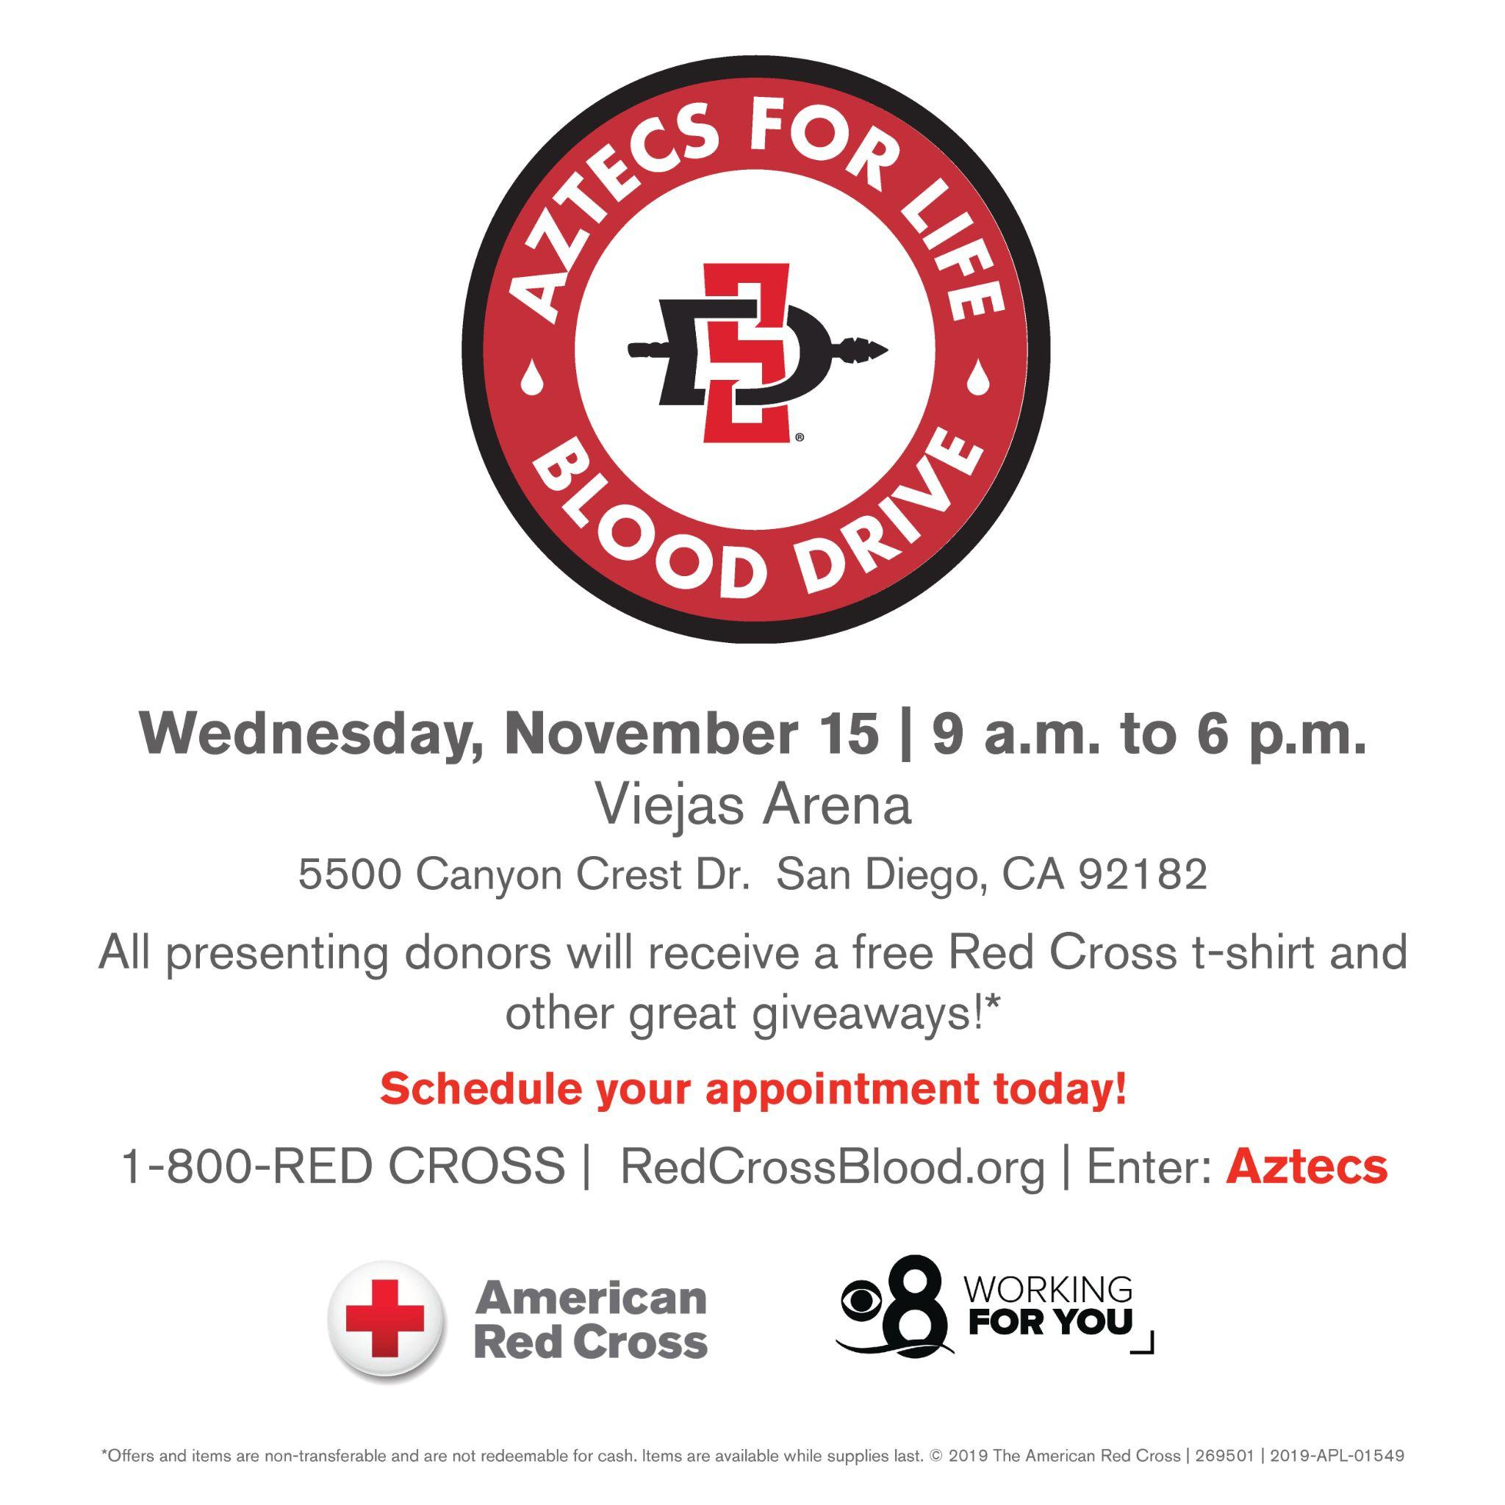

New Business
n/a

Old/Unfinished Business
Scholarship Budget
Sophie: I would like to entertain a motion to approve increasing the scholarship budget from $5000 to $8200 to give $205 scholarships to 5 members of each chapter; 2 new members, 3 actives.
Avery LeBlanc, Alpha Gamma Delta delegate moves to approve the motion. Seconded by Alondra Orozco, Kappa Delta delegate. The vote will take place on Monday, October 2nd.
- VOTE: PASSED
- IN FAVOR: ΑΧΩ, ΑΓΔ, ΑΦ,ΔΓ, ΓΦΒ, ΚAΘ, ΚΔ, ΠΒΦ
- AGAINST: none

CHAPTER NEWS:
Alpha Chi Omega- Morgan Anapolsky (alphachiomegapanhellenic@gmail.com)
- Chapter news: We are looking forward to our Aztec Lanes bowling sisterhood tomorrow night!
- Highlights: Our PC 22s are having a great time bonding with the 23s over their big little dates this past week!
- Lowlights: None
- Questions: Can I see you after meeting about the hazing attestation form? We do not know who the final advisor is that hasn’t signed it.

Alpha Gamma Delta- Avery LeBlanc (agd.campusrelations.sdsu@gmail.com)
- Chapter news: We have officially ended our COB/Recruitment process and have loved meeting all our new members!
- Highlights: We had our new member retreat at Mission Bay this weekend and it was a blast!
- Lowlights: We may have to postpone/relocate our Philo event :( UPDATE: it will now be held at ou charter house ! here is the new flyer :) 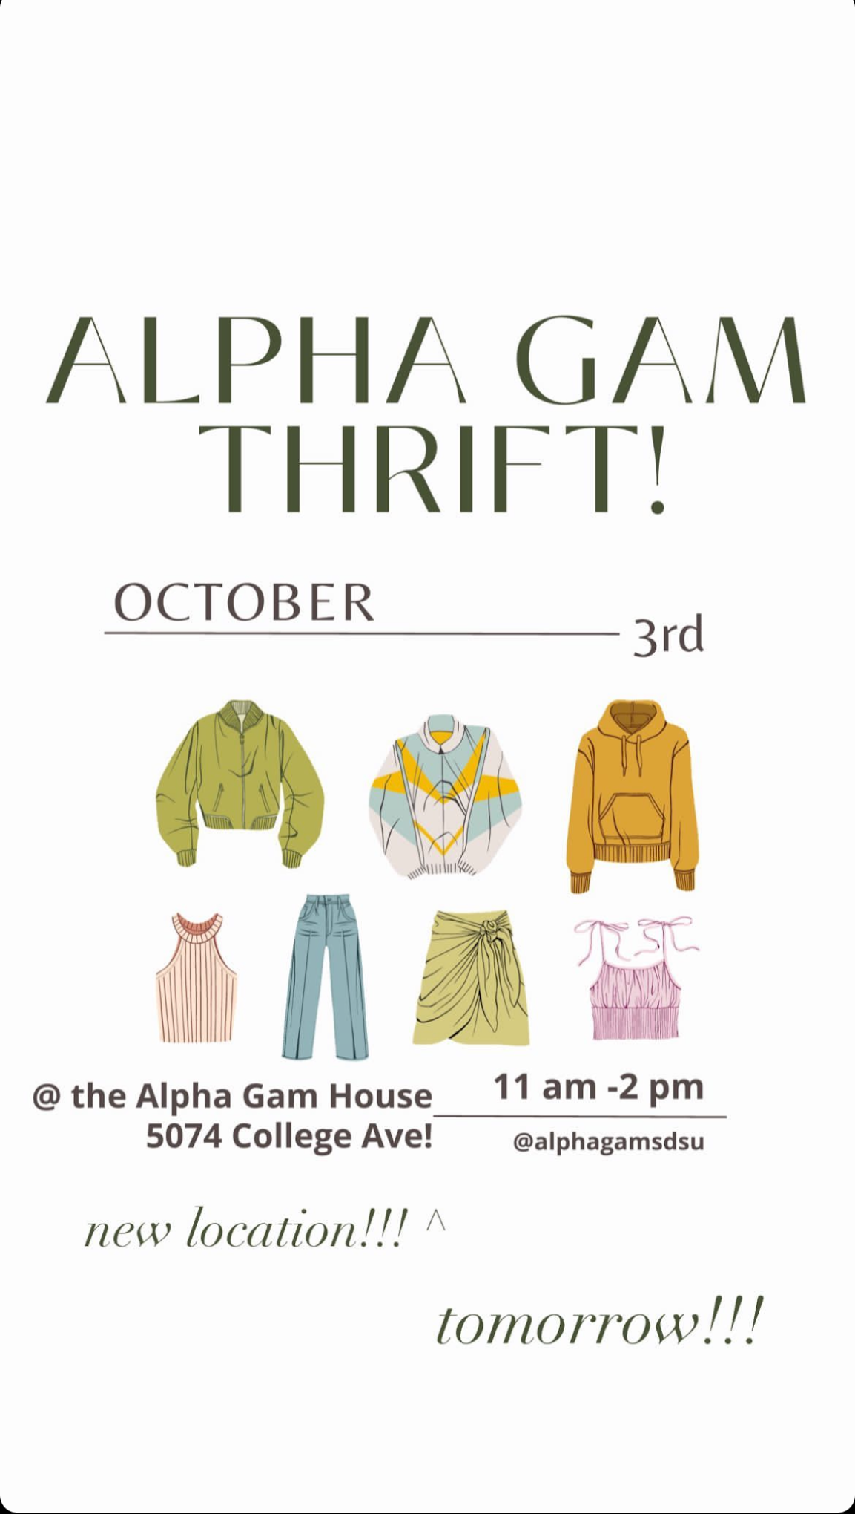
- Questions: n/a
Alpha Phi- Lucia Bronzo-Munich (alphaphipanhellenicsdsu@gmail.com):
- Chapter news: Our date dash is this Thursday!
- Highlights: Fall 22s & 23s are getting excited for big/little with week 2 of ivy linking
- Lowlights: n/a
- Questions: Any updates on new member symposiums?

Delta Gamma- Kenna McCabe (sdsudgpanhellenic@gmail.com):
- Chapter news: We are holding a backpack charm making sisterhood this sunday!
- Highlights: We had an amazing sisterhood pop up at our house this week with HLH!
- Lowlights: N/A
- Questions:
  - Accreditation packet requirements for this semester are either not being held, or the dates may have not been updated? What should we do for these sections that do not have events or is there a way to change them?
    - CM-A-1: “Chapter completes all necessary components of the Recognized Student Organization application and has acquired fully “Recognized” status by Monday, November 7, 2022.” (This will be adjusted)
    - LED-C-2 (This will be adjusted)

Gamma Phi Beta- Kayla Mendoza (sdsugammaphibetapavp@gmail.com):
- Chapter news: We’re looking forward to our date dash next week!
- Highlights: Everyone is super excited for big little reveal this month.
- Lowlights: n/a
- Questions: n/a

Kappa Alpha Theta- Taryn Greenlee (vpp.theta.sdsu@gmail.com)
- Chapter news: We have our Sister Dash this Friday at Mission Beach
- Highlights: Everyone is getting excited about big/little week next week
- Lowlights: N/A
- Questions: N/A

Kappa Delta- Alondra Orozco ( panheldelbetarho@gmail.com )
- Chapter news: We welcomed home our COBs yesterday
- Highlights: We have our date dash event this Friday!
- Lowlights: None
- Questions:
  - Is there a way to edit the Recruitment survey to anonymous? It says the name is optional but it requires members to put their email.
  - For EAS #21823 (Oct 8) and #21988 (Oct 11) can we get our classroom assignments? Also is the classroom big enough to seat at least 150 people?
    - 10/8 approved (storm hall confirmation sent to lulu)
    - Working on 10/11 - need room assignment
  - Does anyone have SDSU One’s contact info? I have tried reaching out to them twice now with events for this semester and they ghosted me :(
    - Kaleigh Lacouture (klacouture@sdsu.edu)

Pi Beta Phi- Annie Deal (caepsilonpd@gmail.com)
- Chapter news: we have our philo event pie a pi phi 10-2 this wed!
- Highlights: our big/little process is going so well and everyone is so pumped
- Lowlights: n/a
- Questions: n/a

ANNOUNCEMENTS
TAYLORS BDAY 🎂🎂🎂🎂🎂🎂🎂🎂🎂🎂🎂🎂🎂🎂🎂

ADJOURNMENT:
Motion: ΚΔ Second: ΓΦΒ
Time: 3:47pm

