College Panhellenic Association || San Diego State University
Delegate Meeting Minutes || 10/16/23 || 3pm || Pierce Greek Life Center

See “HIGHLIGHTS” section below for important information for chapters to bring back to their chapters!

ΑΧΩ, ΑΓΔ, ΑΦ,ΔΓ, ΓΦΒ, ΚAΘ, ΚΔ, ΠΒΦ

ROLL CALL:
Present: ΠΒΦ, ΚΔ, ΚAΘ, ΑΦ, ΓΦΒ, ΔΓ, ΑΓΔ, ΑΧΩ, ΑΦ

Absent:

GUESTS:
- Dance Marathon
- NPHC

APPROVAL OF MINUTES::
Motion:ΑΓΔ | Seconded: ΠΒΦ

FINANCIAL UPDATE: The Treasurer reported as follows as of:

Beginning balance: $188,286.17

Revenue | --
Expenses | $8,200.00

Ending Balance: $180,086.17

GREEK COMMUNITY RELATIONS REPORTS:
NPHC Representative: President - Regena Gomes - (president.nphc@gmail.com) reported:
- NPHC fundraiser is still happening until Oct 23!! We raised $467 in 5 days!
- NPHC also just went to the breast cancer walk yesterday at Balboa Park
- Kappa Alpha Psi- Kappa Homekoming Nov 2nd
- Delta Sigma Theta- Having events for Black Women’s Awareness Month
  - Study Abroad Program on 10/18
- Phi Beta Sigma- “Chop It Up” free haircuts on 10/18 from 4-5:30pm in Matayuum Suite
  - Sigma halloween 10/21

USFC Representative: Scholarship Director - Jalen Arbis - (scholarshipdirector.usfc@gmail.com) reported:
- Alpha Psi Rho and Delta Sigma Psi attended breast cancer walk @Balboa
- Lambda Sigma Gamma: VRSTL Letters Partnership (10/2-10/30) & Spooky Basket Raffle (10/13-10/30)
  - 10% off using code LSG10
  - $3 one ticket & $5 for two (venmo: SDSU_LSG)
- Sigma Phi Omega: Urban Bubble Fundraiser (10/19 11am-11pm)

IFC Representative: - Joey Salvail - (jsalvail3784@sdsu.edu) reported:
- Thank you for getting on the call and discussing collaboration with us
- We will have many risk requirements / documents in the next couple of weeks
- I have a lot of work to do today - Joey
GLAB Representative: TBA (cpa.sdsuglab@gmail.com) reported:
- Apply for GLAB

Rho Lambda Representative: TBA reported:

OFFICER REPORTS
The President, Sophie Rokaw, (president.cpa.sdsu@gmail.com) reported:
- Hope you all have had a good weekend!
- Please keep pushing the Girls Supporting Girls shirts!!! Every chapter that sells 50 shirts will get 100$ donated to their philanthropy of their choice!

The Executive Vice President, Lex Sabbatino, (executivevp.cpa.sdsu@gmail.com) reported:
- CPA applications open today at 4pm! You need to share this with your chapter! Please direct any questions to me.
- Please encourage your Presidents to put down their name more than once on their interview slots spreadsheet I emailed them!

The Vice President of Programming, Macy Kobzeff, (programming.cpa.sdsu@gmail.com) reported:
- Next week CPA will be doing walk arounds in your chapters for promoting applications and philanthropy (im texting your presidents)
→ here is the schedule if you would like it Walk Arounds Fall 2023
- November 1st Panhellenic wide speaker Bonny Shade :)
- Shadow me! 714-475-4888

The Vice President of Community Wellness, Elizabeth Gill, (communitywellness.cpa.sdsu@gmail.com) reported
- Happy Monday!
- Bonny Shade coming November 1st!
The Vice President of Finance, Marissa Temple, (finance.cpa.sdsu@gmail.com) reported:
- Hi everyone! Happy Monday :)
- Should have scholarship checks next week

The Vice President of Membership, Alexa Trcka, (membership.cpa.sdsu@gmail.com) reported:
- Hi Happy Monday! Hope you all had a great weekend!!!
- Text me if you are interested in my position and want to shadow me! 714-400-5289

The Vice President of New Members, Roxanne Elisha, (newmembers.cpa.sdsu@gmail.com) reported:
- Hi everyone! Happy monday! Nothing from me
- Let me know if any of you are interested in my position

The Vice President of Communications, Riley Bellomo, (communications.cpa.sdsu@gmail.com) reported:
- Hi everyone! Nothing from me, have a great week!

The Vice President of Judicial Affairs, Adriana Juricic, (judicial.cpa.sdsu@gmail.com) reported:
- Hi everyone! Nothing from me except new business and old business lol

The Vice President of Campus Relations, Maisie Vargas, (campusrelations.cpa.sdsu@gmail.com) reported:
- No report!
- I hope your semesters are going well & you are all taking care of yourselves!

The Vice President of Philanthropy, Taylor Cloutier, (philanthropy.cpa.sdsu@gmail.com) reported:
- Congrats to Pi Phi and GPhi on your philanthropy events!! :)
- Circle of Sisterhood Fundraising Updates!
  - October 25th tabling event
    - 10/25 Circle of Sisterhood Philanthropy Tabling Sign Up
    - Please share this with members to help with tabling and earn community service hours:)
  - October 22/23 we will be speaking at your meetings about Circle of Sisterhood
  - Opportunity drawing with two prize packs! Prizes will be announced soon but donations will be through venmo…winners will be announced Friday October 27th!
- 2023 Volunteer Opportunities
  - Conversation with International Students (October 19th)
  - Vision of Children Beach Boys Concert Event (October 28th)

The Vice President of Scholarship, Noemi Portillo, (scholarship.cpa.sdsu@gmail.com) reported:
- Happy week 8!
- Reach out to me if you are having difficulty finding accred opportunities! I am here to support you all but please reach out so I can help!
- AGD please see me after meeting!
- Here is the Fall 2023 Accred Packet – please reference this first!

The Vice President of Diversity, Equity, and Inclusion, Kenna Mo, (dei.cpa.sdsu@gmail.com) reported
- No report (:

Panhellenic Advisory Team
Kayla Snow (ksnow@sdsu.edu)
Jason Fitzer (jfitzer@sdsu.edu)
Kristen Lemaster (klemaster@sdsu.edu)

- FSL Chapter Coach reminder - you can always reach out if you need support!
- EAS
  - Kappa Delta X Delta Gamma (22393) - to connect with Nate on specifics
  - 22390 - Kappa delta (approved)
  - 22056 - Alpha Phi (approved)
  - 22188 - Delta Gamma (need approval from union)
  - 22385 - Alpha Chi Omega (Classroom to be requested)

- EAS Event Planning reminder - late requests will not be approved
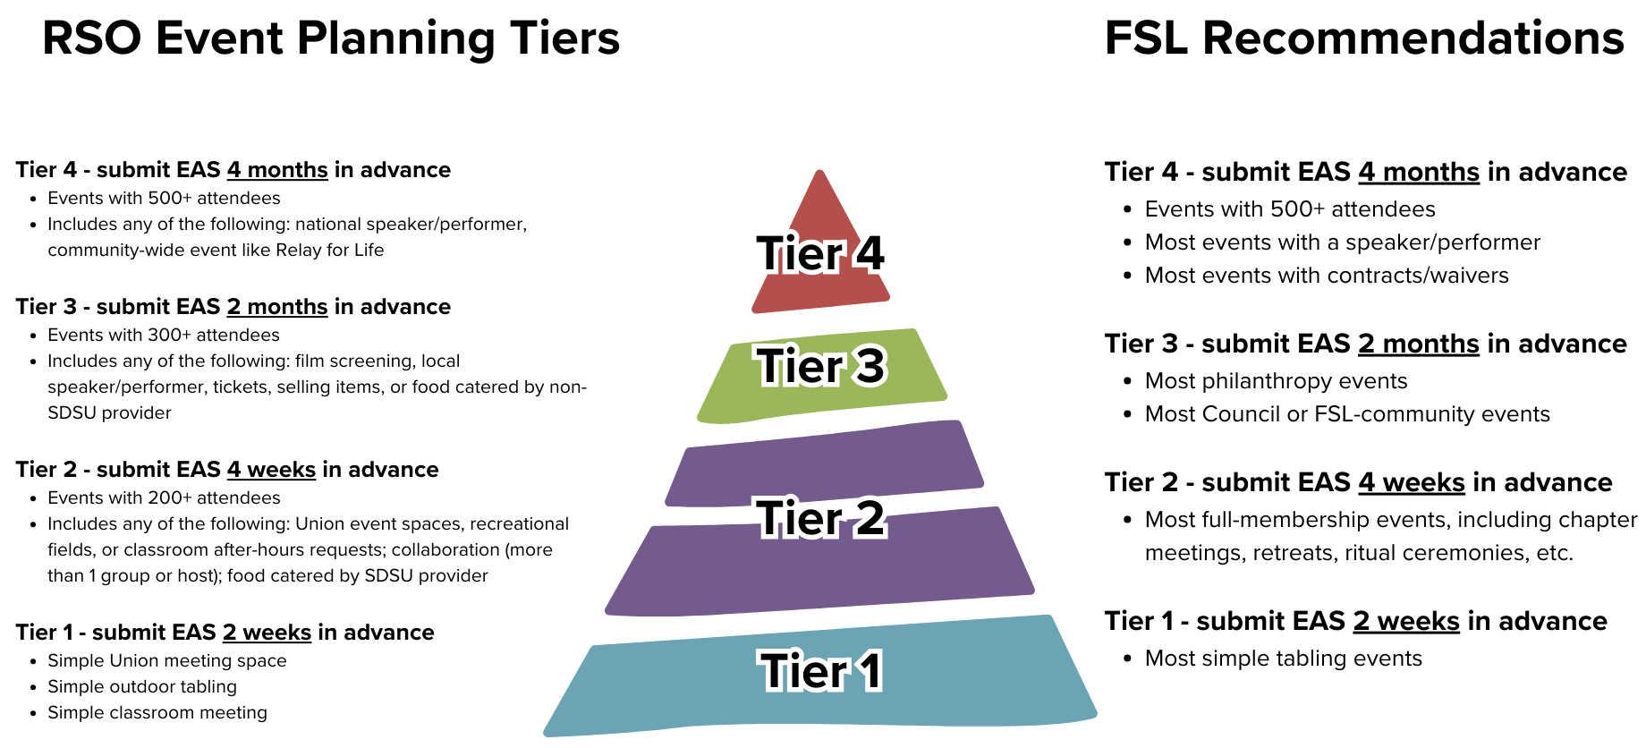
- New Member Education:
  - FSL NME Sessions (all virtual):
    - Friday Oct. 20, 2-5pm (Pi Phi + AGD)
    - Wednesday Oct. 25, 7-10pm (APhi + KAT)
    - May be able to offer limited number of makeup sessions but still determining availability.
- Accreditation:
  - Updated Community Wellness events - tracker here
- Incomplete COB processes:
  - Alpha Gamma Delta
  - Alpha Phi
  - Delta Gamma
  - Gamma Phi Beta
  - Kappa Alpha Theta
- Missing NME plans:
  - Alpha Gamma Delta
- Submit your updated chapter roster to FSL as soon as all bids have been answered!

New Business

CPA Slating Bylaw
Sophie: I move to amend the CPA Bylaws, Article IV. Section 4 Officer-Holding Limitations and Section 5 Slating Procedure to read as follows:

Section 4. Officer Eligibility

- No more than 4 members from the same CPA regular members association shall hold office during the same term.
- CPA Delegates may not concurrently hold an office in the CPA.
- All candidates slated must have completed at least one semester as an active member in a CPA Chapter, have a cumulative 2.7 overall GPA, and have completed or be in the semester that they are completing 60 academic units to qualify for the position. All candidates slated for an office holding a Vice President title are recommended but not limited to having held a leadership position in a CPA Chapter or other Student Organization.
- The candidates slated to the positions of CPA President or CPA Executive Vice President are recommended but not limited to having held an office on the CPA Executive Board or on their own Chapter's Executive Board, The officer slated to the position of CPA Vice President of Membership must have participated in Fall Primary Recruitment as an active chapter member on a Chapter’s Recruitment Team and/or CPA officer and/or recruitment guide (Rho Gamma) to qualify for the position.
- The Officer slated to the position of CPA Vice President of New Members is recommended but not limited to having participated in Primary Recruitment as a CPA Officer and/or recruitment guide (Rho Gamma).
- CPA Executive Board officers are ineligible to serve as recruitment counselors (Rho Gammas) in the same period as they are serving your term unless extra Recruitment Guides are needed during Primary Recruitment due to the amount of women registered for the recruitment process. Additionally, appointed Rho Gammas and elected CPA officers cannot serve on the recruitment team for their respective chapters.

Section 5. Election Process
- Applications will be made available during the fall semester.
- Once the application deadline closes, the CPA Executive Board will review the applications and determine which candidates will move on to the interview phase.
- Members of the CPA Executive Board, one member of Sigma Chi Alpha and a SLL staff member will serve as the interview panel. Each applicant will be interviewed individually.
  - Sigma Chi Alpha is the coalition of Chapter Presidents.
- Once interviews have concluded, the CPA Executive Board will come together to produce the slate with one applicant per office. Each candidate slated and unslated for office will be contacted. All results will be kept confidential until the slate is presented at the Panhellenic Council meeting.
  - The CPA President serves as chair for the election process.
  - If the CPA President is rerunning for the next board, the Executive Vice President shall serve as chair for the election process.
- Challenges to the slate
  - Within 72 hours, un-slated candidates must determine if a challenge will be made to the selection slate.
  - Only candidates that applied and were interviewed are eligible to challenge the slate.
  - The CPA Executive Board will notify the current slated candidate that they will be challenged.
  - If a slated candidate chooses to challenge another position, the slated candidate relinquishes their slated position.
  - The selected slate will be presented at the next Panhellenic Council meeting.
- Voting procedure on challenges to the slate:
  - The slating meeting will be held the week following the presentation of the slate to the CPA Delegates.
  - Sigma Chi Alpha are invited to the meeting.
  - The CPA President will ask whether or not there are any challenges to the slate.
If there is a challenge(s), proceed with the following steps.
- The challenges will go in order of the officers stated in Article IV Officers and Duties Section 1 Officers, starting with President.
- Each candidate challenging the slated office shall give a speech of no more than 3 minutes.
  - Following the challenging speech(es), the member slated for the office that is challenged will give a speech of no more than 3 minutes.
  - Following the speeches, the challenging candidate(s) and slated candidate will leave the room.
  - The Panhellenic Council shall have the opportunity to discuss the qualifications of the candidates. Once discussion has concluded, the CPA President shall call for a vote on the candidates for the office being discussed.
  - The chapter delegates shall participate in an eyes open vote on whether to keep the slated individual or replace with a member who challenged the slate. The individual with the majority votes will be placed on the slate.
  - In the case there are more than 1 challenger and one candidate does not receive a majority vote, the top two candidates with the highest vote will be placed in a runoff.
- Voting on the selection slate shall proceed as follows:
  - The CPA President will present the slate.
  - Each chapter regardless of the number of representatives present will only have one vote.
  - The slate will be voted on as a whole by eyes open vote and will pass with majority vote of the chapter delegates.
  - If the slate does not pass by majority vote, each office is voted upon individually.
  - The offices will be voted on individually in order of the officers stated in Article IV Officers and Duties Section 1 Officers, starting with President.
  - A majority vote is needed to affirm the slated candidate.
  - If a slated officer does not receive a majority vote, then the CPA Executive Board will reconvene. The CPA Executive Board will identify a new candidate and present to the Panhellenic Council for approval

Avery LeBlanc, Alpha Gamma Delta delegate moves to approve the motion. Seconded by Morgan Anapolsky, Alpha Chi Omega delegate. The vote will take place on Monday, October 23rd.

NPHC Donation
Sophie: I would like to entertain a motion to donate $1500 to NPHC to help fund their NPHC Thanksgiving.

Alondra Orozco, Kappa Delta delegate moves to approve the motion. Seconded by Taryn Greenlee, Kappa Alpha Theta delegate. The vote will take place on Monday, October 23rd.

Dance Marathon Donation
Sophie: I would like to entertain a motion to donate $1500 to Dance Marathon.

Annie Deal, Pi Beta Phi delegate moves to approve the motion. Seconded by Kenna McCabe, Delta Gamma delegate. The vote will take place on Monday, October 23rd.

Old/Unfinished Business

CPA Position Bylaw Changes
Sophie: I move to amend the CPA Bylaws, Article IV. Section 9 Duties and Expectations of Officers to read as follows:

Section 9. Duties and Expectation of Officers
All officers of the CPA are to be held responsible for the following duties:
General:
    - Promote a positive Panhellenic environment
    - Communicate regularly with the CPA Advisor(s).
    - Be familiar with the NPC Manual of Information and all governing documents of the San Diego State University Panhellenic Association.
    - Maintain current copies of the following: CPA bylaws and standing rules; the CPA chapter roster; CPA chapter delegate directory and other pertinent materials.
    - Attend all CPA Delegate Meetings.
    - Coordinate the training of the successor.
    - Perform all other duties as applicable to the office as prescribed by the parliamentary authority adopted by the Association..
Recruitment:
    - Assist the Membership Recruitment Committee with tasks as assigned.
    - During the summer term, must 1) be available to assist in preparation for fall formal recruitment and/or2) attend meetings on-campus. 1-3 required beginning no later than August 1.

- President
- The President serves as the primary representative and spokesperson for the CPA with the University, the other Greek Councils (NPHC, USFC, and IFC) and Panhellenic Chapters. The President convenes and presides at meetings of the Sigma Chi Alpha (council of sorority chapter presidents), Panhellenic Executive Board, and Panhellenic Council. The President serves as an ex-officio member of every Panhellenic Committee. The President also serves as a member on the Membership Recruitment Committee during Fall Recruitment. The President serves as the primary liaison for the Panhellenic extension process.
- Executive Vice President
- The Executive Vice President oversees the Continuous Open Bidding recruitment process: including working with Fraternity and Sorority Life to track who is eligible for Continuous Open Bidding. The Executive Vice President coordinates the application, interview, slating and election process for the CPA Executive Board officers. The Executive Vice President serves as a member on the Membership Recruitment Committee during Fall Recruitment.
- Vice President of Programming
- The Vice President of Programming coordinates CPA community building and educational events including council/board events and a semesterly developmental speaker series. The Vice President of Programming also creates a Panhellenic-wide calendar for smooth planning of events without overlap. The Vice President of Programming promotes CPA participation in social excellence opportunities provided by the university or other organizations and coordinates tabling events to promote involvement. Lastly, the Vice President of Programming assists in making room and campus reservations for the executive board.
- Vice President of Community Wellness
- The Vice President of Community Wellness is dedicated to advancing health and wellness in the Panhellenic and Greek community. The Vice President of Community Wellness is involved with educating members on mental and physical health, addressing issues such as sexual violence, and more. Responsibilities encompass organizing events for the community and the executive board and inspiring individual chapters to do likewise. The Vice President of Community Wellness also actively seeks out opportunities for the Greek community to enhance their knowledge of health and wellness, and motivating members to participate in these opportunities. Additionally, the Vice President of Community Wellness encourages Panhellenic members to engage in the vibrant campus culture by attending sporting events, further uniting the Greek community with the broader student body.
- Vice President of Recruitment External
- The Vice President of Recruitment External is involved with coordinating the execution and evaluating Panhellenic Association recruitment processes of fall formal recruitment. The Vice President of Recruitment External leads and directs the Recruitment Team and the Panhellenic Executive Board during primary recruitment. The Vice President of Recruitment External convenes summer meetings alongside Vice President of Recruitment Internal with chapter Vice President’s of Membership. The Vice President of Recruitment External works with the University and Programming Committees to finalize primary recruitment planning dates as well as plan and organize potential new member orientation, organizing security, recruitment counselors (Rho Gammas) and CPA Exec stations.
- Vice President of Recruitment Internal
- The Vice President of Recruitment Internal is responsible for coordinating the execution and evaluating Panhellenic Association recruitment processes of fall primary recruitment. The Vice President of Recruitment Internal leads and directs the Recruitment Team and the Panhellenic Executive Board during primary recruitment. The Vice President of Recruitment Internal’s main responsibilities include creating daily recruitment schedules including date, time, and number of rounds. The Vice President of Recruitment Internal will coordinate all potential new member (PNM) schedule accommodations, create dates and party times, make daily schedules, assist in daily selections, invite lists, and bid matching. Lastly, the Vice President of Recruitment Internal facilitates the technology needs for recruitment.
- Vice President of Recruitment Counselors
- The Vice President of Recruitment Counselors coordinates the application process for recruiting recruitment counselors (Rho Gammas) from the chapters. Additionally, the Vice President of Recruitment Counselors conducts interviews, and selects candidates for the recruitment counselor position. The Vice President of Recruitment Counselors plans and coordinates training to provide recruitment counselors all necessary information and resources to fulfill their roles during recruitment. The Vice President of Recruitment Counselors also serves as a member on the Membership Recruitment Committee during Fall Recruitment.
- Vice President of Communications
- The Vice President of Communications takes and manages all aspects of the recording of the minutes for CPA Executive Board Meetings and Panhellenic Delegate Meetings. The Vice President of Communications creates, manages, posts, and interacts with any and all Panhellenic social media including but not limited to Instagram, Facebook, and the Panhellenic website. The Vice President of Communications ensures all social media promotes San Diego State University Panhellenic Association accomplishments as well as other Greek Councils.. The Vice President of Communications serves as a member of the Membership Recruitment Committee during primary Recruitment and coordinates the efforts to promote Potential New Member sign up via online platforms.
- Vice President of Judicial Affairs
- The Vice President of Judicial Affairs oversees the CPA judicial process. The Vice President of Judicial Affairs conducts an annual bylaw review and recommends amendments to the CPA Executive Board and Panhellenic Council.. The Vice President of Judicial Affairs makes and presents a Title IX informative presentation to the Panhellenic chapters in the spring semester. The Vice President of Judicial Affairs also oversees all recruitment infractions that may occur during the fall primary recruitment process. The Vice President of Judicial Affairs serves as a member on the Membership Recruitment Committee during Fall Recruitment.
- Vice President of Finance
- The Vice President Finance supervises the finances of the SDSU CPA and creates and maintains the annual budget. The Vice President Finance approves and oversees all expenses the Panhellenic Council incurs and must handle all payments and reimbursements in a timely manner. The Vice President Finance collects local Panhellenic dues from each chapter each semester. The Vice President Finance maintains current financial records, provides weekly budget updates at Panhellenic Council meetings, and maintains financial transparency both within the Council and with Panhellenic chapters on campus. The Vice President Finance serves as a member on the Membership Recruitment Committee during Fall Recruitment.
- Vice President of Diversity, Equity, and Inclusion
- The Vice President of Diversity, Equity, and Inclusion is a leadership role focused on fostering an inclusive and equitable environment within the college panhellenic association. The Vice President of Diversity, Equity, and Inclusion works closely with the chapter Diversity representative to develop initiatives that promote diversity and inclusion, including organizing speakers and encourage that practices align with Diversity, Equity, and Inclusion (DEI) principles. The Vice President of Diversity, Equity, and Inclusion actively encourages open dialogue and seeks to create a welcoming space where everyone feels valued and represented. The Vice President of Diversity, Equity, and Inclusion also serves as a member on the Membership Recruitment Committee during Fall Recruitment.
- Vice President of Campus Relations
- The Vice President of Campus Relations' main priority is to promote involvement in the community of Greek councils at SDSU. The Vice President of Campus Relations must attend all other Greek council meetings including IFC, NPHC, and USFC. In these meetings, The Vice President of Campus Relations must promote all events held by Panhellenic chapters as well as note events by other councils to report to Panhellenic. The Vice President of Campus Relations must also get involved with Associated Students organizations including but not limited to: Associated Students Campus Safety Commission.
- Vice President of Philanthropy
- The Vice President of Philanthropy oversees individual chapter philanthropy events and meets with each chapter to help them succeed with their event. The Vice President of Philanthropy hosts one Panhellenic-wide philanthropy event each semester. The Vice President of Philanthropy works with the SDSU and local community to provide community service opportunities for members to participate in.
- Vice President of Scholarship
- The Vice President of Scholarship focuses on academic development and scholarship recognition. The Vice President of Scholarship works with the chapters to support the academic component of accreditation and the fulfillment of each requirement set by the advisory team. The Vice President of Scholarship coordinates the distribution of scholarships to members of the Panhellenic community. Additionally, the Vice President of Scholarship coordinates the Scholarship dinner held at the end of each semester to recognize members of the Panhellenic community and the scholastic (or academic) efforts of the chapters.

Alondra Orozco, Kappa Delta delegate moves to approve the motion. Seconded by Lucia Bronzo-Munich, Alpha Phi delegate. The vote will take place on Monday, October 16th.
- VOTE: PASSED
- IN FAVOR: ΑΧΩ, ΑΓΔ, ΑΦ,ΔΓ, ΓΦΒ, ΚAΘ, ΚΔ, ΠΒΦ
- AGAINST: none

Increasing Financial Scholarship Budget
Sophie: I would like to entertain a motion to increase the budget for the financial need scholarship. This is the rolling scholarship that Vice President of Finance, Marissa, oversees.
Avery LeBlanc, Alpha Gamma Delta delegate moves to approve the motion. Seconded by Alondra Orozco, Kappa Delta delegate. The vote will take place on Monday, October 16th.
- VOTE: PASSED
- IN FAVOR: ΑΧΩ, ΑΓΔ, ΑΦ,ΔΓ, ΓΦΒ, ΚAΘ, ΚΔ, ΠΒΦ
- AGAINST: none

SISSTER Donation
Sophie: I would like to entertain a motion to donate $500 to SISSTER and FRAT manners in order to help them put on the events they put on for our community for free.
Alondra Orozco, Kappa Delta chapter delegate moves to approve the motion. Seconded by Morgan Anapolsky, chapter delegate for Alpha Chi Omega. The vote will take place on Monday, October 16th.
- VOTE: PASSED
- IN FAVOR: ΑΧΩ, ΑΓΔ, ΑΦ,ΔΓ, ΓΦΒ, ΚAΘ, ΚΔ, ΠΒΦ
- AGAINST: none

CHAPTER NEWS:
Alpha Chi Omega- Morgan Anapolsky (alphachiomegapanhellenic@gmail.com)
- Chapter news: We have a speaker from the Innocence Project coming to our house to talk about her work tonight.
- Highlights: We're looking forward to parents weekend!
- Lowlights: None
- Questions: Is there a specific place to find information to provide when we are communicating with professors to be our new academic advisor?
  - Nothing specific - they can reach out to our office if they have specific questions

Alpha Gamma Delta- Avery LeBlanc (agd.campusrelations.sdsu@gmail.com)
- Chapter news: We are so excited for our parents weekend events coming up !
- Highlights: We had so much fun at our date dash this past weekend :))
- Lowlights: NA
- Questions: NA
Alpha Phi- Lucia Bronzo-Munich (alphaphipanhellenicsdsu@gmail.com):
- Chapter news: Annual Red Dress Gala is this Friday Oct 20th! Excited to raise some money for the Alpha Phi foundation!
- Highlights: Our sisters had a great time fundraising for Triumph Together this weekend
- Lowlights: n/a
- Questions: Update on e-bids/COB process

Delta Gamma- Kenna McCabe (sdsudgpanhellenic@gmail.com):
- Chapter news: We are looking forward to hosting our parents and alumni this weekend at our Anchor Gala!
- Highlights: Our big little reveal was last weekend at Hepner and was so fun! We also had a Torrey Pines hike yesterday as well!
- Lowlights: N/A
- Questions: How will the scholarship checks be shared? Will we be receiving them or our VP Finance? - Marissa will be giving the scholarship checks to you all during CPA meeting to take back to your VP of Finance - noemi
  - Can the current bylaws be shared for revision for the previous new business motion?
  - bylaws

Gamma Phi Beta- Lane Hammond (sdsugammaphibetapavp@gmail.com):
- Chapter news: We are looking forward to our parents day weekend events and spending time together.
- Highlights: We are having our new member presents this Sunday!
- Lowlights: n/a
- Questions: n/a

Kappa Alpha Theta- Taryn Greenlee (vpp.theta.sdsu@gmail.com)
- Chapter news: We’re excited for our Parents Weekend event on Sunday
- Highlights: We had a successful big/little reveal and initiated our Omicron class
- Lowlights: n/a
- Questions: Is the next CW-A-1 workshop confirmed for 10/25 @7pm?
  - 24th

Kappa Delta- Alondra Orozco ( panheldelbetarho@gmail.com )
- Chapter news: We are excited to be having a volleyball tournament during our parents weekend brunch!
- Highlights: We had a sisterhood beach bonfire yesterday!
- Lowlights: na
- Questions: na

Pi Beta Phi- Annie Deal (caepsilonpd@gmail.com)
- Chapter news: We are so excited for our parents weekend brunch!
- Highlights: Date dash was super fun this past weekend and our new members are finishing up their member education to be initiated soon
- Lowlights: n/a
- Questions: if our president is interested in running for cpa exec should they sign up for interviews?
  - My VPNM was wondering if new members get notified about the virtual sessions?
    - Yes, all PBP new members & Abbey were emailed on 10/13 🙂 - KKL

ANNOUNCEMENTS
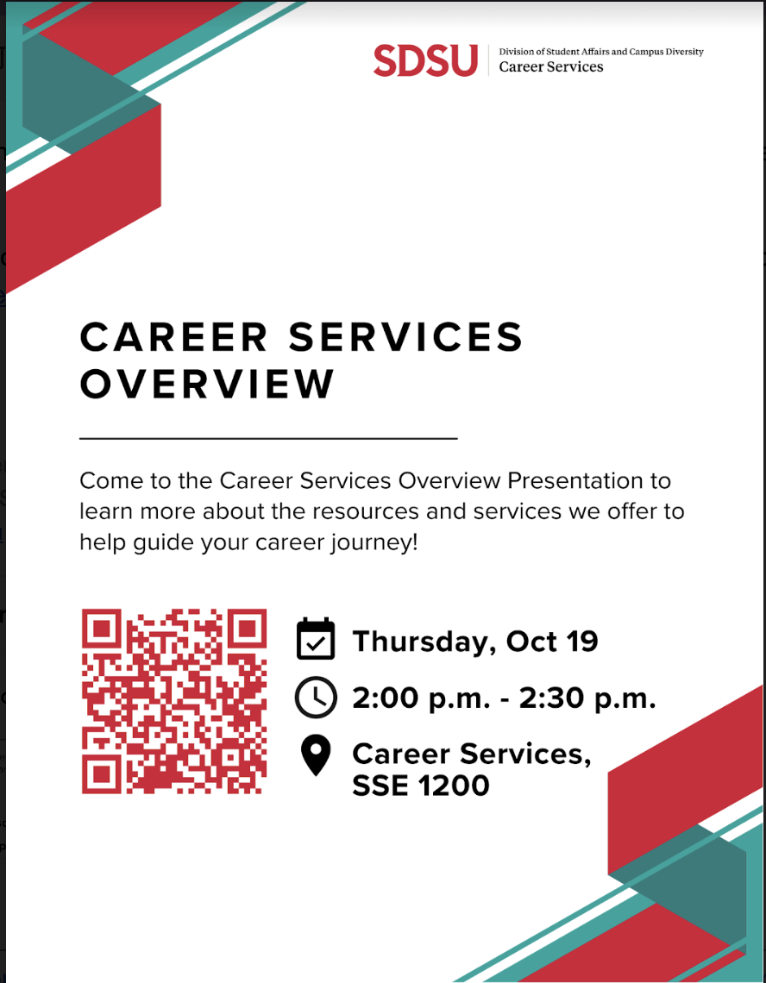

ADJOURNMENT:
Motion: ΑΓΔ, ΠΒΦ
Time: 3:50pm

