College Panhellenic Association || San Diego State University
Delegate Meeting Minutes || 9/18/23 || 3pm || Pierce Greek Life Center

See “HIGHLIGHTS” section below for important information for chapters to bring back to their chapters!

ΑΧΩ, ΑΓΔ, ΑΦ,ΔΓ, ΓΦΒ, ΚAΘ, ΚΔ, ΠΒΦ

ROLL CALL:
Present: ΓΦΒ, ΑΓΔ, ΔΓ, ΑΧΩ, ΑΦ, ΚΔ, ΚAΘ

Absent: ΠΒΦ

GUESTS:
- P-CAST

APPROVAL OF MINUTES::
Motion: ΑΓΔ | Seconded: ΓΦΒ

FINANCIAL UPDATE: The Treasurer reported as follows as of:

Beginning balance: $193,266.45

Revenue | --
Expenses | $1,750.00

Ending Balance: $191,516.45

GREEK COMMUNITY RELATIONS REPORTS:
NPHC Representative: President - Regena Gomes - (president.nphc@gmail.com) reported:
- Meet the Greeks tomorrow at 7pm in student union theater
- Deltas Meet the Nu Upsilon chapter BRC 7:13 today
- Deltas and Kappas Crimson and cream skate night sept 21 at Skateworld
- Sigma study jam started yesterday biweekly in love library
- Zetas- Girl talk at BRC Friday Sept 22 5pm
- AKAs elementary school drive bin in BRC and Amazon wishlist
  - https://www.amazon.com/registries/gl/guest-view/XOIK5H03HA3L

USFC Representative: Scholarship Director - Jalen Arbis - (scholarshipdirector.usfc@gmail.com) reported:

IFC Representative: - Joey Salvail - (jsalvail3784@sdsu.edu) reported:
- Happy Monday
- Bid Day is the 22nd,.
- IFC is finalizing a powderpuff date with CPA
Rho Lambda Representative: - Liz Jewel - (sdsurholambda@gmail.com) reported:
- Rho Lambda is accepting applications for this semester, and has reached out to all chapter presidents to coordinate walk-around presentations about our organization!
- Applications will close at the end of the month and we look forward to welcoming new members to our chapter
- Have an amazing week! :)

GLAB Representative: TBA (cpa.sdsuglab@gmail.com) reported:
- n/a

OFFICER REPORTS
The President, Sophie Rokaw, (president.cpa.sdsu@gmail.com) reported:
- Stoles are being ordered tonight so if you have not corrected any of the spelling please do it ASAP!!
- Shadowing
- Minutes, going forward & Excuses.
  - Minutes need to be completed 2 hours in advance. This is a HARD deadline for motions, as it will give us the time we need to prepare to have this motions brought to the floor!

The Executive Vice President, Lex Sabbatino, (executivevp.cpa.sdsu@gmail.com) reported:
- Hi everyone, please encourage your members/executive board to shadow CPA!

The Vice President of Programming, Macy Kobzeff, (programming.cpa.sdsu@gmail.com) reported:
- Happy Monday! Not much from me, let me know if you’d like to shadow!

The Vice President of Community Wellness, Elizabeth Gill, (communitywellness.cpa.sdsu@gmail.com) reported
- Happy Monday! Nothing from me, have a great week!

The Vice President of Finance, Marissa Temple, (finance.cpa.sdsu@gmail.com) reported:
- Happy Monday :)
- No report

The Vice President of Membership, Alexa Trcka, (membership.cpa.sdsu@gmail.com) reported:
- If anyone is interested in my position and wants to shadow me for my position, hmu!
- No report from me<3 have a good monday

The Vice President of New Members, Roxanne Elisha, (newmembers.cpa.sdsu@gmail.com) reported:
- have a great week nothing from me 😽

The Vice President of Communications, Riley Bellomo, (communications.cpa.sdsu@gmail.com) reported:
- Hi everyone!! Happy Monday!
- Here is the graphic for the Gone Bananas Event THIS SATURDAY!

The Vice President of Judicial Affairs, Adriana Juricic, (judicial.cpa.sdsu@gmail.com) reported:
- Infraction reports are done and Presidents of chapters who received infractions will be getting an email from me tonight or tomorrow latest.

The Vice President of Campus Relations, Maisie Vargas, (campusrelations.cpa.sdsu@gmail.com) reported:
- Hi!
- I attend Campus safety commission meetings on behalf of CPA and just wanted to relay some helpful info to u all!
- It’s really important you all tell your chapters about the SDSU safe app if they don’t know already! It has really helpful resources, please encourage your girls to download it and look around at it for a min to see all you can do with it. I attached a QR code to download the app if you wanna use that cuz its easier!
- Along with that sdsu kinda of revamped the red and black shuttle. Now it is the Red & black safe ride program, which is essentially the same thing but now after 10pm students can order a ride like an uber but its through the school. They are also in the process of getting more vehicles so this will be even more accessible !

The Vice President of Philanthropy, Taylor Cloutier, (philanthropy.cpa.sdsu@gmail.com) reported:
- Hey everyone sorry I couldn’t be there!
- If you want to shadow me or know anyone interested let me know! 7607038735
- 2023 Volunteer Opportunities
  - Conversations with International Students September 19th
  - PB Half Marathon October 5th, 6th, 7th
  - Susan G. Komen More than Pink walk November 5th

The Vice President of Scholarship, Noemi Portillo, (scholarship.cpa.sdsu@gmail.com) reported:
- Happy week 5!
- Scholarships for Fall 2023 are now open! They are open today (9/18) and will close on Friday (9/29). No late responses will be accepted! The chosen recipients will be announced during our CPA meeting on Monday (10/2)! Here are the links for each chapter:
  - Alpha Chi Omega
  - Alpha Gamma Delta
  - Alpha Phi
  - Delta Gamma
  - Gamma Phi Beta
  - Kappa Alpha Theta
  - Kappa Delta
  - Pi Beta Phi
- Central Intelligence Agency Information Sessions
  - Location: Extended Studies 206
  - Event Date: Monday, October 30, 2023
  - Event Time:
    - 9:00 am -10:30 am Information Session
    - 11:00 am - 12:30 pm Information Session
    - 2:30 - 3:30 pm Resume Review
  - Details: Students can learn about the variety of career and paid internship opportunities available to them. The presentation will include details about application processes and suggestions for making them competitive for employment. This event will be held in the Extended Studies Building on the second floor room 206. Registration is not required.
- Here is the Fall 2023 Accred Packet – please reference this first!

The Vice President of Diversity, Equity, and Inclusion, Kenna Mo, (dei.cpa.sdsu@gmail.com) reported
- Nothing from me. Enjoy your week (:

Panhellenic Advisory Team
Kayla Snow (ksnow@sdsu.edu)
Kristen Lemaster (klemaster@sdsu.edu)
- Chapter Meeting Spaces: every chapter was assigned a room! We know it is not ideal, but appreciate your continued flexibility and will coordinate a smoother process for next semester.
- EAS reminder: we have been very lenient, but after Oct. 1, late EAS requests will be denied.
- Greek Accreditation Feedback opportunity: Monday, September 25th from 4:00-4:30pm.
  - Intentionally scheduled right after CPA delegates - stay behind if you are able
  - Can also submit the survey: http://bit.ly/23fslaccred by September 29th
  - If you don’t give feedback, nothing can change!
- E-Bids: Still waiting on confirmed NM eligibility. E-bids to be extended later this week.
Madi Anderson (manderson3@sdsu.edu)
- Currently working with IFC’s Risk Chair, Ekene Aniemeka, to collab with CPA, NPHC & USFC to develop a Good Samaritan & Amnesty Policy awareness campaign for the Greek community. Campaign will include community walkarounds by Greek members, social media posts etc.
- Accredited event - Hazing Prevention Week Workshop (risk management/harm reduction)
  - Wednesday, September 27⋅7:00 – 8:00pm in Storm Hall 12
- Last week on Tuesday 9/12, One Stop SHOP (formally “condom cart”) received an influx of students that wanted to come take pictures for accreditation. This unprecedented surge caused SHOP to run out of safer sex supplies very early. While thankful for the participation, please be courteous and give Lauren Bossi a heads up if you will be offering SHOP as accreditation in the future! Her email is lbossi@sdsu.edu
Jason Fitzer (jfitzer@sdsu.edu)
- REMINDER: Any off-campus events with alcohol need to be registered per the RSO Handbook (p. 94). The event needs to be submitted 3 weeks before the event, which includes submission of a Presence form and e-signature of an attestation form.
- Hazing Attestation - following chapters have not yet completed:
  - Alpha Chi Omega
  - Alpha Gamma Delta
  - Gamma Phi Beta
CPA | Alpha Chi Omega
 | Alpha Gamma Delta
 | Alpha Phi | 9/1/23
 | Delta Gamma | 8/31/23
 | Gamma Phi Beta
 | Kappa Alpha Theta | 9/4/23
 | Kappa Delta | 9/1/23
 | Pi Beta Phi | 9/13/23

- Accreditation Feedback: The Pierce Greek Life Center Advisory Team is requesting feedback about the Greek Accreditation process. The current process for Greek Accreditation was launched in 2012 and revised in 2015. The Advisory Team is seeking input to make changes to best serve the needs of chapters and the fraternity and sorority community.

New Business
The motion by Delta Gamma to "pause further extension committee proceedings until Delta Gamma has proper collegiate representation on the board" is not in order. Delta Gamma is invited to discussion with Panhellenic Advisory Team after CPA meeting and motion is referred to the NPC Extension Committee.

Old/Unfinished Business
None

CHAPTER NEWS:
Alpha Chi Omega- Morgan Anapolsky (alphachiomegapanhellenic@gmail.com)
- Chapter news: We had our first chapter meeting in Arts and Letters last night
- Highlights: We are planning parents weekend and are looking forward to having our families in town!
- Lowlights: N/A
- Questions: Could this webinar put on by our nationals be accredited? Would it qualify for CW-E?
  - Yes! Event eligibility under the Accred Packet says: “Events such as inter/national or regional leadership virtual conferences/trainings hosted by the chapter’s executive office are events that chapter’s are encouraged to report in their Greek Accreditation slides.” - noemi
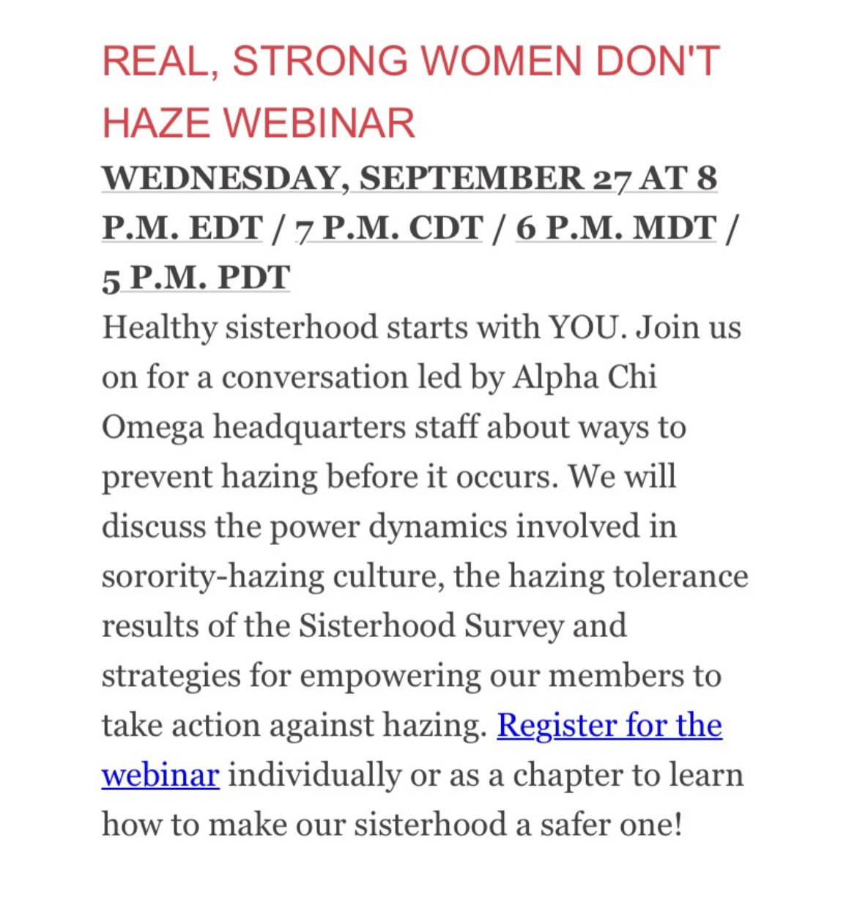

Alpha Gamma Delta- Avery LeBlanc (agd.campusrelations.sdsu@gmail.com)
- Chapter news: We are having a chapter-wide service opportunity at Feeding San Diego this weekend!
- Highlights: We had a super fun karaoke sisterhood night at the house this past weekend!
- Lowlights: none
- Questions: Where does everyone get their Senior Stoles from? We are trying to find a new company!
  - 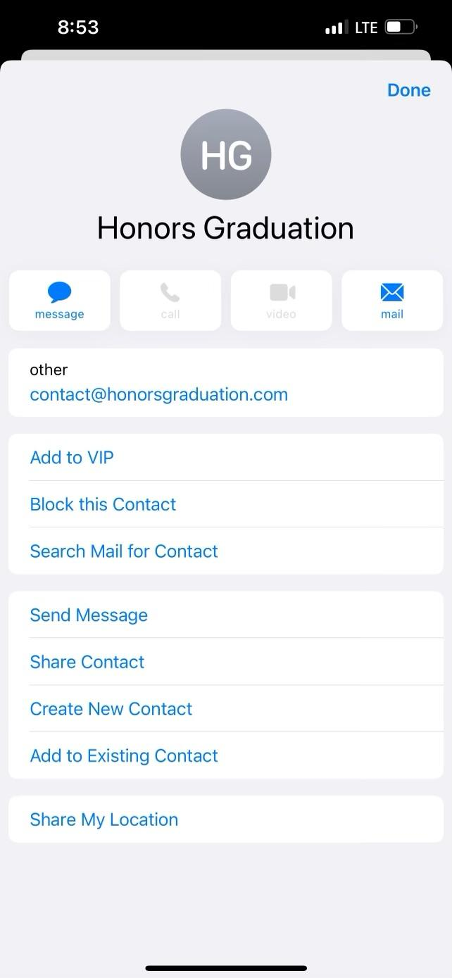-sophie
Alpha Phi- Lucia Bronzo-Munich (alphaphipanhellenicsdsu@gmail.com):
- Chapter news: We are busy planning our Red Dress Gala philanthropy event that will be on Oct. 20th!
- Highlights: It was so fun seeing all our new members at their first chapter meeting last week!
- Lowlights: N/A
- Questions: N/A

Delta Gamma- Kenna McCabe (sdsudgpanhellenic@gmail.com):
- Chapter news: Tomorrow we have a sisterhood event at the San Diego Padres Game!!
- Highlights: We had an amazing chapter meeting last night with two presentations from members and we had a great ISME swim pop up sisterhood at the house last week!
- Lowlights: N/A
- Questions:
  - Can the CPA/IFC calendar be shared again please, I cannot seem to find the link, thank you!?

Gamma Phi Beta- Lucy (my shadow for today <3) (sdsugammaphibetapavp@gmail.com):
- Chapter news: We are excited to have our first formal meeting with all our new members tonight at chapter!
- Highlights: Had a lot of fun at our Frankies Bikinis sale yesterday getting to shop with all our sisters.
- Lowlights: n/a
- Questions: n/a

Kappa Alpha Theta- Taryn Greenlee (vpp.theta.sdsu@gmail.com)
- Chapter news: We’ve started to plan our parents weekend and are super excited for that
- Highlights: We had a really great turnout at last week’s sisterhood sunset swim
- Lowlights: N/A
- Questions: N/A

Kappa Delta- Alondra Orozco ( panheldelbetarho@gmail.com )
- Chapter news: It’s international women’s friendship month and we are planning a sisterhood event with USD KD!
- Highlights: We had a hiking sisterhood event which was so fun.
- Lowlights: n/a
- Questions: n/a

Pi Beta Phi- Annie Deal (caepsilonpd@gmail.com)
- Chapter news: Our new member class had a great first meeting!
- Highlights: We are planning our parents weekend brunch
- Lowlights: n/a
- Questions: n/a

ANNOUNCEMENTS

ADJOURNMENT:
Motion:
Time: 3:25pm

