College Panhellenic Association || San Diego State University
Delegate Meeting Minutes || 10/30/23 || 3pm || Pierce Greek Life Center

See “HIGHLIGHTS” section below for important information for chapters to bring back to their chapters!

ΑΧΩ, ΑΓΔ, ΑΦ,ΔΓ, ΓΦΒ, ΚAΘ, ΚΔ, ΠΒΦ

🎃🎃🎃ROLL CALL: 🎃🎃🎃
Present: ΑΧΩ ΑΦ, ΚΔ, ΑΓΔ, ΚAΘ, ΔΓ, ΠΒΦ

Absent:

🎃🎃🎃GUESTS: 🎃🎃🎃
- Associated Students👻- Event on Nov 3rd
  - Good neighbor cleanup will count for community service and PS-E accreditation
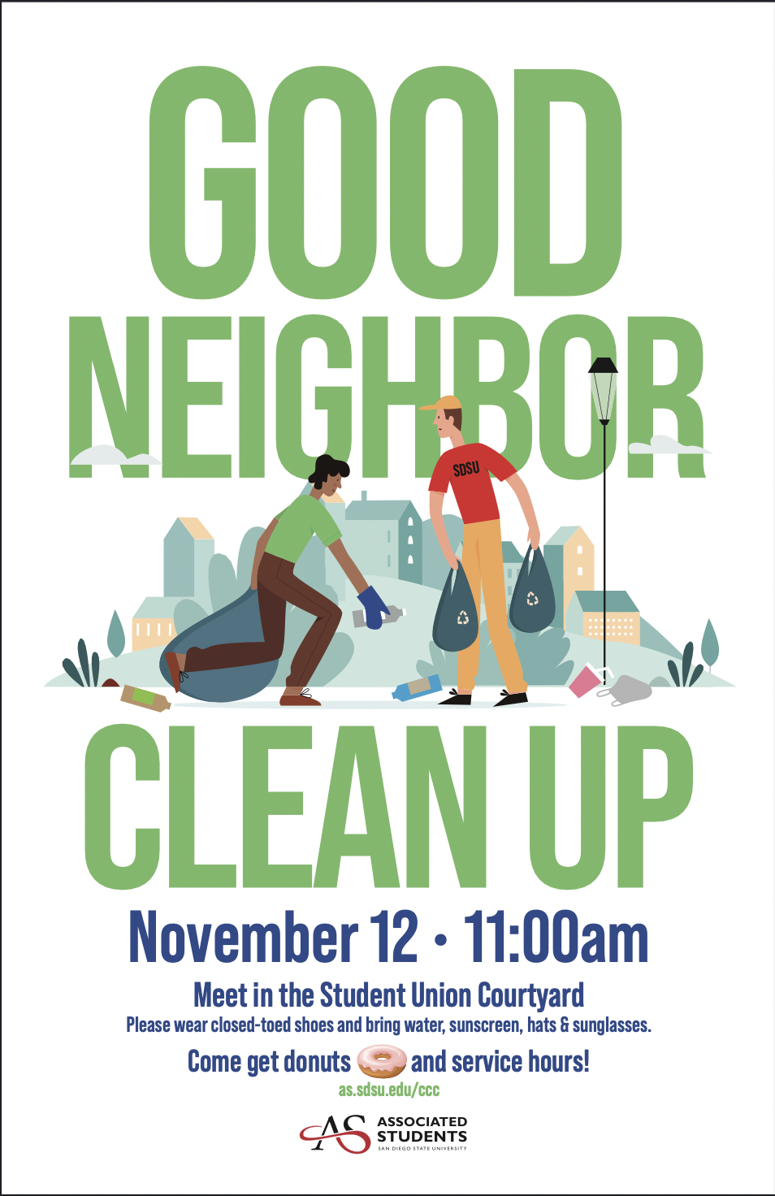
  - AS Career kickoff fulfills accreditation AA-A-2 Academic Achievement
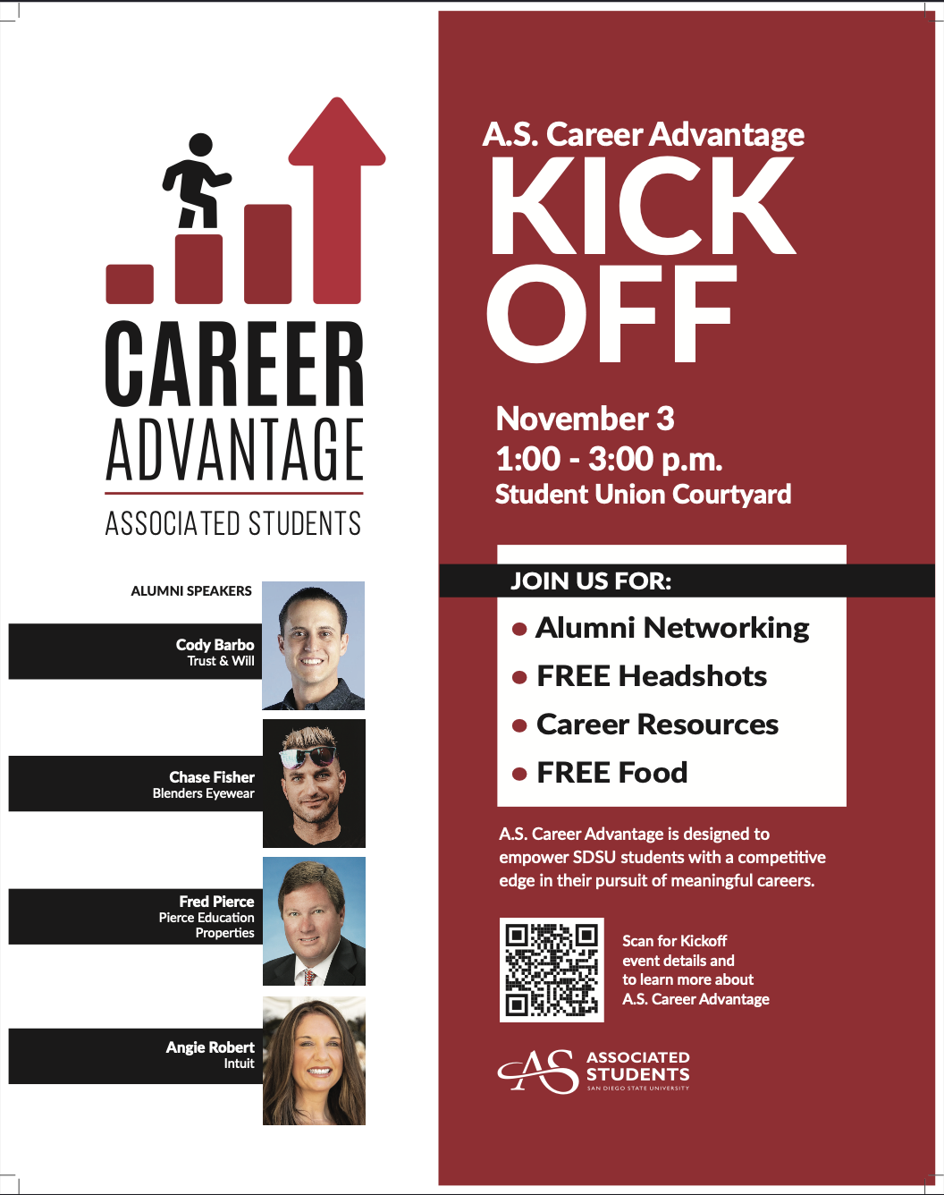

4

- Wishmakers - Tabling and Raffle on Nov1st and 2nd - 11am-2pm

🎃🎃🎃APPROVAL OF MINUTES:🎃🎃🎃
Motion:ΑΓΔ | Seconded: ΑΦ

FINANCIAL UPDATE: The Treasurer reported as follows as of:

Beginning balance: $178,447.77

Revenue | --
Expenses | --

Ending Balance: $178,447.77

🎃🎃🎃GREEK COMMUNITY RELATIONS REPORTS: 🎃🎃🎃
NPHC Representative: President - Regena Gomes👻 - (president.nphc@gmail.com) reported:
- NPHC YARDSHOW- Nov 3 in Montezuma Hall at 7pm
- AKA- Breast cancer workshop at 4pm in the BRC
- 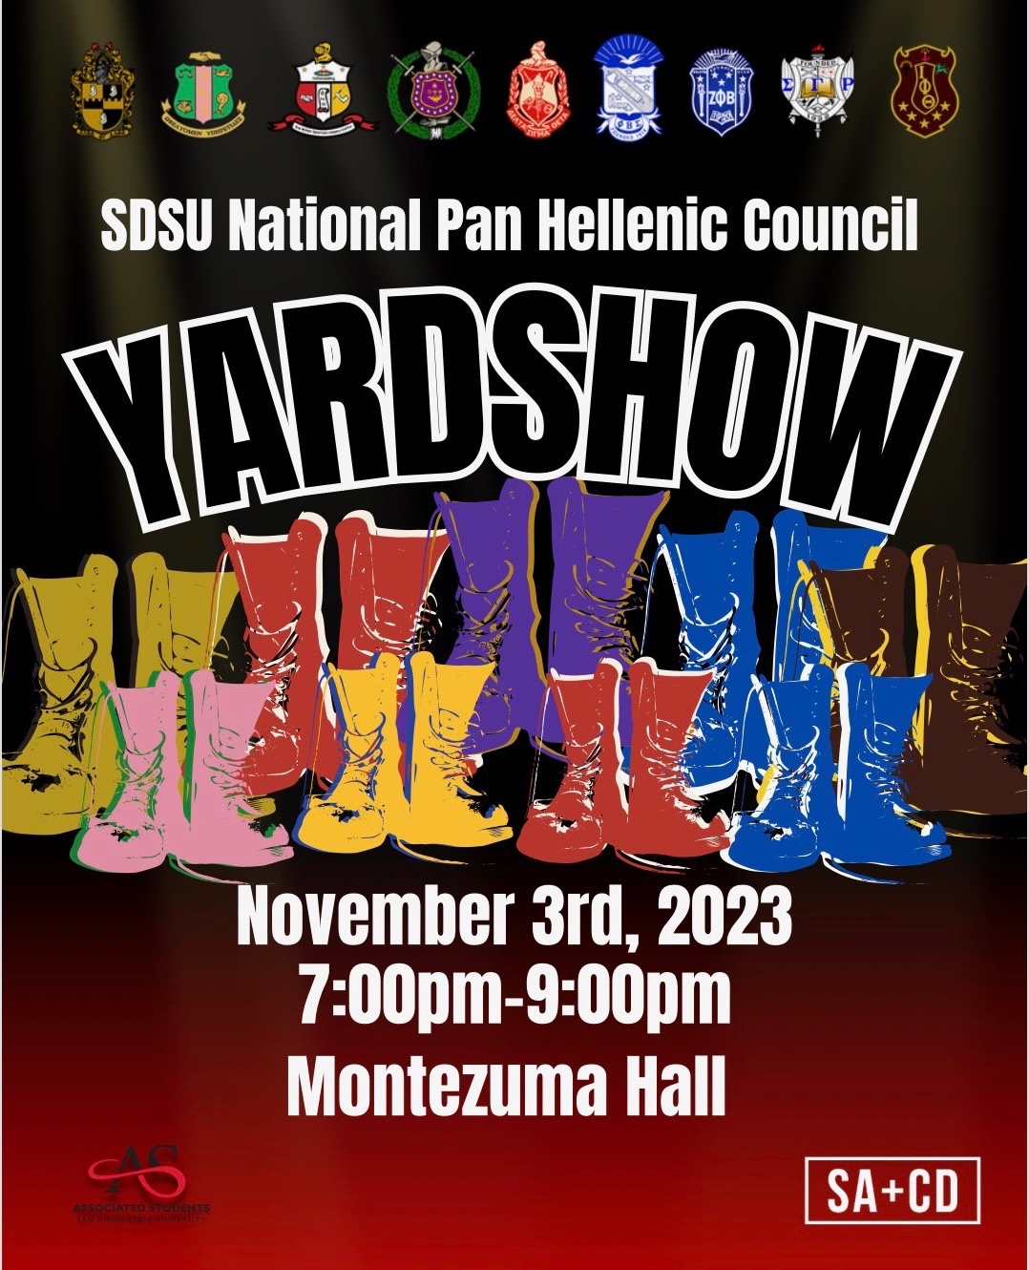

USFC Representative: Scholarship Director - Jalen Arbis👻 - (scholarshipdirector.usfc@gmail.com) reported:
- Sigma Alpha Zeta: “Symbols of Love” Event (Today 7pm)
  - Learn about domestic violence and make care packages for those in need
  - Visionary Suite - 3rd floor of the union
- Upsilon Kappa Delta: Epic Wings Fundraiser (Nov. 7)
  - 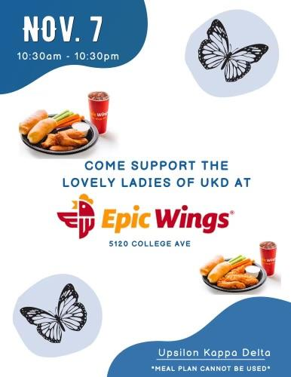

IFC Representative: - VP of Scholarship - Chris Johnson👻 - (scholarship.ifc.sdsu@gmail.com) reported:
- Our guys really enjoyed our joint dinner last week
- Putting in new Risk bylaws this week
GLAB Representative: TBA👻 (cpa.sdsuglab@gmail.com) reported:

Rho Lambda Representative: TBA👻 reported:
- We met with all our new members yesterday evening! Introduced some new members to each other and shared upcoming updates with the group
- Beginning to plan a holiday food drive – we will reach out to chapters in regards to donation bins in the next few weeks :)

🎃🎃🎃OFFICER REPORTS 🎃🎃🎃
The President, Sophie Rokaw👻, (president.cpa.sdsu@gmail.com) reported:
- HAPPY HALLOWEEN! 🎃🎃🎃🎃🎃🎃🎃🎃🎃🎃🎃🎃🎃🎃🎃🎃🎃🎃🎃🎃🎃🎃🎃🎃🎃🎃🎃🎃🎃🎃🎃🎃🎃🎃🎃🎃🎃🎃🎃🎃🎃🎃🎃🎃🎃🎃🎃🎃🎃🎃🎃🎃🎃🎃🎃🎃🎃🎃🎃🎃🎃🎃🎃🎃
- CPA Exec applications close tonight! Please reach out to your chapters and encourage them to apply! We are still missing representation from several chapters !!
- ALL THINGS EXTENSION! (if this was the only thing you were going to listen to at meeting this IS VERY important)
  - We have the honor of hosting Tri Delta, and Chi Omega for Extension Presentations!
  - There will be two campus wide presentations, one for each group! Tri Delta will be on campus on Nov 7th, and Chi Omega will be on campus on Nov 9th.
  - Due to the size of the room we have booked (AL201) we are offering an in-person, and zoom option to accommodate for large interest in attending events! It is STRONGLY recommended that your members on campus attend the presentations in person!
  - EVERYONE should be encouraged to attend. We need feedback from as many groups as possible on campus!
  - To CPA Delegates. I will be sending this information to your presidents on Friday. Please send this information out to your chapters ASAP! This invite is extended to your actives, your alumni, and your advisors! Please email your alumni networks, actives, and advisors to encourage them all to attend!
  - To our other council delegates (NPHC, USFC, IFC). Your feedback is also HIGHLY taken into consideration. Please pass on the invite of our campus presentations to your chapters and your councils! It is extremely important that the entirety of the greek communities opinions are taken into consideration!
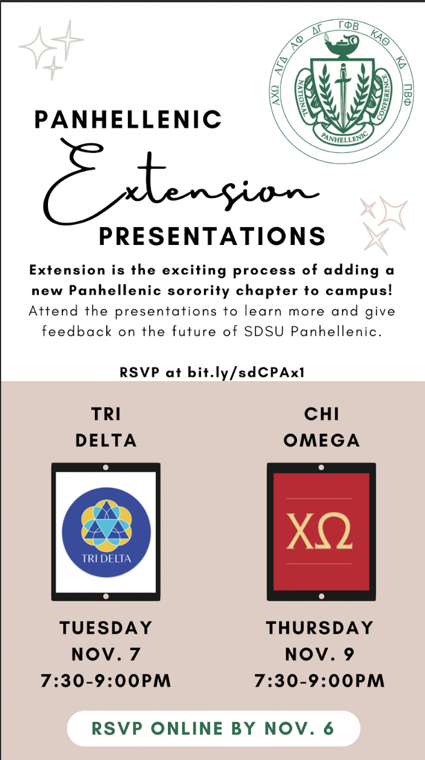
  - If you have friends not in Greek Life, or even friends who don’t attend SDSU please invite them as well! We need anyone and everyone’s feedback.
  - From Kristen,
    - Due to space capacity on campus, we ask that you RSVP in advance for either the in-person or Zoom option. In-person presentations will be held in Arts & Letters 201. After each presentation, you will be asked to submit a brief evaluation survey. Your feedback will provide valuable information to the committee as we prepare to make a recommendation, so we encourage you to attend both organization presentations if possible. Please RSVP using this form (short link: bit.ly/sdCPAx1) by Monday, November 6th at 1:00pm.
    - PLEASE send out this link!!! This is the RSVP link!

The Executive Vice President, Lex Sabbatino👻, (executivevp.cpa.sdsu@gmail.com) reported:
- CPA applications update:(
- You all slay<3

The Vice President of Programming, Macy Kobzeff👻, (programming.cpa.sdsu@gmail.com) reported:
- 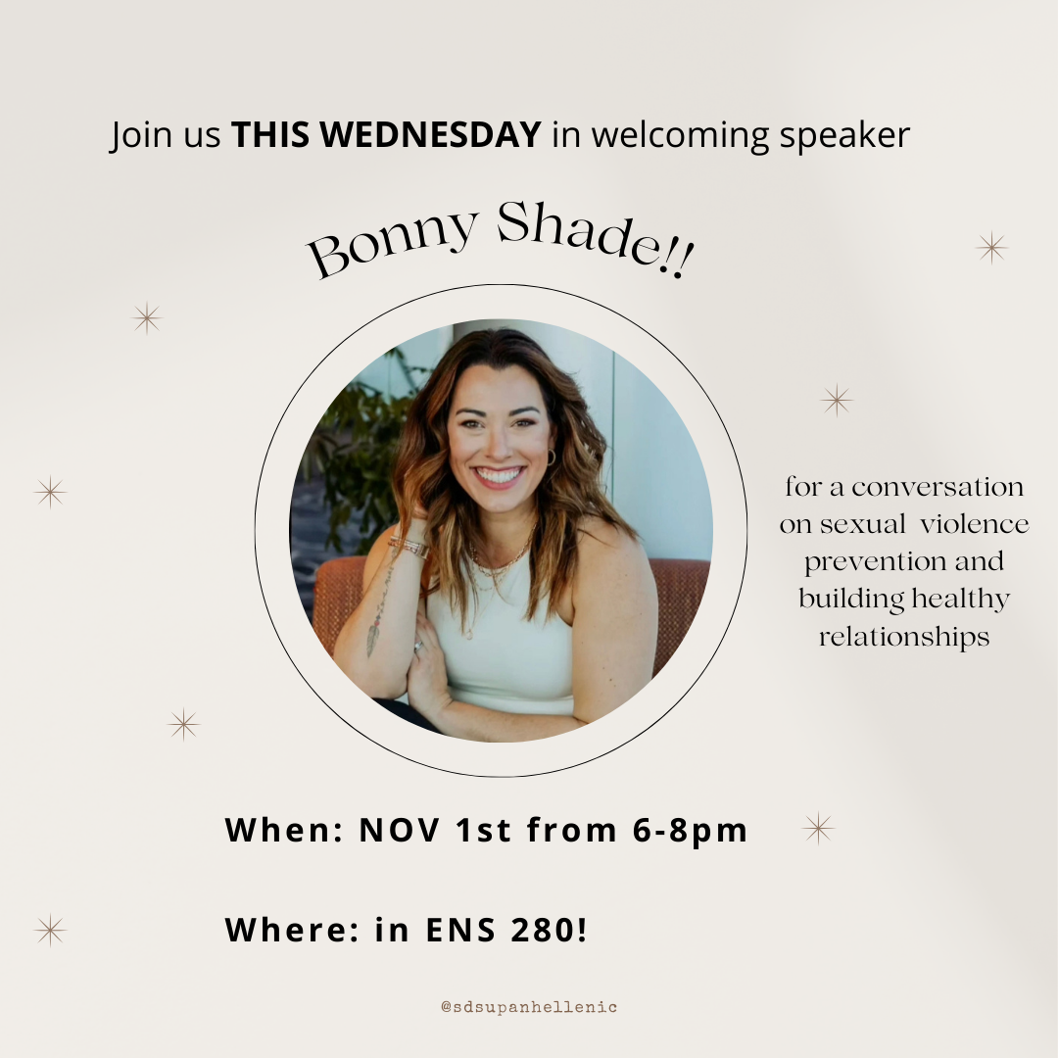
- Please promote this to your chapters! It will count for CR-C-1 accred :)

The Vice President of Community Wellness, Elizabeth Gill👻, (communitywellness.cpa.sdsu@gmail.com) reported
- Happy Monday!
- Come out to Bonny Shade on Wednesday! Her speech is amazing
The Vice President of Finance, Marissa Temple👻, (finance.cpa.sdsu@gmail.com) reported:
- Hi everyone!
- Should have scholarship and financial hardship checks next week! Thanks so much for your patience <3

The Vice President of Membership, Alexa Trcka, (membership.cpa.sdsu@gmail.com) reported:
- Hi everyone!
- Keep pushing CPA Exec apps <3

The Vice President of New Members, Roxanne Elisha👻, (newmembers.cpa.sdsu@gmail.com) reported:
- Hi yall, nothing from me, happy halloween! Stay safe 🥳

The Vice President of Communications, Riley Bellomo👻, (communications.cpa.sdsu@gmail.com) reported:
- Hi everyone have a happy and safe halloween!!
- Bonny shade is awesome I’m excited to see her again!! Plz come
- Composites are here yay!! Grab one from me at the end of meeting!
- We have a little q and a going for cpa apps so mention that

The Vice President of Judicial Affairs, Adriana Juricic aka Shoreclub bouncer👻, (judicial.cpa.sdsu@gmail.com) reported:
- hope everyone had a safe halloweekend and continues to be safe this week!

The Vice President of Campus Relations, Maisie Vargas👻, (campusrelations.cpa.sdsu@gmail.com) reported:
- I am super sick i wish i could see ur cute faces!
- Keep encouraging your chapters to participate in dance marathon & Aztecs rock hunger!! it’s super important the Greek community stays involved & supports ❤️
- Have a lovely Halloween, stay safe!

The Vice President of Philanthropy, Taylor Cloutier👻, (philanthropy.cpa.sdsu@gmail.com) reported:
- Hey everyone! I hope you had a fun and safe halloweekend! And happy halloween eek spooky!
- Thank you to everyone here and to all your members who helped tabled and made donations to help Circle of Sisterhood
  - We raised $731 in one week which is AMAZING! Thank you thank you thank you!💘
  - Winners for the raffle were announced on Instagram!
  - Thank you to Theta who bought the most of the girls supporting girls shirt! We will be making a donation to your philanthropy of choice! Please come talk to me after meeting!
- If any of your members who helped table need the point of contact for community service hours have them use my name and my cpa email (linked above)
- @dg could you talk to me after meeting really quick?
- 2023 Volunteer Opportunities
  - Conversation with International Students November 2nd
  - Neighborhood Clean Up on November 11th

The Vice President of Scholarship, Noemi Portillo👻, (scholarship.cpa.sdsu@gmail.com) reported:
- Happy week 10 and Halloween eve <3
- CR-C-1 - Bonny Shade event
- AA-A-2 - A.S. Career Kick-off
- PS-E - A.S. Good Neighbor Clean-Up
- Here is the Fall 2023 Accred Packet – please reference this before texting me!
  - Please reach out to me if you need any help finding opportunities for accred!!

The Vice President of Diversity, Equity, and Inclusion, Kenna Mo👻, (dei.cpa.sdsu@gmail.com) reported
- (:

🎃🎃🎃Panhellenic Advisory Team🎃🎃🎃
Kayla Snow 👻(ksnow@sdsu.edu)
Jason Fitzer 👻(jfitzer@sdsu.edu)
Kristen Lemaster👻 (klemaster@sdsu.edu)

Happy Homecoming!!!
- Rosters
  - Remember to email sllfraternitysororitylife@sdsu.edu if you haven’t already with an updated chapter roster! This helps us catch anyone we might’ve missed with e-bids.
- Accreditation FSL Wellness Workshops
  - Wednesday, Dec 6 from 7-8pm on campus: Wellness Strategies
- Chapter Live-In Request process will be launching before this semester ends. What we need from your chapters by Friday Nov. 3 (email klemaster@sdsu.edu) :
- What is the current live-in capacity of your chapter facility?
    - Total # of rooms and # of beds per room
    - Total # of live-in members
- What is the anticipated live-in capacity of your chapter facility for 2024-2025?
    - Total # of rooms and # of beds per room
    - Total # of live-in members
- How many sophomores currently live in your chapter facility?
- New Member Education
  - Makeup Session This afternoon (10/30) from 4-7pm zoom links were sent out this morning
- Off Campus Events with Alcohol registration
  - A general reminder to register all events taking place off campus with alcohol (including date dashes)
Off-Campus Event Registration
Off-Campus events with alcohol at the event should complete the Presence form. The form requests information about the event, as well as a risk management plan.

Once the Presence submission is reviewed the Chapter President and Alumnae/i advisor will receive a document for e-signature. The process is not an approval of the event, but rather the chapter sharing details of the event and affirming acknowledgement of relevant policy and process. The form needs to be submitted 3 weeks before the event date.
- Any event where alcohol is planned to be present must be registered with a completed Attestation form (sent through Adobe for an e-signature for the Chapter President & Advisor)
- Events submitted less than 3 weeks are out of compliance with our policy.

NPHC Yard Show

🎃🎃🎃New Business🎃🎃🎃
N/A

🎃🎃🎃Old/Unfinished Business🎃🎃🎃

Sophie: I motion to give $200 to help IFC purchase chips and waters to give out to people this weekend.
Alondra Orozco, Kappa Delta delegate moves to approve the motion. Seconded by Avery LeBlanc, Alpha Gamma Delta delegate. The vote will take place on Monday, October 30th.
- VOTE: NOT PASSED
- IN FAVOR: ΑΧΩ
- AGAINST: ΑΓΔ, ΑΦ,ΔΓ, ΓΦΒ, ΚAΘ, ΚΔ, ΠΒΦ

Sophie: I move to amend the CPA Bylaws, Article IX. Finances to read as follows:

Section 1. Fiscal Year
The fiscal year of the CPA shall be from [July, 31] to [June, 30] inclusive.

Section 2. Contracts
Signatures of the President, Executive Vice President, or Vice President of Finance shall be required to bind the San Diego State University Panhellenic Association on any contract.

Section 3. Checks
All checks issued on behalf of the CPA shall bear dual signatures. The following shall be authorized to be one of the two required signatures: President, Vice President of Finance, CPA Advisor.

Section 4. Payments
All payments due to the CPA shall be received by the Vice President of Finance who shall record them. Checks for payments shall be made payable to the CPA.

Section 5. Dues
- NPC dues shall be paid yearly as invoiced by the NPC office.

- CPA membership dues shall be an assessment per member and new member.
  - The amount of such dues for the next academic year shall be determined by the CPA Vice President of Finance and President and voted on by the CPA Delegates.
  - The dues of each CPA member fraternity and sorority shall be payable semesterly.
  - Dues will be invoiced per total amount of active and new members registered on the CPA chapter roster. If not paid by due date, a $10 late fee per day.
  - Spring dues will be invoiced the 1st week of March, and will be paid, in full, two weeks following the invoice date.
  - Fall dues will be invoiced on the 1st week of November, and will be paid, in full, two weeks following the invoice date.
C. FINANCIAL DELINQUENCY: If a chapter fails to complete council dues payment within allotted time frame, the chapter will be placed on Financial Delinquency status.
  - A late fee will be enacted after a 30 day grace period. Any days that school is not in sessions shall not count towards the 30 days
    - A 10% penalty may be levied on any unpaid amount after the 30 days.

Section 6. Fees and Assessments
The CPA Delegates shall have the authority to determine fees and assessments as may be considered necessary.

Section 7. CPA Financial Sponsorships:
A. Proposal Submission
- All organizations or entities seeking a financial sponsorship from the College Panhellenic Association (CPA) must submit either a written proposal to the CPA President and CPA Vice President of Finance with why they are requesting a financial sponsorship from the council. The details shall include, but are not limited to, the event date(s), event time(s), purpose of funds, and what the funds will be used for. The requesting organization can either present in-person to the CPA Executive Board and the CPA Chapter Delegates at a CPA delegate meeting or have the CPA President and/or CPA Vice President of Finance read and insert the entity’s written request proposal in the CPA Delegate Meeting Minutes under the “New Business” section.
B. Voting Process
- After the proposal(s) has been presented to CPA Chapter Delegates via “New Business”, the proposal shall be placed under “Old Business” of the CPA Delegate Meeting Minutes at the following CPA Delegate Meeting. In this instance, the CPA Chapter Delegates may motion to entertain a discussion and/or conduct a vote on whether to fulfill the requested amount from the entity. If a CPA Delegate Meeting is not being held, an electronic vote may be conducted by the CPA President with all CPA Chapter Delegates.
C. Granting Financial Sponsorship
- If the vote is passed, the CPA President shall email the requesting entity within 24 hours of the vote being conducted that a sponsorship is being granted on behalf of CPA. The CPA President shall also inform the requesting entity of the expectations aligned below.
- The CPA President shall collaborate with the CPA Vice President of Finance to submit a completed check request with a corresponding memo to Associated Students.
D. Expectations of Entities/Organizations Granted a Financial Sponsorship
- Entities granted a financial sponsorship from CPA shall adhere to the following expectations to ensure CPA is recognized and/or representation at the event which must include at least one (1) of the following components:
I. Verbal recognition of College Panhellenic Association at the event
II. Listing “Sponsored by College Panhellenic Association (and/or NPC Crest)” on the event flier

Section 8. Presidential Stipend:
1. The CPA President shall receive a stipend of one thousand dollars ($1,000.00) out of the College Panhellenic Association’s General Budget that amounts to five hundred dollars ($500) each semester.
2. The CPA President will be responsible for fulfilling her duties. If at any time the council determines that the CPA President isn’t fulfilling her duties, the council may, through two-thirds (2/3) vote, terminate the stipend, on a prorated basis. If such action is to be considered by the Council, the CPA Executive Vice President will preside over the meeting during the discussion and vote on the matter.
Alondra Orozco, Kappa Delta delegate moves to approve the motion. Seconded by Avery LeBlanc, Alpha Gamma Delta delegate. The vote will take place on Monday, October 30th.
- VOTE: PASSED
- IN FAVOR: ΑΧΩ, ΑΓΔ, ΑΦ,ΔΓ, ΓΦΒ, ΚAΘ, ΚΔ, ΠΒΦ
- AGAINST: n/a

🎃🎃🎃CHAPTER NEWS:🎃🎃🎃
Alpha Chi Omega- Morgan Anapolsky👻 (alphachiomegapanhellenic@gmail.com)
- Chapter news: We are looking forward to big little next week!
- Highlights: We had the best time at date dash last week!
- Lowlights: None
- Questions: When will the financial hardship scholarship recipients be receiving their scholarships?
  - Next week - marissa

Alpha Gamma Delta- Avery LeBlanc👻 (agd.campusrelations.sdsu@gmail.com)
- Chapter news: We are having our Overnight Sisterhood Retreat at Pali Retreat Center this weekend !
- Highlights: We had a super fun and cute mini pumpkin decorating sisterhood event this past week !
- Lowlights:
- Questions:
Alpha Phi- Lucia Bronzo-Munich👻 (alphaphipanhellenicsdsu@gmail.com):
- Chapter news: We are looking forward to Big Little this weekend!
- Highlights: Disneyland sisterhood on thursday!
- Lowlights: n/a
- Questions:Does participating in Aztecs Rock Hunger push day count for PS-E
  - Noemi Portillo yes! - noemi
- Is the CW-A-1 tracking sheet updated? My chapter went to the hazing prevention seminar but isn't noted
  - jfitzer@sdsu.eduNoemi Portillo

Delta Gamma- Kenna McCabe👻 (sdsudgpanhellenic@gmail.com):
- Chapter news: We are holding a house tour for our alumni this weekend to show them around!
- Highlights: We had a great time with KD at our sisterhood event!
- Lowlights: We were underwhelmed by the lack and quality of the risk resources that were provided this weekend. In the future, we would hope to see more purposeful action taken for the safety of our community.
- Questions: Does the November 3rd event count as accred? If so, what section?
  - Yes AA-A-2! -noemi Noemi Portillo
  - Do we have an updated tracker for the FSL workshops so we are aware of where we stand currently?

Gamma Phi Beta- Alexandra Tornberg 👻 (sdsugammaphibetapavp@gmail.com):
- Chapter news: We are beginning our elections process next week.
- Highlights: We had big little on Friday and enjoyed spending time with our families.
- Lowlights: n/a
- Questions: n/a

Kappa Alpha Theta- Nicole Linder👻 (vpp.theta.sdsu@gmail.com)
- Chapter news: We have our retreat this Saturday at Belmont park
- Highlights: We had a fun Depop sisterhood event last week
- Lowlights: n/a
- Questions: n/a

Kappa Delta- Alondra Orozco👻 ( panheldelbetarho@gmail.com )
- Chapter news: We are hosting a KD alumni event at our house this Saturday!
- Highlights: We really enjoyed our movie night with DG
- Lowlights: none
- Questions:
  - When will the CW-A-1 tracking sheet be updated?
  - How many Community Wellness A-1 events are required this semester? We haven't received confirmation yet. - two, confirmed by KKL 🙂

Pi Beta Phi- Annie Deal👻 (caepsilonpd@gmail.com)
- Chapter news: We have our initiation this coming weekend & big little!
- Highlights: We are announcing our formal tonight at chapter :)
- Lowlights: n/a
- Questions: n/a

🎃🎃🎃ANNOUNCEMENTS🎃🎃
N/A

🎃🎃🎃ADJOURNMENT: 🎃🎃🎃
Motion:
Time: 3:31pm

