College Panhellenic Association || San Diego State University
Delegate Meeting Minutes || 11/27/23 || 3pm || Pierce Greek Life Center

See “HIGHLIGHTS” section below for important information for chapters to bring back to their chapters!

ΑΧΩ, ΑΓΔ, ΑΦ, ΔΓ, ΓΦΒ, ΚAΘ, ΚΔ, ΠΒΦ

ROLL CALL:
Present: Α ΓΔ, ΠΒΦ, ΚΔ,ΔΓ, ΑΦ, ΚAΘ, ΓΦΒ

Absent:

GUESTS:
- This Thursday, there will be a FREE concert open to SDSU students & life! Twinsick concert at North Park Observatory & it is to promote a new app, called Yes!! Delegates, we want reps from AXO, KD, AGD, and THETA, so if you can pass out to your Social Chairs and have them contact me + send this flyer, all of Greekthat would be amazing!!!! Scan the QR code, download the app, and send it to your members! 7144005289

APPROVAL OF MINUTES::
Motion:ΑΓΔ | Seconded: ΠΒΦ

FINANCIAL UPDATE: The Treasurer reported as follows as of:

Beginning balance: $151,230.49

Revenue | --
Expenses | $4,916.95

Ending Balance: $146,313.54

GREEK COMMUNITY RELATIONS REPORTS:
NPHC Representative: President - Regena Gomes - (president.nphc@gmail.com) reported:
- No report! Just getting ready for the next semester

USFC Representative: Scholarship Director - Jalen Arbis - (scholarshipdirector.usfc@gmail.com) reported:
- No report!

IFC Representative: - Chris Johnson - (scholarship.ifc.sdsu@gmail.com) reported:
- Trent is leaving

GLAB Representative: TBA (cpa.sdsuglab@gmail.com) reported:

Rho Lambda Representative: Abi Seeley (aseeley1726@sdsu.edu) reported:
- Holiday food drive is 12/3-12/9
- Chapter representatives will be setting up donation bins for their chapters to donate to!

OFFICER REPORTS
The President, Sophie Rokaw, (president.cpa.sdsu@gmail.com) reported:
- Hi everyone, thank you all so incredibly much for your hard work and dedication this past year. It has been an honor to work with you all this year. I appreciate all the support that you all have given us this year, and hope for you all the best! I am so thankful for you all, and good luck in all of your future endeavors! You all are in extremely capable hands with the next board!
  - Last time yall will ever hear me call people silly nicknames too 😭
- Highlight: Meeting all of you all <3
- Lowlight: having the most debilitating anxiety attack of my life at disneyland at our board retreat

The Executive Vice President, Lex Sabbatino, (executivevp.cpa.sdsu@gmail.com) reported:
- It’s been a pleasure to be Sophie’s stunt double

The Vice President of Programming, Macy Kobzeff, (programming.cpa.sdsu@gmail.com) reported:
- Thank you guys for devouring every week kisses xoxo
- Highlight: Going to AFLV West and spending time with some interesting characters (including riley and adriana) from the Idaho Greek community at 4 a.m. outside the hotel in the rain
Lowlight: My poor planning of the cpa x ifc dinner in spring on st patrick's day (causing far too many shenanigans in public)

The Vice President of Community Wellness, Elizabeth Gill, (communitywellness.cpa.sdsu@gmail.com) reported
- Sound Bath with Susan Hytken Wednesday Nov. 29th from 5:30-7pm at Hillel
- 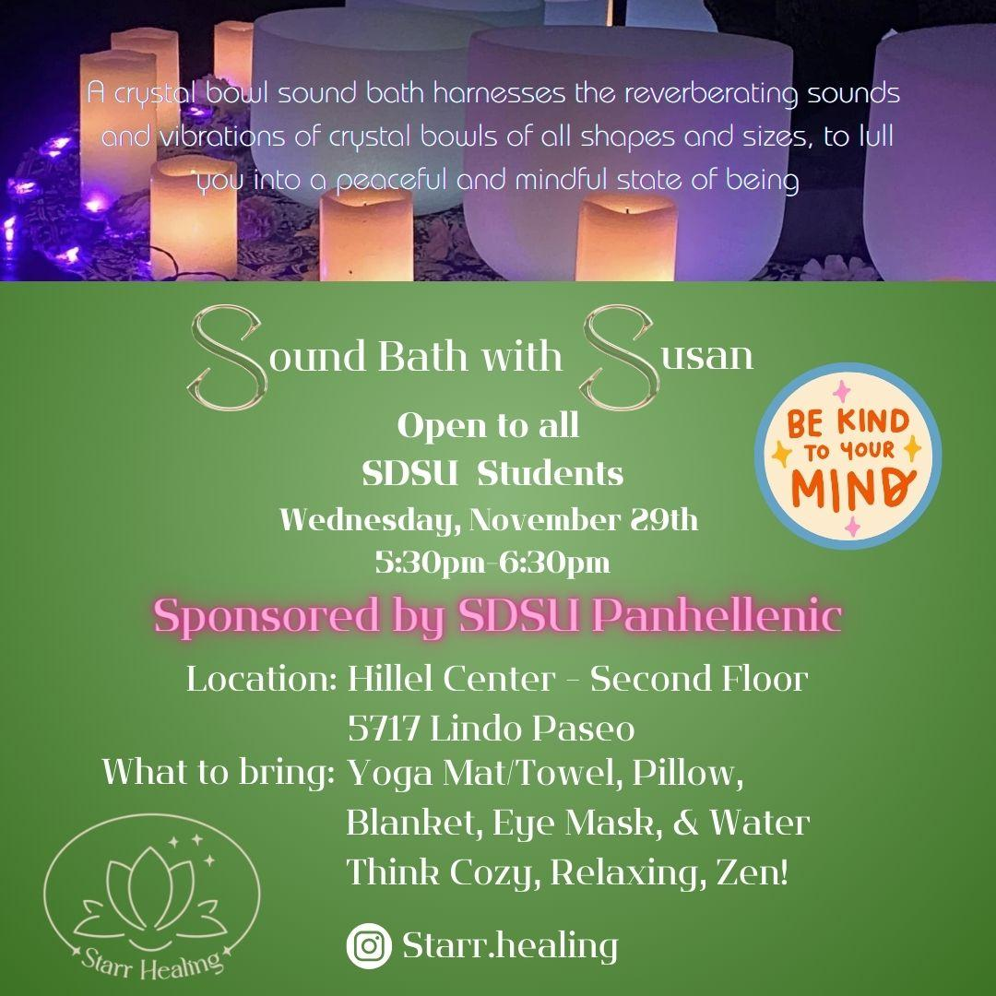
- Thank y’all for a great year!
The Vice President of Finance, Marissa Temple, (finance.cpa.sdsu@gmail.com) reported:
- Happy monday!
- Head Tax Invoices went out! Due next Monday
- Thanks for a great year <3 you all slay so hard

The Vice President of Membership, Alexa Trcka, (membership.cpa.sdsu@gmail.com) reported:
- Happy Monday!
- Thank you for such a great year and the work everyone put in this year during Recruitment! We put on the largest Recruitment ever at SDSU this year and I am so proud of all your VPMs and chapters for being so well-rounded and amazing!! Wishing the best of luck to the two amazing women taking on my position xoxo
- Highlight: planning the 10th largest recruitment in the country this year!!! Lowlight: falling asleep on the trolley on the way to our St Pattys IFC dinner

The Vice President of New Members, Roxanne Elisha, (newmembers.cpa.sdsu@gmail.com) reported:
- Thank you all for your diligent work and putting up with us and our antics every week, we are so appreciate of you!! Have a great rest of your semester!
- Highlight: AFLV west Lowlight: the hats

The Vice President of Communications, Riley Bellomo, (communications.cpa.sdsu@gmail.com) reported:
- THANK YOU ALL you guys slayed so hard and no more weekly emails from meeee :) Good luck with everything in the future its been such an honor representing the panhel community <3
VP comm out ✌️❣️😎
- Highlights: AFLV west <3 & seeing all the new mems on bid day after all the hours of werk
- Lowlights: every time i forgot to share the minutes on thursdays and had a sunday freakout oops sorry xoxo

The Vice President of Judicial Affairs, Adriana Juricic, (judicial.cpa.sdsu@gmail.com) reported:
- Highlight: AFLV hands down funniest experience ever and ❤️Dane from Boise State❤️
- Lowlight: reading the bylaws over and over
- Thank you all for your hard work this past year. It has been an honor to serve this community and we truly could not have done it without all of you. You are all very much appreciated by our board and we extend our deepest thanks to you all. I’ve spent 2.5 years in this room in your seats as well as on this side now and it truly is such an amazing experience. I hope you all as delegates and exec have enjoyed every minute of it. To the next board, this experience really gives u the opportunity to make some of your best friends so enjoy it. VP Judicial signing off😢

The Vice President of Campus Relations, Maisie Vargas, (campusrelations.cpa.sdsu@gmail.com) reported:
- Thank you and the rests of your exec boards for all of your patience and effort this past year. It has been lovely getting to know you all and I’ll miss staring at your gorgeous faces every week! I hope we have made sitting over there as enjoyable for you all as possible <3
- Highlight: giggling during recruitment
- Lowlight: being one of two women in ifc meeting every week

The Vice President of Philanthropy, Taylor Cloutier, (philanthropy.cpa.sdsu@gmail.com) reported:
- Hi everyone!
- Reminder that the community service hours tracker sheet is linked on the accreditation packet (i’ve gotten a couple questions about it so just to make sure everyone knows)
- Thank you all for an amazing year and thank you for everything you have done this past year! Wishing you all the best on your future endeavors <3
- Highlight: guilting rapp into donating to Circle of Sisterhood (or the time my security guard for recruitment kept offering me snacks while I was stationed outside of AXO)
- Lowlight: my security guard who was stationed outside of AXO with me was #interesting

The Vice President of Scholarship, Noemi Portillo, (scholarship.cpa.sdsu@gmail.com) reported:
- Happy week 14(?)
- Highlight: being on this board <3
- Lowlight: accred </3
- Let me know if you need any last-minute help with accred!
- Thank you all for a great year! I’m thankful to have worked with you all and wish y’all a great rest of the school year!

The Vice President of Diversity, Equity, and Inclusion, Kenna Mo, (dei.cpa.sdsu@gmail.com) reported
- 😭

Panhellenic Advisory Team
Kayla Snow (ksnow@sdsu.edu)
Kristen Lemaster (klemaster@sdsu.edu)
- We hope everyone had a wonderful break!
RSO: Organizations who are still in “conditional recognition”
- Alpha Chi omega - Fire Inspection
- Alpha Gamma Delta - Certificate of Liability
- Delta Gamma - Fire Inspection - COL (1/24)
- Gamma Phi Beta - Fire Inspection - COL (12/1)
- Kappa Alpha Theta - Fire Inspection
- Kappa Delta - Advisor approval and orientation completion

RSO officer change over for Spring
  - If your organization is undergoing officer changes - please read
    - As the semester comes to a close, we want to ensure all chapters are set for the upcoming school year. With that being said; RSO, ILAT & Banking Trainings are now open for registration. You can find all information on how to register at https://sacd.sdsu.edu/student-life-leadership/student-organizations/start-renew. If you have any questions please reach out to the SLLfraternitysororitylife@sdsu.edu email and we will get back to you. Have a wonderful week!
    - Outgoing presidents - please be sure that you do NOT remove yourselves as president just yet (you will be removed from RSO access).
    - You will need to add another officer to remove you and add the new president, who would then be able to add in all new officers
    - If you have trouble with this transition - email Kayla (ksnow@sdsu.edu)
      - I will be happy to add folks in
- Incoming Executive board roster
  - Please submit a complete Executive Board Officer List following elections
  - send it to sllfraternitysororitylife@sdsu.edu
- Off Campus Events with Alcohol - can register Spring events now if planned
  - All chapters hosting off-campus events must register events 3 weeks ahead to be in compliance with CSU policy
  - This includes third party venues
  - https://sdsu.presence.io/form/off-campus-events-with-alcohol-registration-form
- EAS Tier reminders for events taking place in Spring
  - Please be sure to look at your calendars for Spring and submit events needing more time

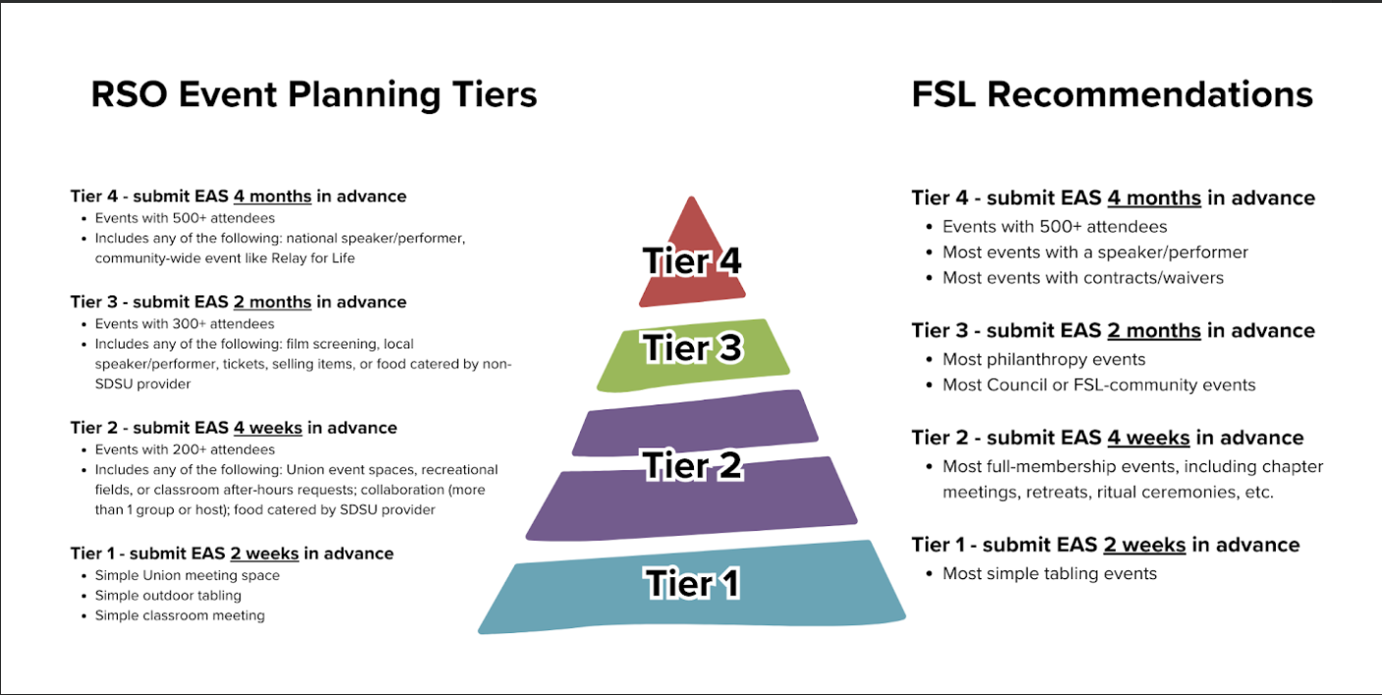

- Upcoming FSL events & initiatives:
  - December 1: last FSL New Member Education session (RSVPp[[4 here)
    - Chapters that have not met 90%: AXO, AGD, Theta, KD, Pi Phi
    - If this seems wrong, please update your roster in RSO as soon as possible.
  - December 4: Chapter Live-In Request form will open, closes January 31
    - All chapter presidents, housing officers, etc. will receive an email (if we know who they are based on your chapter exec rosters 🙂)
    - Must reach accredited status for Fall 2023 for members to participate
  - December 6: last FSL Wellness Workshop for Accreditation (attendance tracked here)
    - Wellness Strategies & Stress Management, 7-8pm in AL 201
    - Chapters that have not met attendance requirements: AXO, AGD, GPhi, Theta
  - December 10: Accreditation slides due
  - December TBD: RSVP for TEAM retreat (presidents), January 10-12, 2024

MISC opportunities: SDSU’s Got Talent

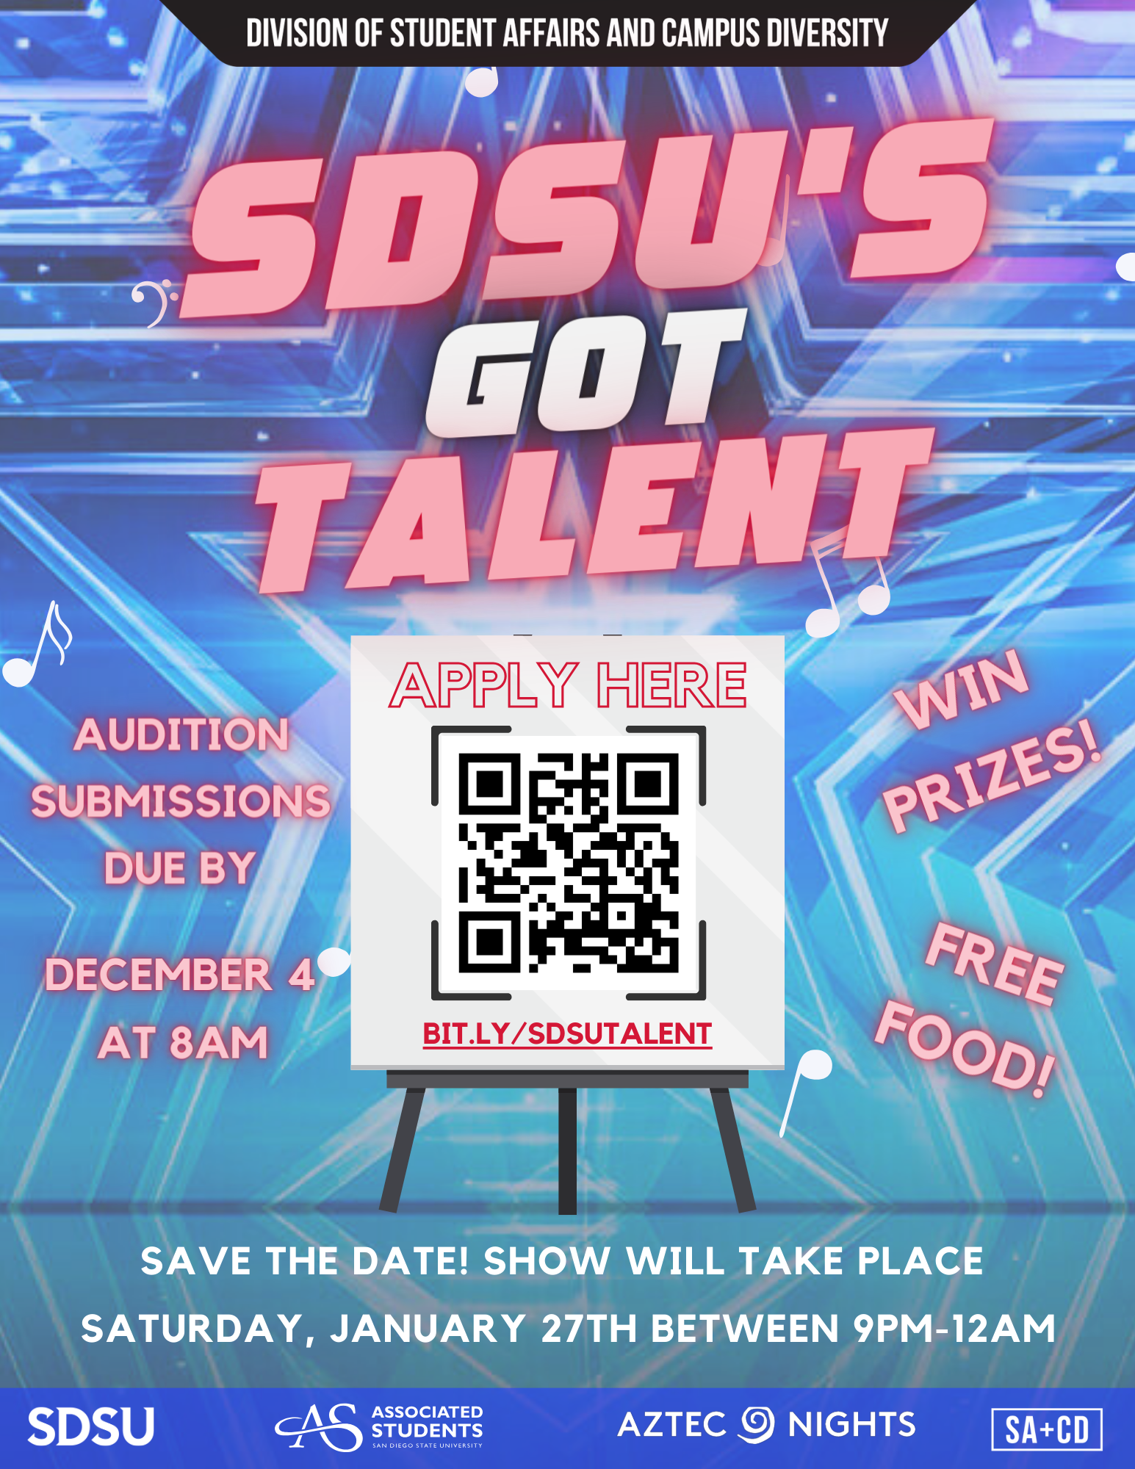

New Business

Slate Challenge Vote
Sophie: Do we have a challenge?
Misha: Challenging for the Vice President of Scholarship
Voting for the Challenged Position
- VOTE: PASSED
- IN FAVOR: 6
- AGAINST: 2

Slate Approval Vote
- VOTE: PASSED
- IN FAVOR: ΑΓΔ, ΑΦ, ΔΓ ΑΧΩ, ΚΔ, ΓΦΒ, ΚAΘ, ΠΒΦ
- AGAINST: none

President | abby garcia
EVP | abbey wilson
Judicial | carlie scott
r external | genevieve gardner
r internal | ella yarrow
finance | Haley Otten
r counselors | katelyn medley
dei | bre pierce
comm | katie murphy
philo | lindsay freitas
campus r | madeline eff
scholar | ellie newberg
programming | madison cadena
comm wellness | kerri scutt

Old/Unfinished Business

CHAPTER NEWS:
Alpha Chi Omega- Morgan Anapolsky (alphachiomegapanhellenic@gmail.com)
- Chapter news: We have our exec elections tomorrow night!
- Highlights: We're super excited for our formal on Thursday!
- Lowlights:
- Questions:

Alpha Gamma Delta- Avery LeBlanc (agd.campusrelations.sdsu@gmail.com)
- Chapter news: We have our Formal this Friday and are super excited to celebrate a wonderful semester !
- Highlights: We had a nice and restful Thanksgiving break
- Lowlights:
- Questions:
Alpha Phi- Lucia Bronzo-Munich (alphaphipanhellenicsdsu@gmail.com):
- Chapter news: We just announced the 2023-2024 Exec Board and Jacey Greene will be taking over my position yay!!
- Highlights: Our members had a great time reconnecting w friends and family this thanksgiving week
- Lowlights: n/a
- Questions: n/a

Delta Gamma- Kenna McCabe (sdsudgpanhellenic@gmail.com):
- Chapter news: We have our overnight chapter retreat this weekend and a philanthropy event at the house this thursday! (Flyer shared in the delegates gc)
- Highlights: We officially elected our new executive board last weekend!
- Lowlights: N/A
- Questions: N/A

Gamma Phi Beta- Layla Tyree (sdsugammaphibetapavp@gmail.com):
- Chapter news: We are electing our next exec board tonight.
- Highlights: Our formal is on Friday!
- Lowlights: n/a
- Questions: n/a

Kappa Alpha Theta- Taryn Greenlee (vpp.theta.sdsu@gmail.com)
- Chapter news: Our formal is this Friday.
- Highlights: Everyone had a restful break!
- Lowlights: N/A
- Questions: N/A

Kappa Delta- Alondra Orozco ( panheldelbetarho@gmail.com )
- Chapter news: Our new exec board will be installed today at meeting
- Highlights: We have formal Friday!
- Lowlights: none
- Questions: none

Pi Beta Phi- Annie Deal (caepsilonpd@gmail.com)
- Chapter news: we are installing our new slate soon!
- Highlights: everyone is happy to be back and ready for finals
- Lowlights: n/a
- Questions: n/a

ANNOUNCEMENTS
Love you all -old board

ADJOURNMENT:
Motion:
Time: 4:15, meeting will be completed next week

